Unit 9 Lesson 11: Plotting the Weather

1 California Rain (Optional)

Student Task Statement
What do you notice? What do you wonder?
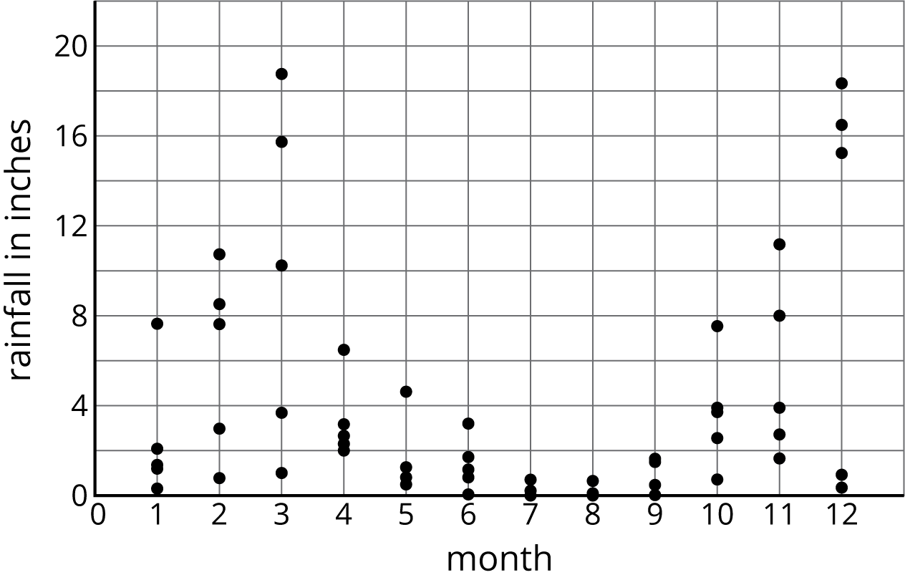

2 Data Snooping (Optional)

Student Task Statement
The table shows the average high temperature in September for cities with different latitudes. Examine the data in the table.
city | latitude (degrees North) | temperature (degrees Fahrenheit)
Atlanta, GA | 33.38 | 82
Portland, ME | 43.38 | 69
Boston, MA | 42.22 | 73
Dallas, TX | 32.51 | 88
Denver, CO | 39.46 | 77
Edmonton, AB | 53.34 | 62
Fairbanks, AK | 64.48 | 55
Juneau, AK | 58.22 | 56
Kansas City, MO | 39.16 | 78
Lincoln, NE | 40.51 | 77
Miami, FL | 25.45 | 88
Minneapolis, MN | 44.53 | 71
New York City, NY | 40.38 | 75
Orlando, FL | 28.26 | 90
Philadelphia, PA | 39.53 | 78
San Antonio, TX | 29.32 | 89
San Francisco, CA | 37.37 | 74
Seattle, WA | 47.36 | 69
Tampa, FL | 27.57 | 89
Tucson, AZ | 32.13 | 93
Yellowknife, NT | 62.27 | 50
- What information does each row contain?
- What is the range for each variable?

- Do you see an association between the two variables? If so, describe the association.

3 Temperature vs. Latitude (Optional)

Student Task Statement
- Make a scatter plot of the data.
- Describe any patterns of association that you notice.

- Draw a line that fits the data. Write an equation for this line.
© CC BY Open Up Resources. Adaptations CC BY IM.

