Lesson 14: Count Out Objects
- Let’s figure out how many toppings we need to put on our pizza.

Warm-up: How Many Do You See: 5-frames and Fingers
How many do you see?
How do you see them?
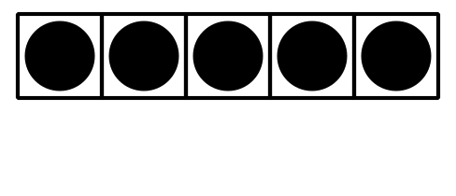
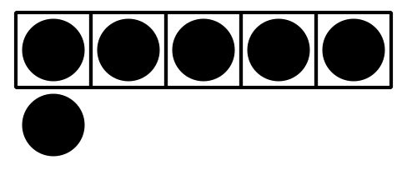
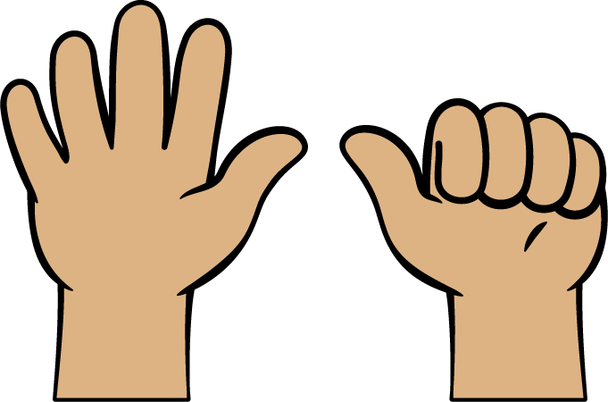

14.1: Toppings on Pizza

14.3: Introduce Bingo, Images and Numbers
Choose a center.
Bingo
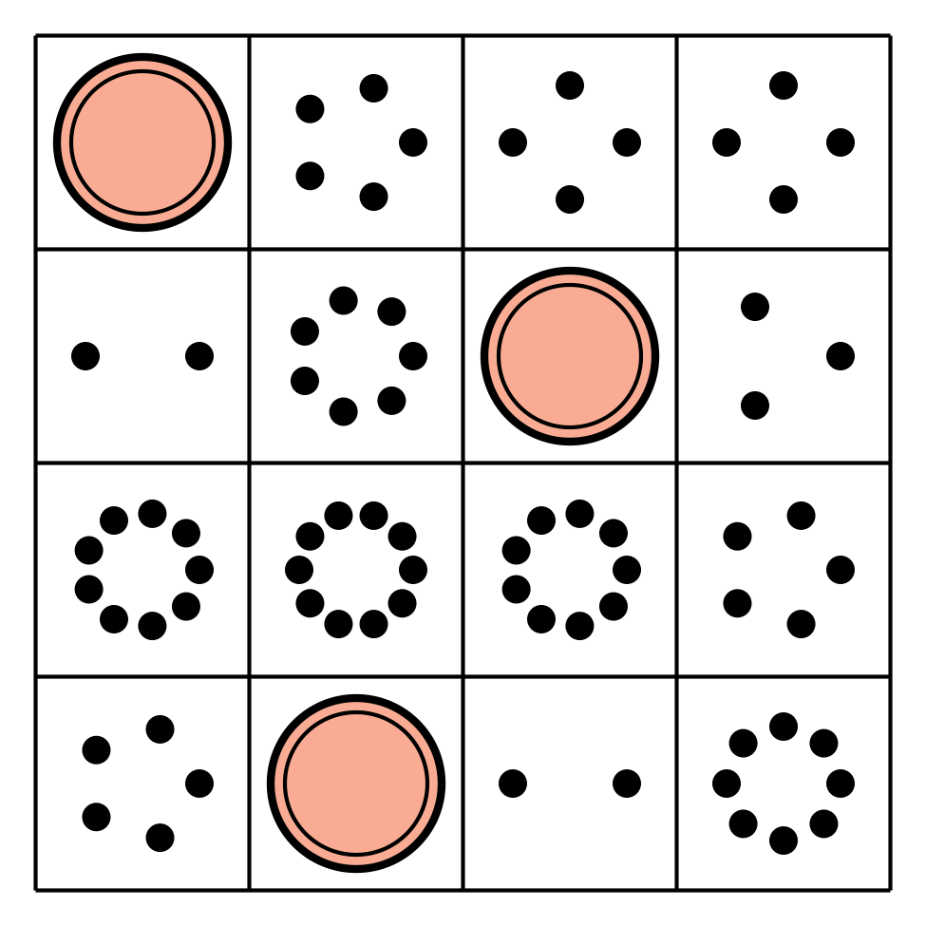
Number Race
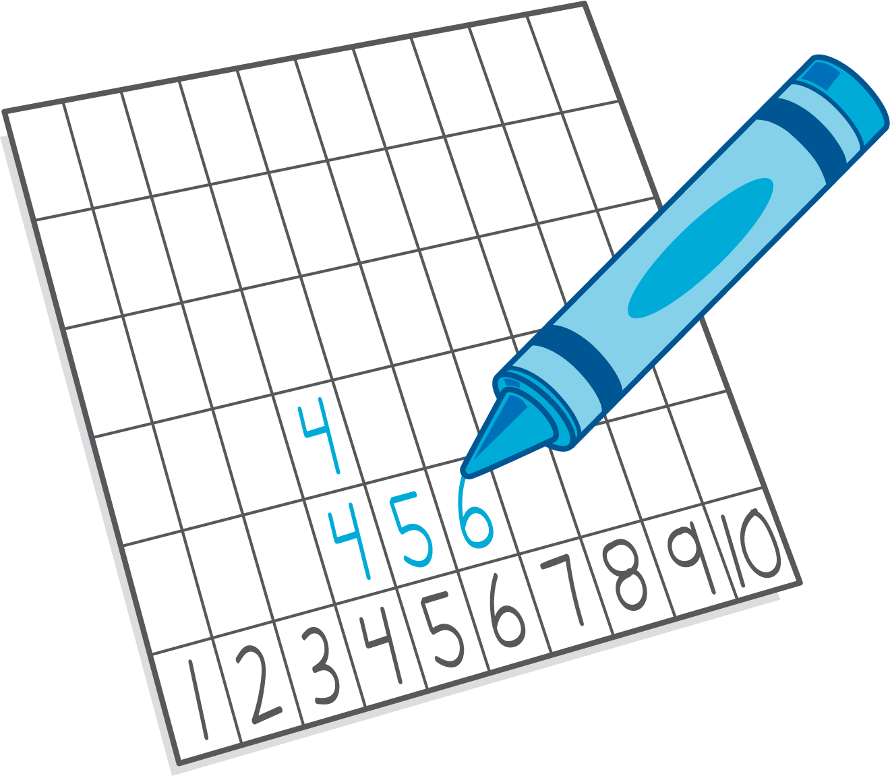
Geoblocks
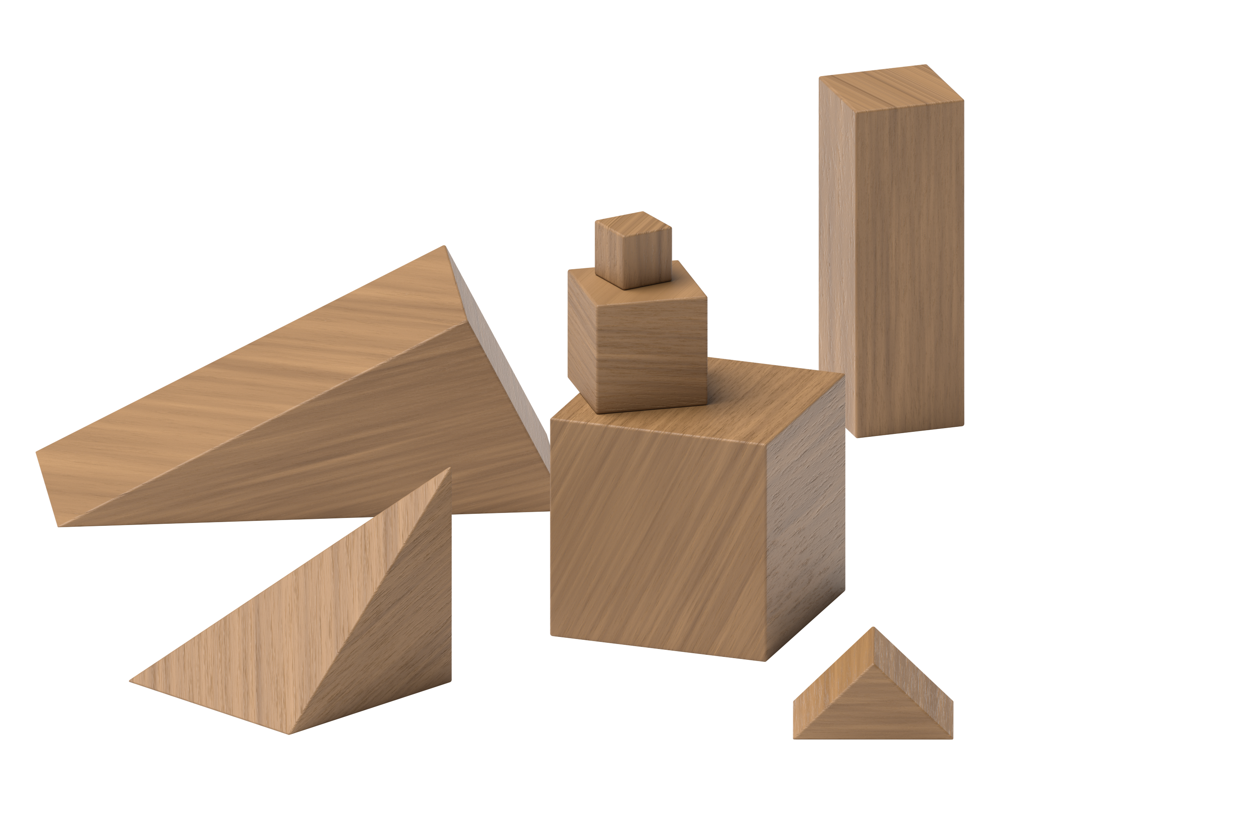
Math Fingers
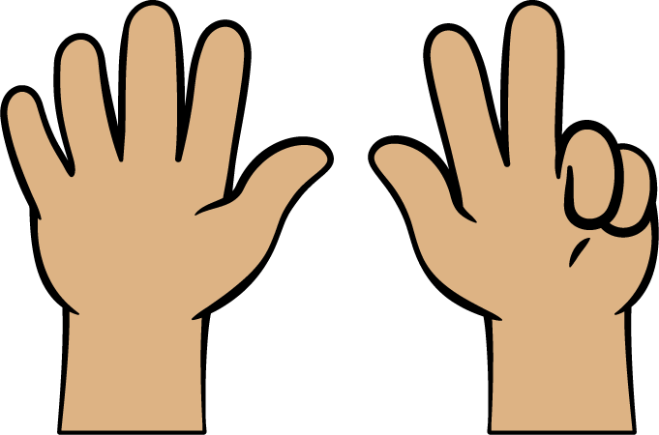
© CC BY 2021 Illustrative Mathematics®

