Unit 6 Lesson 8: Make Numbers with 10 and Some More (Part 2)

WU How Many Do You See: Numbers on a 10-frame (Warm up)

Student Task Statement
How many do you see?
How do you see them?
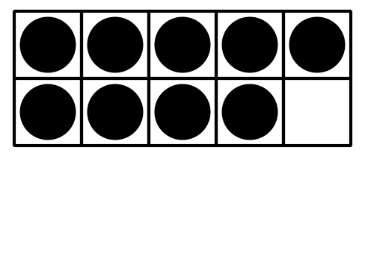
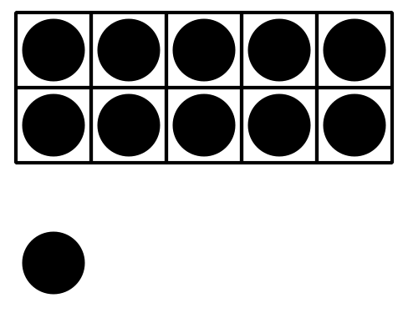
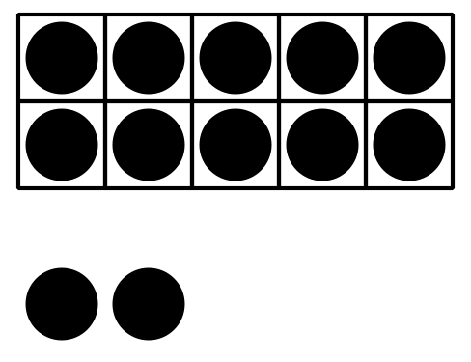
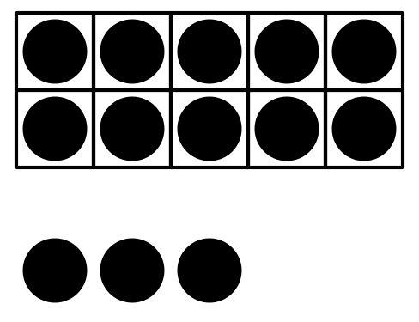

1 Make Number Cards

Student Task Statement

2 Make Each Number

Student Task Statement
11
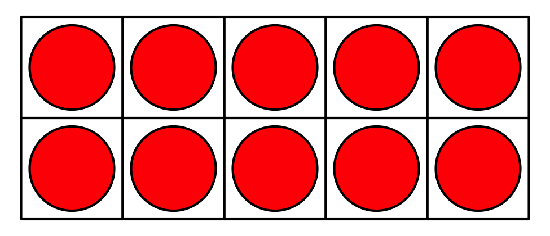
19
15
17
14
12

3 Introduce Bingo, Numbers 11–19

Student Task Statement
© CC BY 2021 Illustrative Mathematics®

