Lesson 7 Practice Problems
- Noah solved the equation $5x^{2}=45$. Here are his steps:
- $\begin{matrix}5x^{2} & =45 \\ x^{2} & =9 \\ x & =3\end{matrix}$
- Do you agree with Noah? Explain your reasoning.
- Find the solution(s) to each equation, or explain why there is no solution.
  - $\sqrt{x+4}+7=5$
  - $\sqrt{47−x}−2=4$
  - $\frac{1}{2}\sqrt{20+x}=5$
- Which is a solution to the equation $\sqrt{5−x}+13=4$?
  - 86
  - 81
  - 9
  - The equation has no solution.
- Select all expressions that are equal to $\frac{1}{{\left(\sqrt{2}\right)}^{5}}$.
  - $\text{-}\frac{5}{\sqrt{2}}$
  - $\frac{1}{\sqrt{2^{5}}}$
  - $\frac{1}{\sqrt{32}}$
  - $\text{-}{\left(\sqrt{2}\right)}^{5}$
  - $\text{-}2^{\frac{5}{2}}$
  - $2^{\text{-}\frac{5}{2}}$
- (From Unit 3, Lesson 5.)
- Which are the solutions to the equation $x^{2}=36$?
  - 6 only
  - -6 only
  - 6 and -6
  - This equation has no solutions.
- (From Unit 3, Lesson 6.)
- Here is a graph of $y=x^{2}$.
- 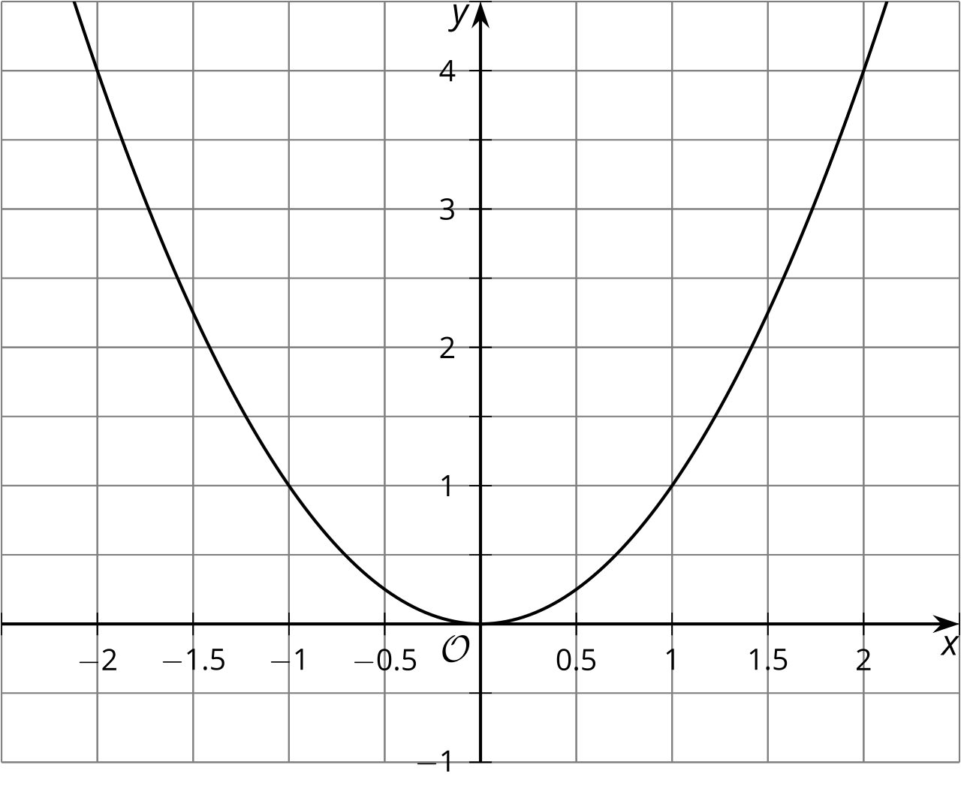
  - Use the graph to estimate all solutions to the equation $x^{2}=3$.
  - If you square your estimates, what number should they be close to?
  - Square your estimates. How close did you get to this number?
- (From Unit 3, Lesson 6.)
- The polynomial function $q\left(x\right)=3x^{3}+11x^{2}−14x−40$ has a known factor of $\left(3x+5\right)$. Rewrite $q\left(x\right)$ as the product of linear factors.
- (From Unit 2, Lesson 12.)
© CC BY 2019 by Illustrative Mathematics®

