Lesson 5 Practice Problems
- The data set represents the number of errors on a typing test.
- 5 | - 6 | - 8 | - 8 | - 9 | - 9 | - 10 | - 10
- 10 | - 12

  - What is the median? Interpret this value in the situation.
  - What is the IQR?
- The data set represents the heights, in centimeters, of ten model bridges made for an engineering competition.
- 13 | - 14 | - 14 | - 16 | - 16 | - 16 | - 16 | - 18
- 18 | - 19

  - What is the mean?
  - What is the MAD?
- Describe the shape of the distribution shown in the dot plot. The dot plot displays the golf scores from a golf tournament.
- 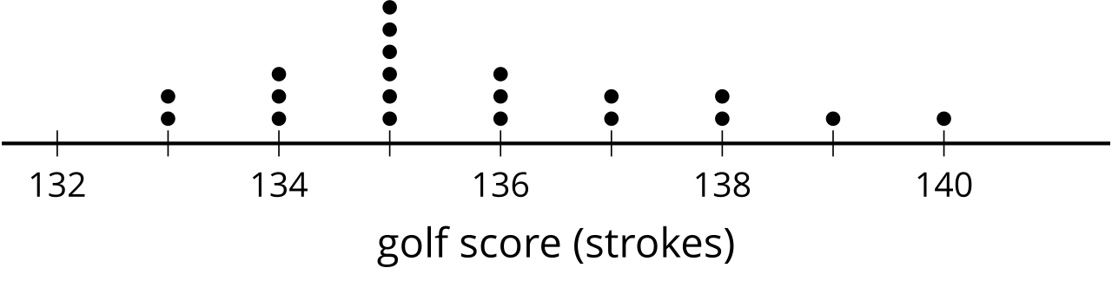

- (From Unit 1, Lesson 4.)
- The dot plot shows the weight, in grams, of several different rocks. Select all the terms that describe the shape of the distribution.
- 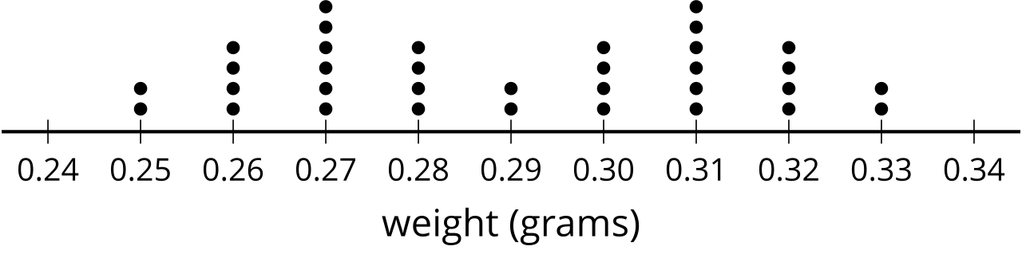
  - bell-shaped
  - bimodal
  - skewed
  - symmetric
  - uniform
- (From Unit 1, Lesson 4.)
- The dot plot represents the distribution of wages earned during a one-week period by 12 college students.
- 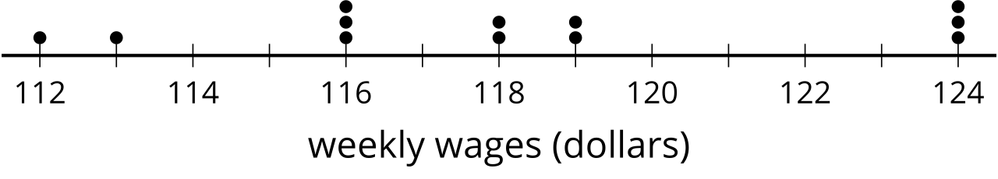
  - What is the mean? Interpret this value based on the situation.
  - What is the median? Interpret this value based on the situation.
  - Would a box plot of the same data have allowed you to find both the mean and the median?
- (From Unit 1, Lesson 3.)
- The box plot displays the temperature of saunas in degrees Fahrenheit. What is the median?
- 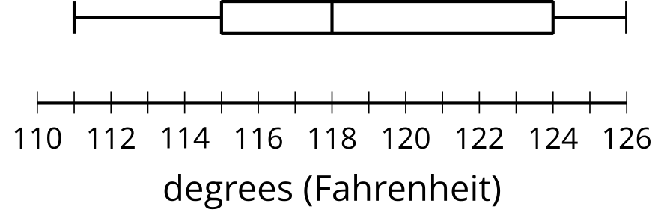
- (From Unit 1, Lesson 2.)
© CC BY 2019 by Illustrative Mathematics®

