Lesson 14: Absolute Value Functions (Part 2)
- Let’s investigate distance as a function.

14.1: Temperature in Toronto
Toronto is a city at the border of the United States and Canada, just north of Buffalo, New York. Here are twelve guesses of the average temperature of Toronto, in degrees Celsius, in February 2017.
5 | 2 | -5 | 3 | 0 | -1 | 1.5 | 4
-2.5 | 6 | 4 | -0.5

- The actual average temperature of Toronto in February 2017 is 0 degree Celsius.
- Use this information to sketch a scatter plot representing the guesses, $x$, and the corresponding absolute guessing errors, $y$.
- 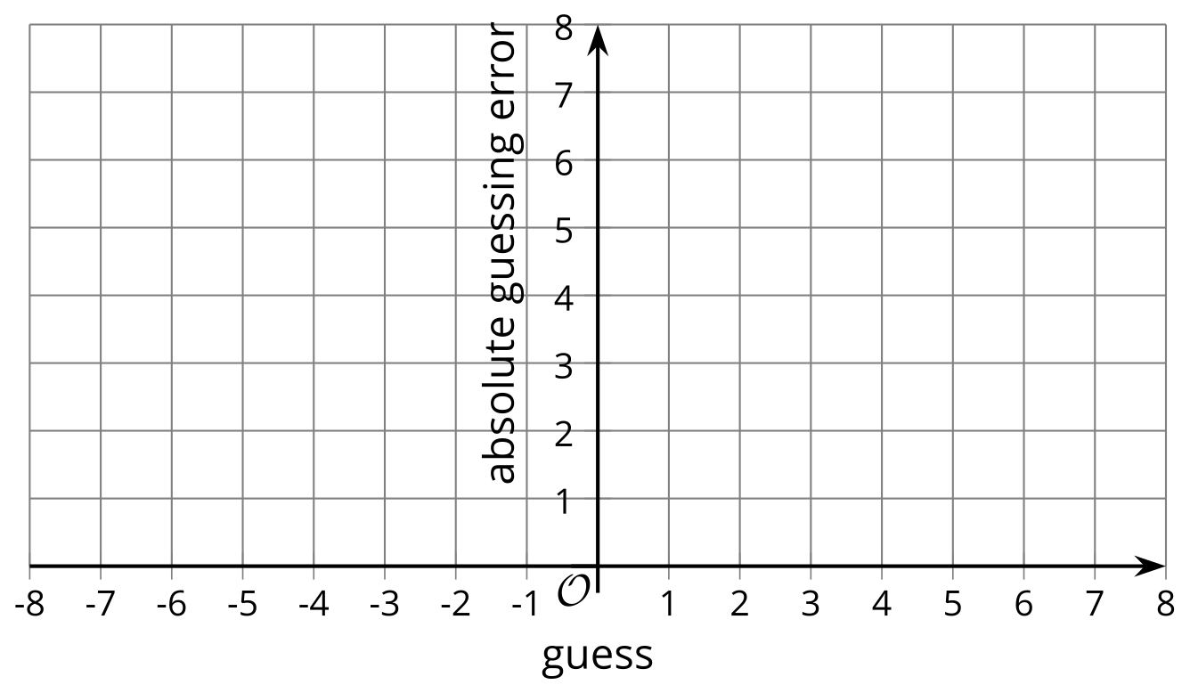
- What rule can you write to find the output given the input?

14.2: The Distance Function
The function $A$ gives the distance of $x$ from 0 on the number line.
- Complete the table and sketch a graph of function $A$.
- $x$ | - $A\left(x\right)$
- 8
 | - 5.6
- $π$
- $\frac{1}{2}$
 | - 1
- 0
- $\text{-}\frac{1}{2}$
- -1
- -5.6
 | - 8
- 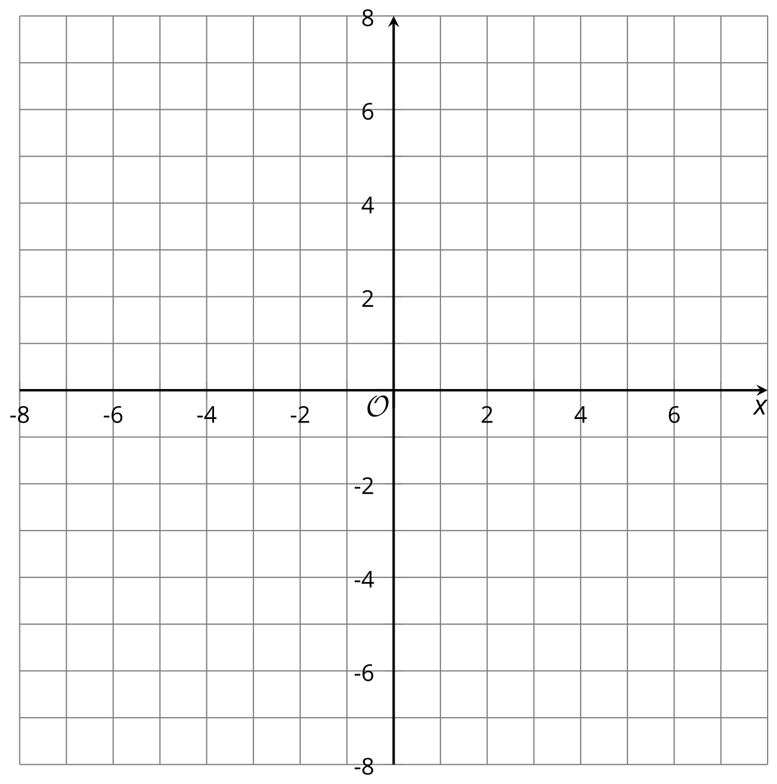
- Andre and Elena are trying to write a rule for this function.
  - Andre writes: $A\left(x\right)=\left\{\begin{matrix}x, & x≥0 \\ \text{-}x, & x<0\end{matrix}\right.$
  - Elena writes: $A\left(x\right)=\left|x\right|$
- Explain why both equations correctly represent the function $A$.

14.3: Moving Graphs Around
Here are equations and graphs that represent five absolute value functions.

$f\left(x\right)=\left|x\right|$
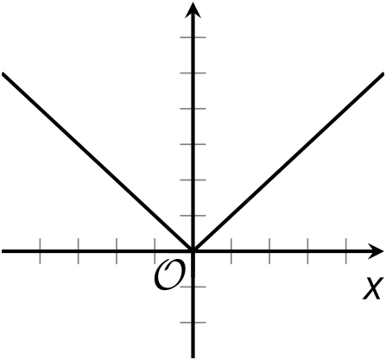

$g\left(x\right)=\left|x−2\right|$
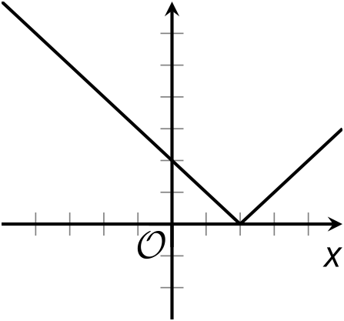

$h\left(x\right)=\left|x+2\right|$
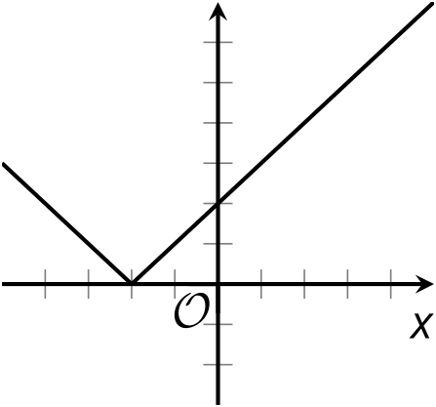

$j\left(x\right)=\left|x\right|−2$
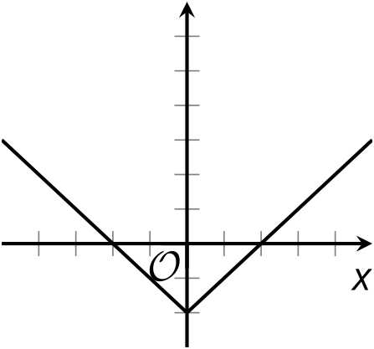

$k\left(x\right)=\left|x\right|+2$
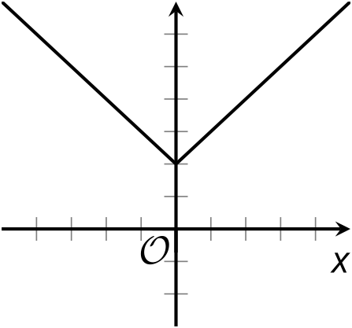
Notice that the number 2 appears in the equations for functions $g,h,j$, and $k$. Describe how the addition or subtraction of 2 affects the graph of each function.
Then, think about a possible explanation for the position of the graph. How can you show that it really belongs where it is on the coordinate plane?

Are you ready for more?
- Mark the minimum of each graph in the activity. Each point you marked represents the least output value of the function.
- In each function, what value of $x$ gives that minimum output value?

  - Another function is defined by $m\left(x\right)=\left|x+11.5\right|$. What value of $x$ produces the least output of function $m$? Be prepared to explain how you know.
  - Describe or sketch the graph of $m$.

14.4: More Moving Graphs Around
Here are five equations and four graphs.
- Equation 1: $y=\left|x−3\right|$
- Equation 2: $y=\left|x−9\right|+3$
- Equation 3: $y=\left|x\right|−6$
- Equation 4: $y=\left|x+3\right|$
- Equation 5: $y=\left|x+3\right|−6$

A
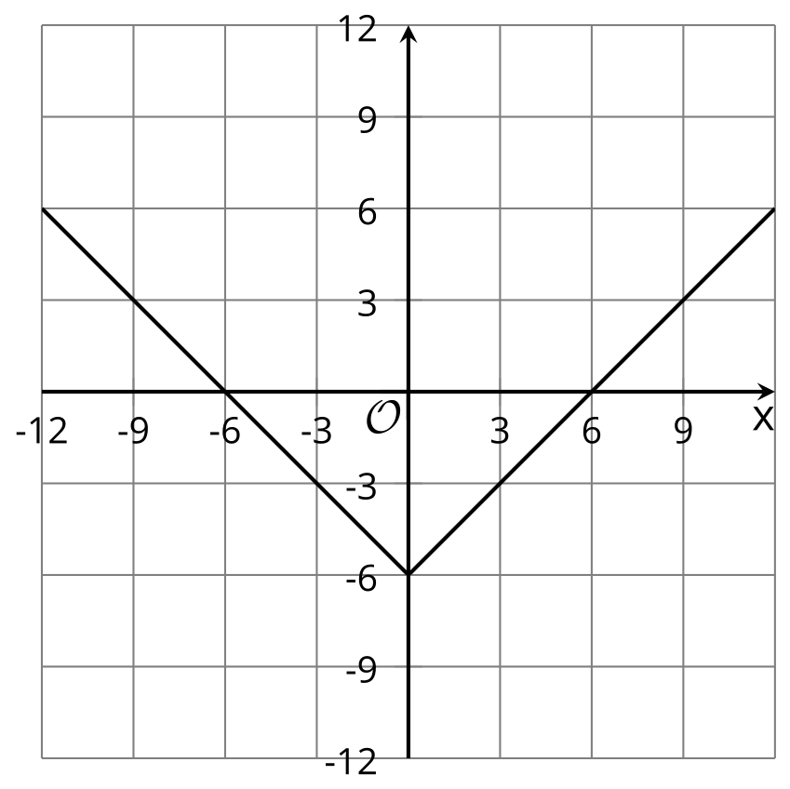

B
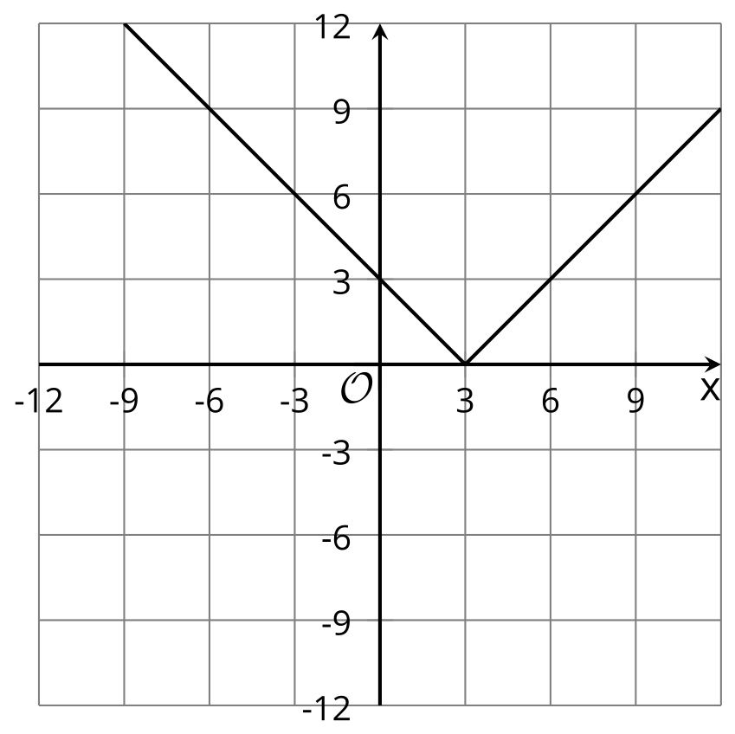

C
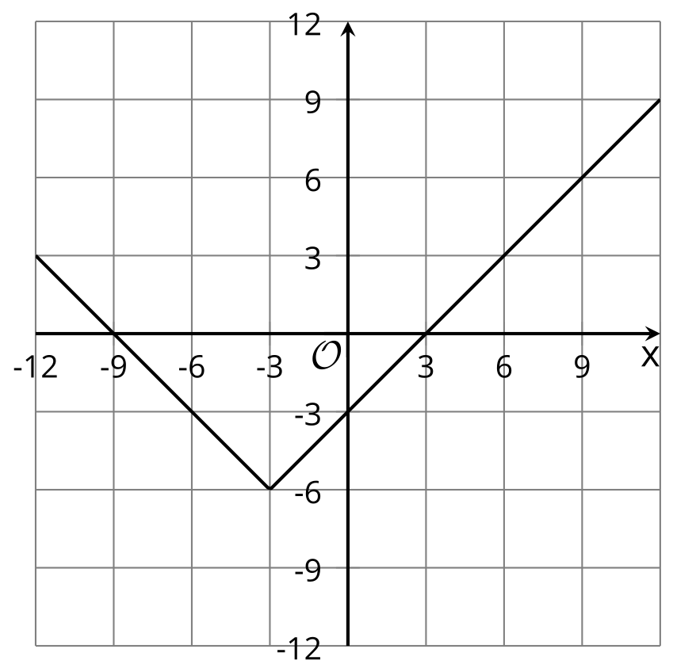

D
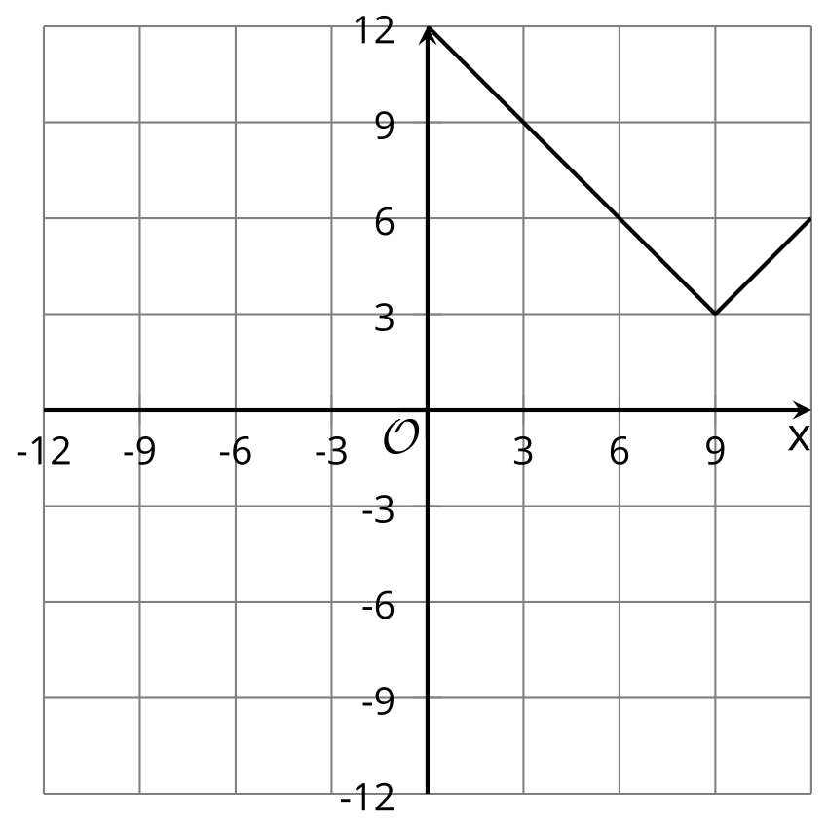

E
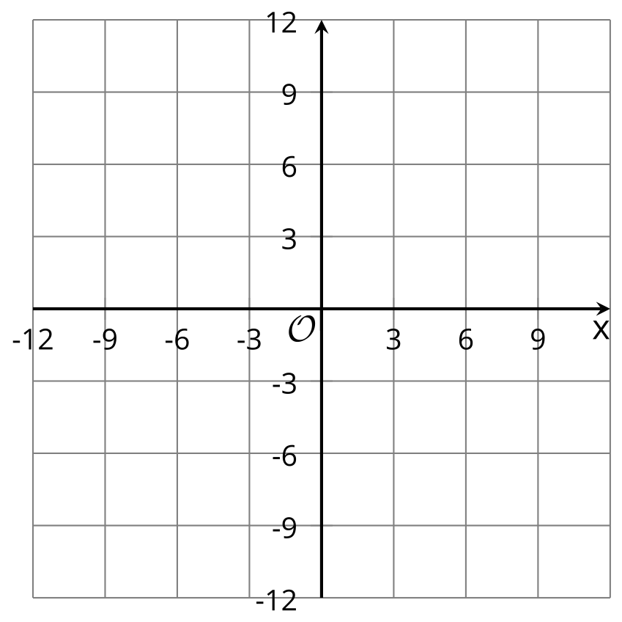
- Match each equation with a graph that represents it. One equation has no match.
- For the equation without a match, sketch a graph on the blank coordinate plane.
- Use graphing technology to check your matches and your graph. Revise your matches and graphs as needed.

Lesson 14 Summary
In a guessing game, each guess can be seen as an input of a function and each absolute guessing error as an output. Because absolute guessing error tells us how far a guess is from a target number, the output is distance.
Suppose the target number is 0.
- We can find the distance of a guess, $x$, from 0 by calculating $x−0$. Because distance cannot be negative, what we want to find is $\left|x−0\right|$, or simply $\left|x\right|$.
- If function $f$ gives the distance of $x$ from 0, we can define it with the equation:
$f\left(x\right)=\left|x\right|$
Function $f$ is the absolute value function. It gives the distance of $x$ from 0 by finding the absolute value of $x$.
The graph of function $f$ is a V shape with the two lines converging at $\left(0,0\right)$.
We call this point the vertex of the graph. It is the point where a graph changes direction, from going down to going up, or the other way around.
We can also think of a function like $f$ as a piecewise function because different rules apply when $x$ is less than 0 and when it is greater than 0.
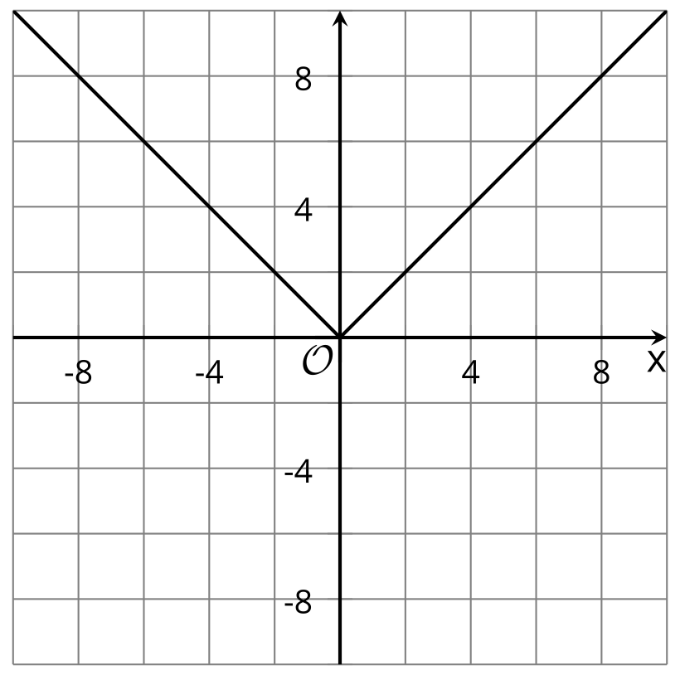
Suppose we want to find the distance between $x$ and 4.
- We can find the difference between $x$ and 4 by calculating $x−4$. Distance cannot be negative, so what we want is the absolute value of that difference: $\left|x−4\right|$.
- If function $p$ gives the distance of $x$ from 4, we can define it with the equation:
$p\left(x\right)=\left|x−4\right|$
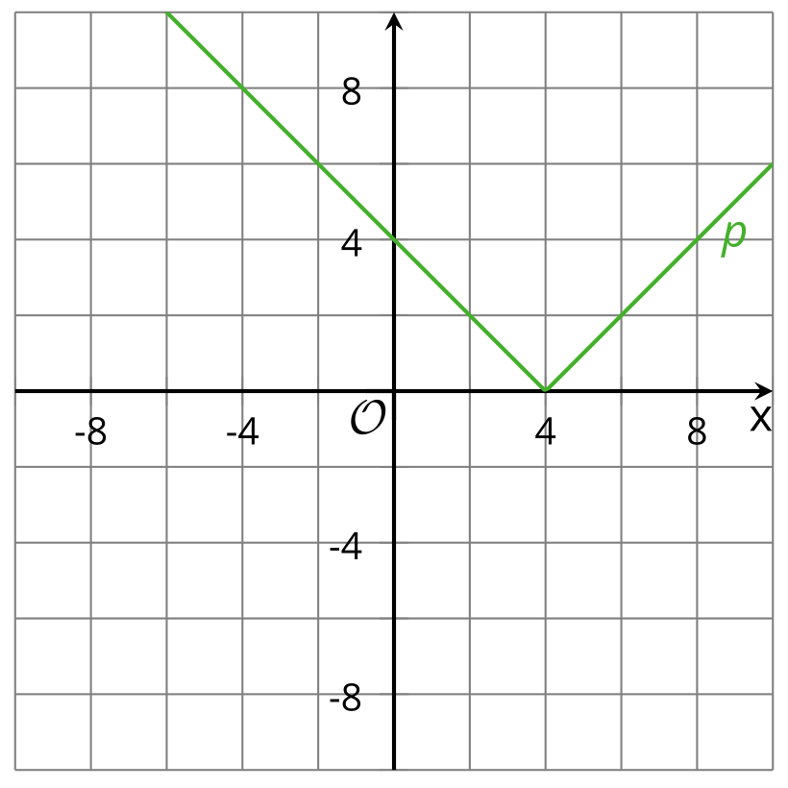
Now suppose we want to find the distance between $x$ and -4.
- We can find the difference of $x$ and -4 by calculating $x−\left(\text{-}4\right)$, which is equal to $x+4$. Distance cannot be negative, so let's find the absolute value: $\left|x+4\right|$.
- If function $q$ gives the distance of $x$ from -4, we can define it with the equation:
$q\left(x\right)=\left|x+4\right|$
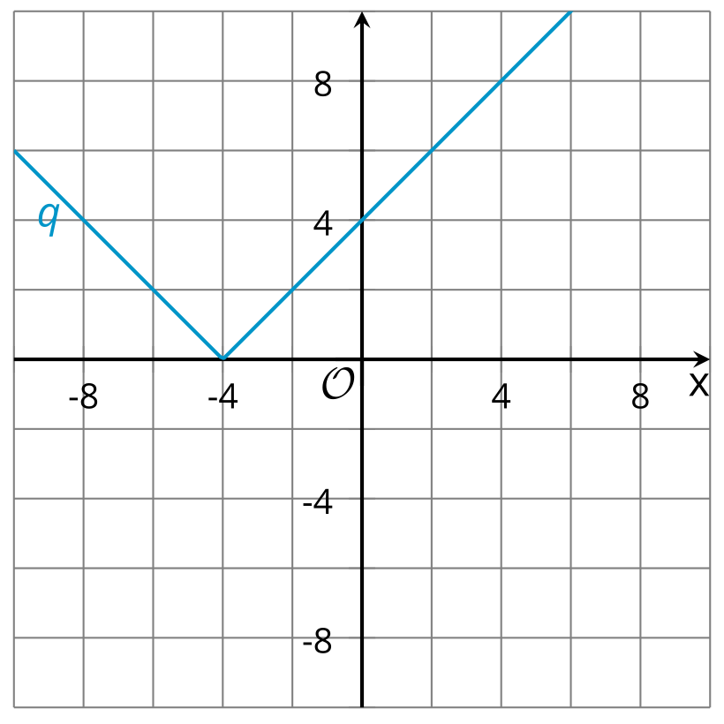
Notice that the graphs of $p$ and $q$ are like that of $f$, but they have shifted horizontally.
© CC BY 2019 by Illustrative Mathematics®

