Unit 4 Lesson 9: The Birds

WU Notice and Wonder: For the Birds (Warm up)

Student Task Statement
What do you notice? What do you wonder?
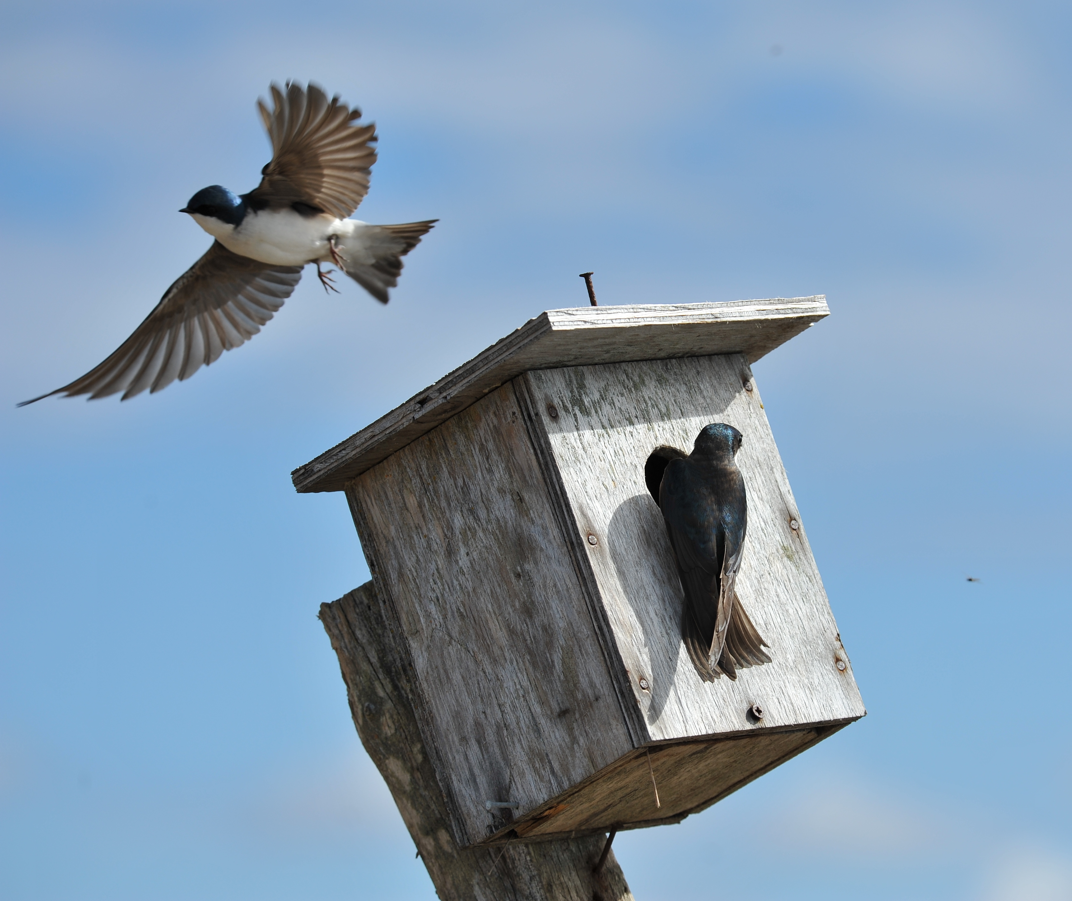

1 Home is Where the Bird Lives

Student Task Statement
Different types of birds use different types of houses. The table gives you the recommended side lengths for birdhouses of various species.
type of bird | side lengths of floor | height | volume estimate
chickadee | 4 in by 4 in | 6 to 10 in
wood duck | 10 in by 18 in | 10 to 24 in
barn owl | 10 in by 18 in | 15 to 18 in
red-headed woodpecker | 6 in by 6 in | 12 to 15 in
bluebird | 5 in by 5 in | 6 to 12 in
swallow | 6 in by 6 in | 6 to 8 in
Estimate a possible volume for each birdhouse. Be prepared to explain your reasoning.

2 What is the Volume?

Student Task Statement
Use the criteria from the table to determine the recommended range of volumes for each type of birdhouse.
type of bird | side lengths of floor | height | range of volume
chickadee | 4 in by 4 in | 6 to 10 in
wood duck | 10 in by 18 in | 10 to 24 in
barn owl | 10 in by 18 in | 15 to 18 in
red-headed woodpecker | 6 in by 6 in | 12 to 15 in
bluebird | 5 in by 5 in | 6 to 12 in
swallow | 6 in by 6 in | 6 to 8 in
© CC BY 2021 Illustrative Mathematics®

