Lesson 1: What Is Volume?

Standards Alignments
Addressing | 5.MD.C.3
Building Towards | 5.MD.C.3

Teacher-facing Learning Goals
- Explore volume by building objects with unit cubes and comparing them.

Student-facing Learning Goals
- Let’s build and compare objects made of cubes.

Lesson Purpose
The purpose of this lesson is for students to understand that solid objects have measurable attributes. Volume is one of these attributes and is defined as the amount of space an object takes up.
In previous grades, students learned that they can count the number of square tiles that cover a plane shape without gaps or overlaps to find the area of the shape. In this lesson, students explore the concept of volume as they build and compare objects made of cubes. Students learn that objects can have different shapes but still take up the same amount of space and that we call this amount an object’s volume.
In the next lesson, students learn that volume is measured in cubic units and use unit cubes to find the volume of different objects. This work builds a conceptual understanding of volume before the introduction of formal ways to calculate the volume of rectangular prisms.
In lessons with images of objects made of cubes, students may question if the objects are missing cubes they can’t see. In these cases, tell students to assume the objects, including prisms, are completely packed with cubes.
Consider taking a community walk and noticing buildings and objects that are shaped like rectangular prisms in the community where your student’s live. In future lessons, you can display a list of these building and objects and ask students to add to the display.
Math Community
Prepare a space, such as a piece of poster paper, titled “Mathematical Community”​ ​and a T-chart with the headers “Doing Math”​ ​and “Norms.” Partition each of the columns into two sections: students and teacher. The two sections encourage the students and teacher to be mindful that both respective parties are responsible for the way math is done in the classroom.
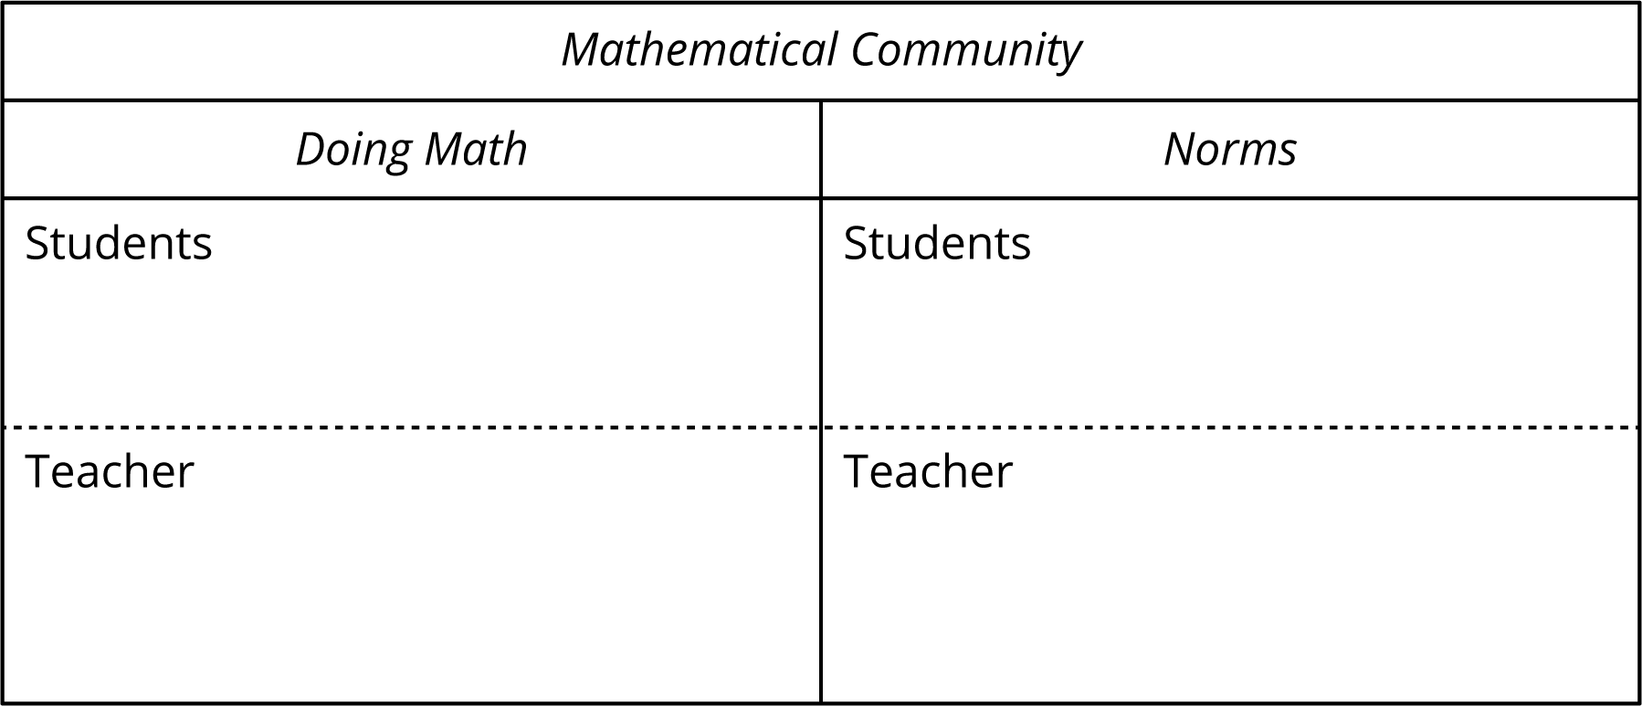

Access for:

Students with Disabilities
- Representation (Activity 2)

English Learners
- MLR2 (Activity 1)

Instructional Routines
Which One Doesn’t Belong? (Warm-up)

Materials to Gather
- Connecting cubes: Activity 2

Materials to Copy
- Isometric Dot Paper Standard (groups of 1): Activity 2

Lesson Timeline
Warm-up | 10 min
Activity 1 | 15 min
Activity 2 | 20 min
Lesson Synthesis | 10 min
Cool-down | 5 min

Teacher Reflection Question
Who participated in math class today? What assumptions are you making about those who did not participate? How can you leverage each of your student’s ideas to support them in being seen and heard in tomorrow’s math class?

Cool-down
(to be completed at the end of the lesson) 5min
Which Has More Volume?

Standards Alignments
Addressing | 5.MD.C.3

Student-facing Task Statement
Which object has a greater volume? Explain or show your reasoning.
A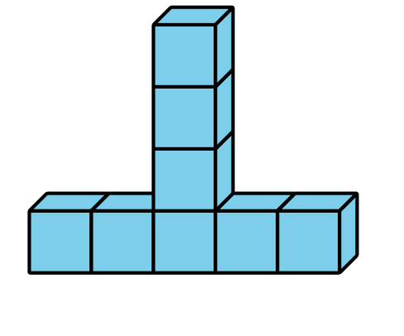
B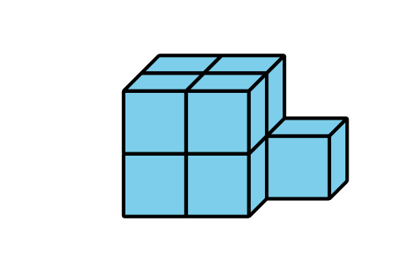

Student Responses
B, it is made of 9 cubes and A is made of 8 cubes.

