Unit 6 Lesson 4: Comparing Quadratic and Exponential Functions

1 From Least to Greatest (Warm up)

Student Task Statement
List these quantities in order, from least to greatest, without evaluating each expression. Be prepared to explain your reasoning.
A. $2^{10}$
B. ${10}^{2}$
C. $2^{9}$
D. $9^{2}$

2 Which One Grows Faster?

Student Task Statement
- In Pattern A, the length and width of the rectangle grow by one small square from each step to the next.
- In Pattern B, the number of small squares doubles from each step to the next.
- In each pattern, the number of small squares is a function of the step number, $n$.

Pattern A
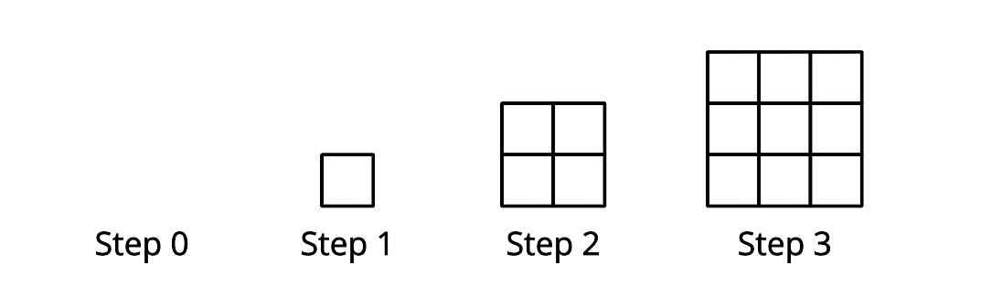

Pattern B
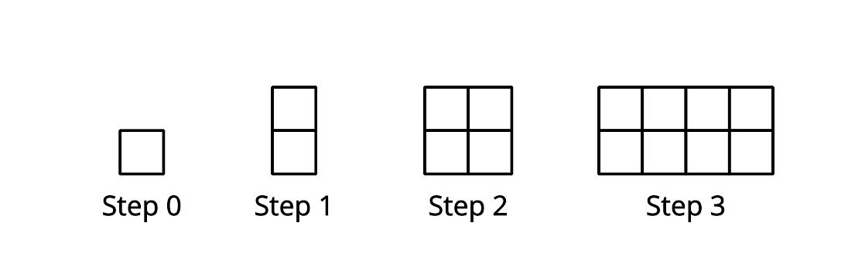
- Write an equation to represent the number of small squares at Step $n$ in Pattern A.
- Is the function linear, quadratic, or exponential?
- Complete the table:
- $n$, step number | - $f(n)$, number of small squares
- 0
- 1
- 2
- 3
- 4
- 5
- 6
- 7
- 8
- Write an equation to represent the number of small squares at Step $n$ in Pattern B.
- Is the function linear, quadratic, or exponential?
- Complete the table:
- $n$, step number | - $g(n)$, number of small squares
- 0
- 1
- 2
- 3
- 4
- 5
- 6
- 7
- 8
How would the two patterns compare if they continue to grow? Make 1–2 observations.

Activity Synthesis
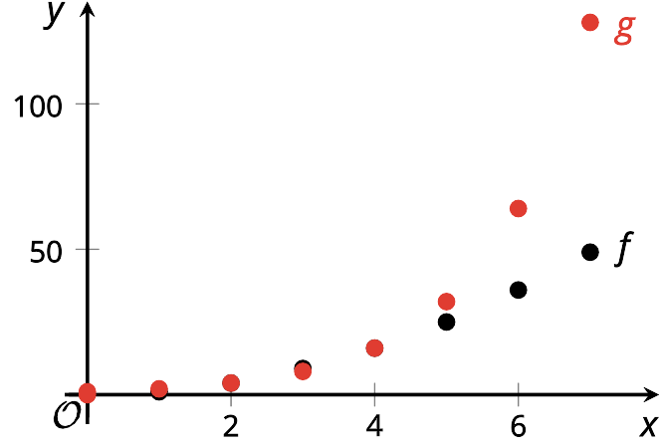

3 Comparing Two More Functions

Student Task Statement
Here are two functions: $p(x)=6x^{2}$ and $q(x)=3^{x}$.
Investigate the output of $p$ and $q$ for different values of $x$. For large enough values of $x$, one function will have a greater value than the other. Which function will have a greater value as $x$ increases?
Support your answer with tables, graphs, or other representations.
© CC BY 2019 by Illustrative Mathematics

