Unit 6 Lesson 8: Estimate and Measure Liquid Volume

WU Number Talk: Divide by 3 (Warm up)

Student Task Statement
Find the value of each expression mentally.
- $30÷3$
- $60÷3$
- $63÷3$
- $54÷3$

1 Estimate Liquid Volume

Student Task Statement
- Clare says the bathtub holds about 2 liters.
- Jada says the bathtub holds about 20 liters.
- Kiran says the bathtub holds about 200 liters.
- 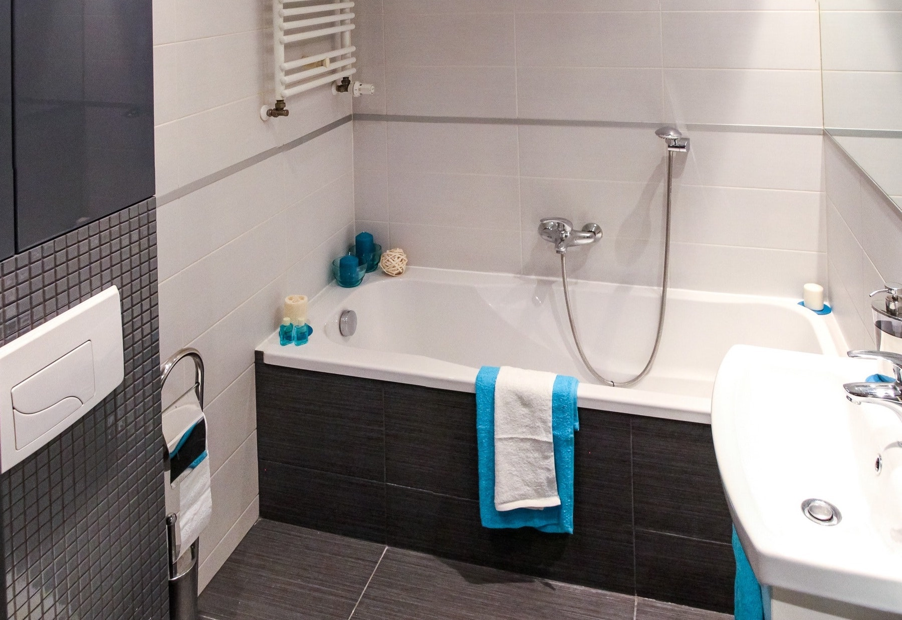
- Whom do you agree with? Explain or show your reasoning.
- Would the bucket and the bottle hold 2 liters, 20 liters, or 200 liters? Explain how you know.
- 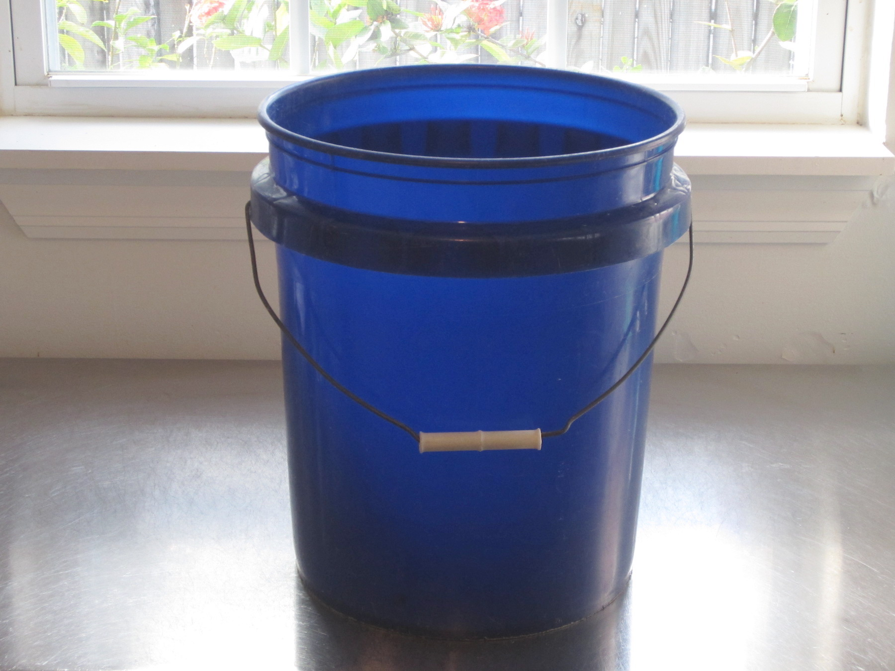
- 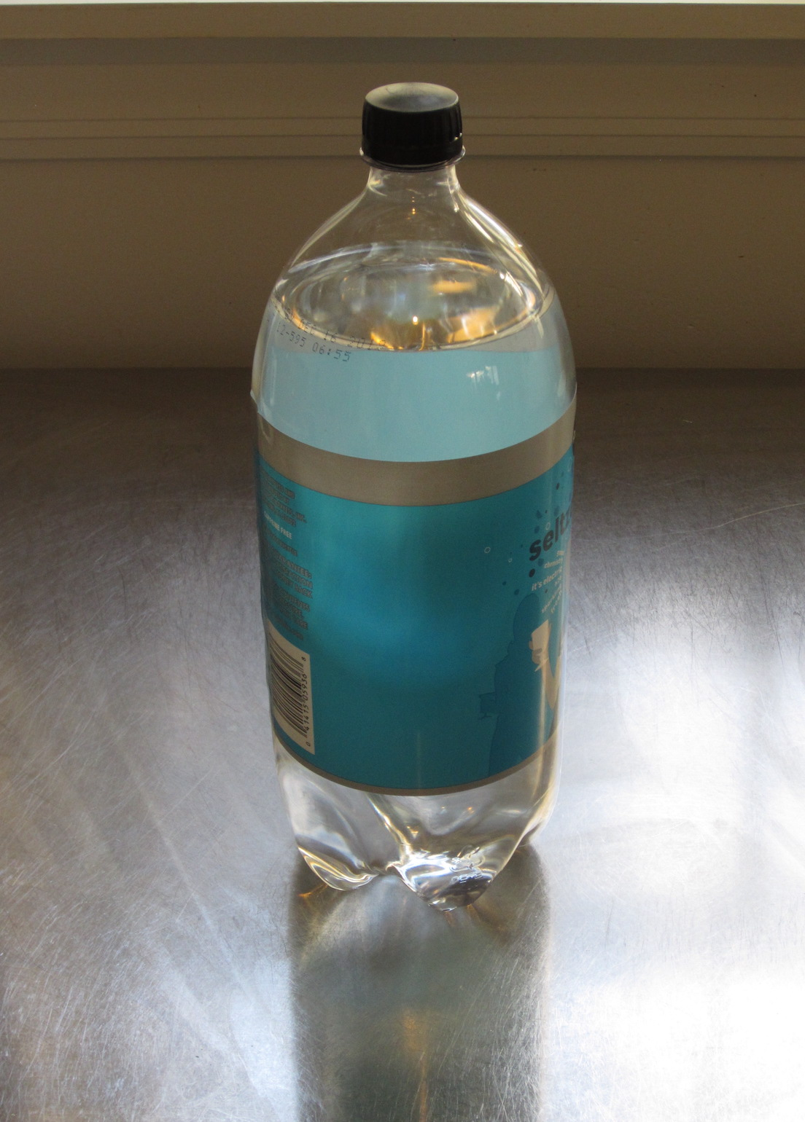
- Match the containers to the number of liters they could hold. Be ready to explain your reasoning.
- item
  - sink
  - 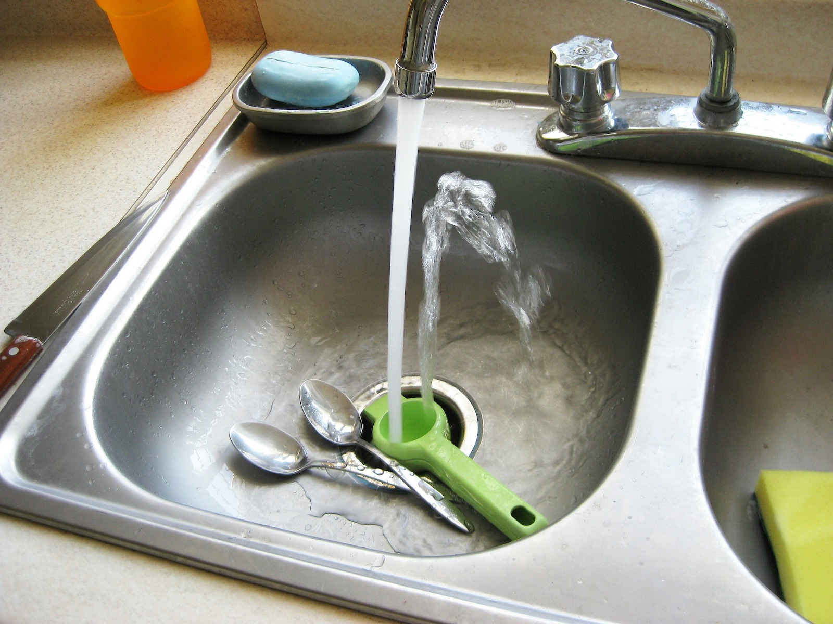
  - kiddie pool
  - 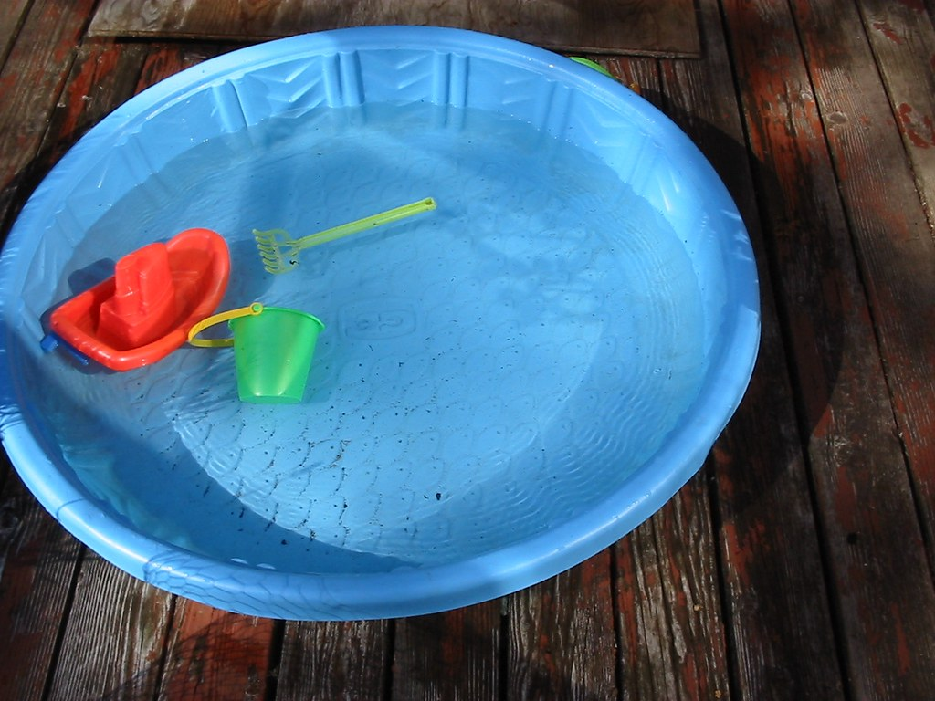
  - pot
  - 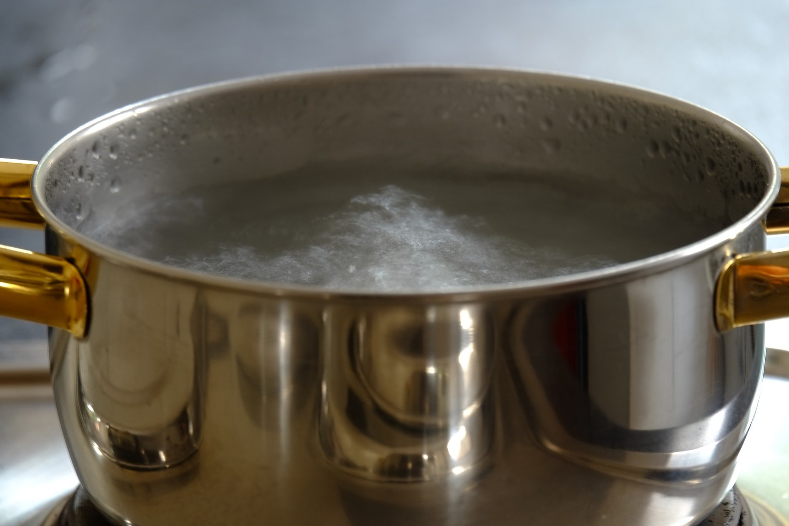
  - toilet tank
  - 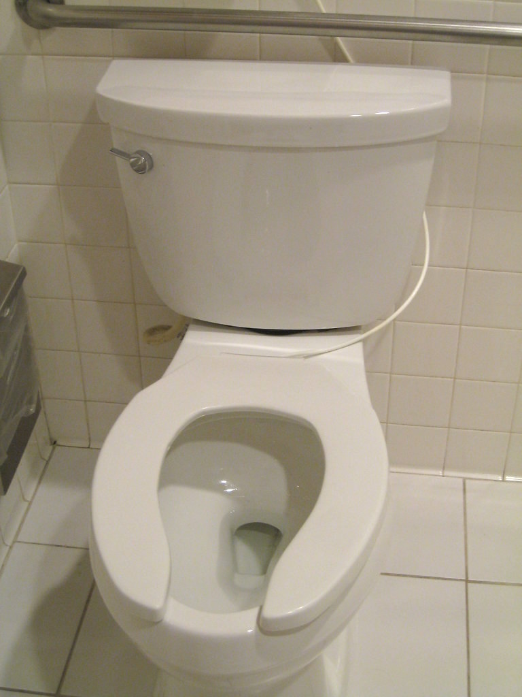
- number of liters
  - 4 liters
  - 6 liters
  - 500 liters
  - 10 liters

2 Measure Liquid Volume

Student Task Statement
What do you notice? What do you wonder?
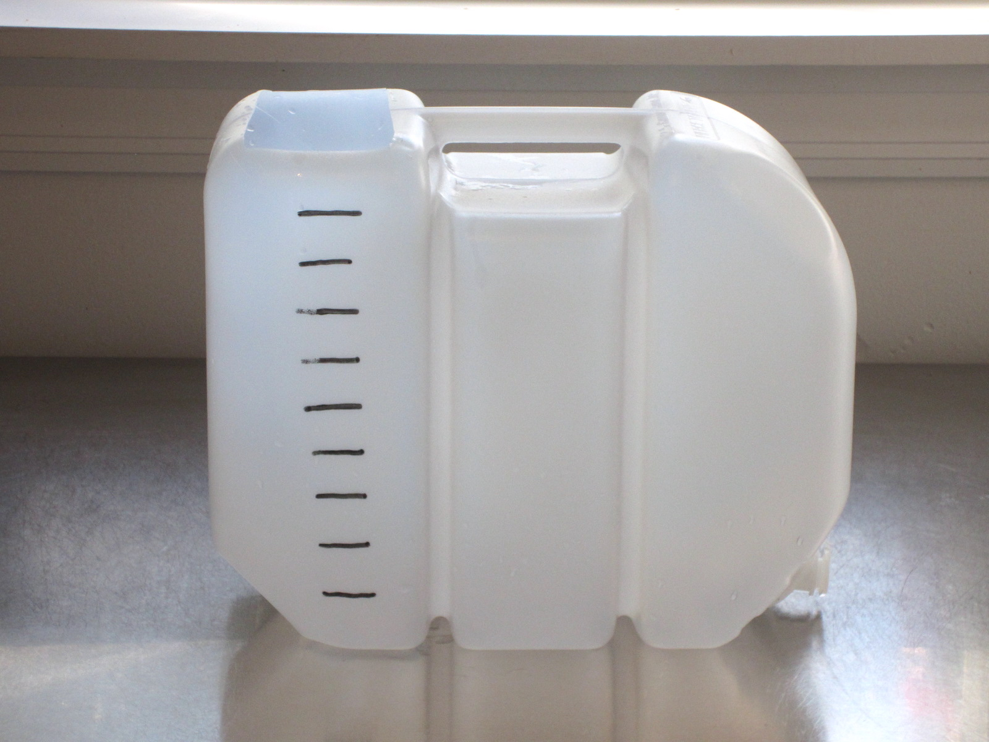
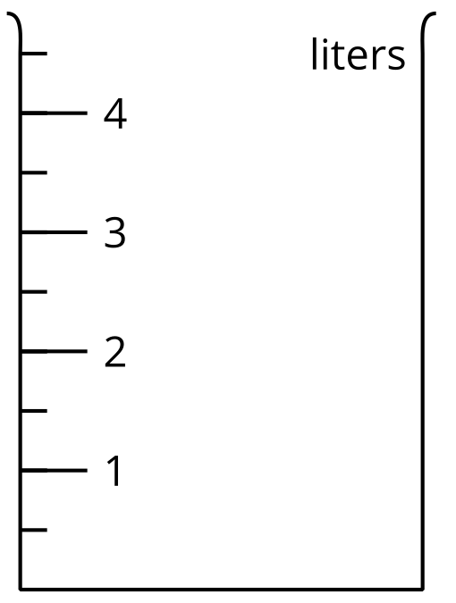
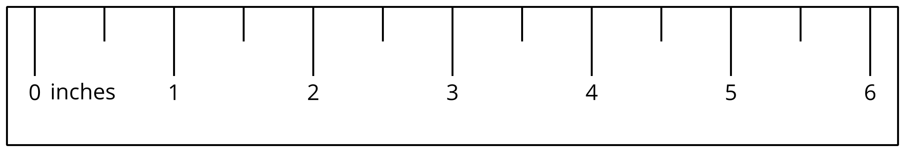
- The container in each image is marked in liters. Find the volume of the liquid.
- A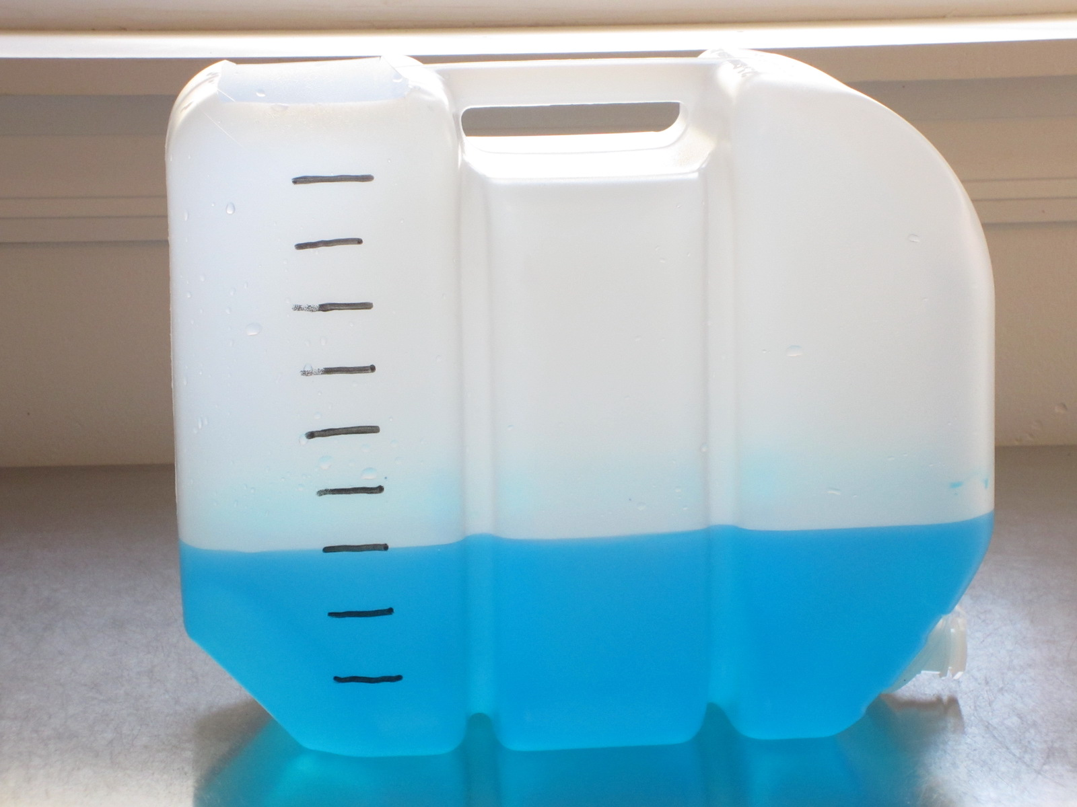
- B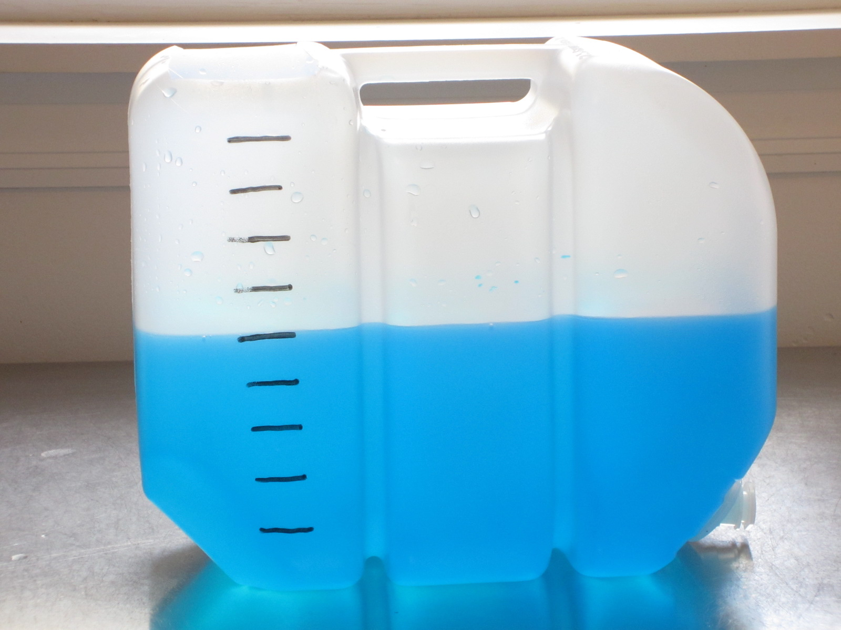
- C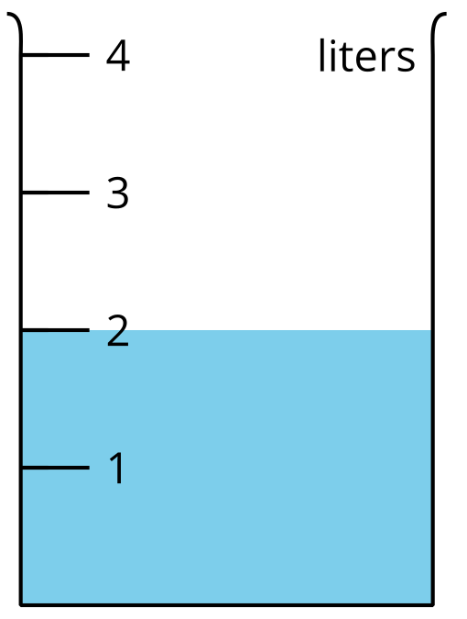
- D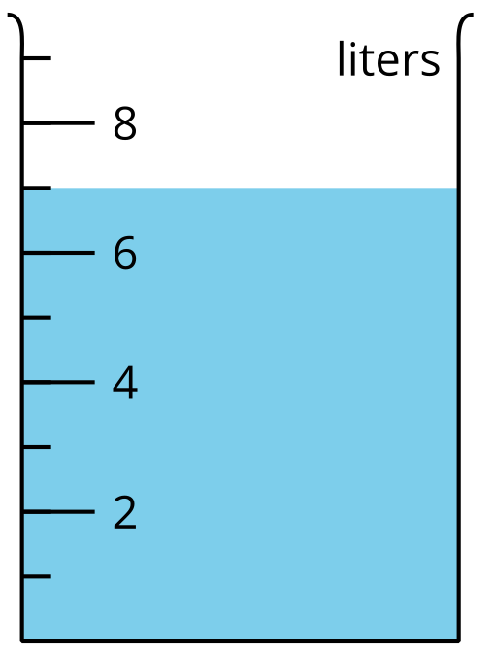
- E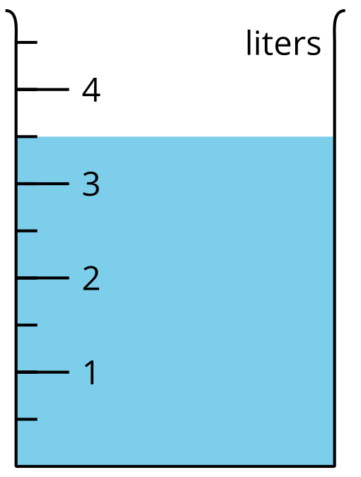
- F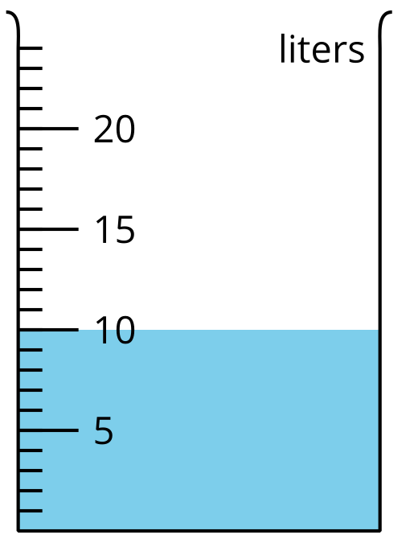
- G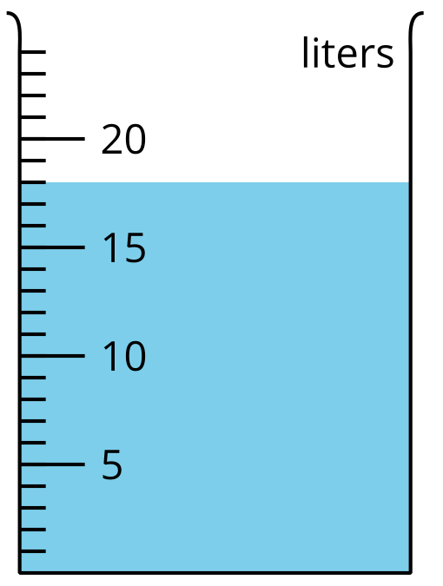
- H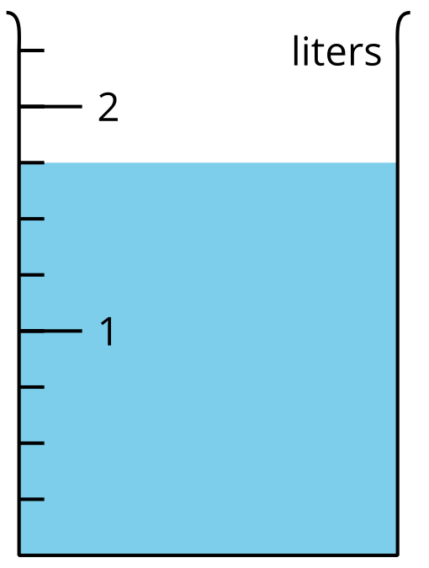
- Shade the images of the empty containers to show the liquid volume.
- P: 1 liter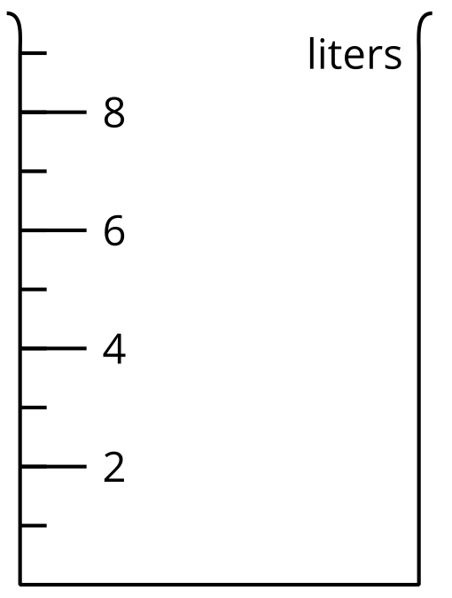
- Q: 8 liters
- R: 7 liters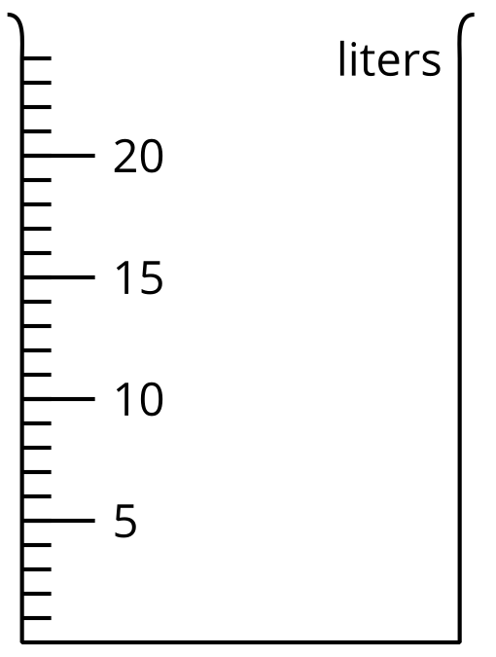
- S: $2\frac{1}{2}$ liters
- T: 23 liters
- If you have time: Of all the containers in this activity, which two containers have the most liquid? How many liters would you have if you combined the liquid in them? Explain or show your reasoning.
© CC BY 2021 Illustrative Mathematics®

