Unit 7 Lesson 1: How Would You Describe These Figures?

WU Notice and Wonder: String Art (Warm up)

Student Task Statement
What do you notice? What do you wonder?
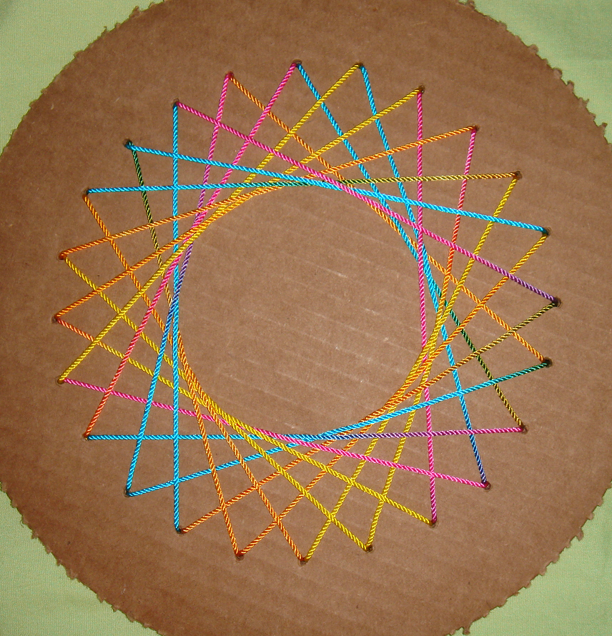

1 Do You See What I See?

Student Task Statement
Work with a partner in this activity. Sit back to back or use a divider to block each other’s view.
Partner A:
- Your teacher will give you a card. Don’t show it to your partner.
- Describe the image on the card—as clearly and precisely as possible—so that your partner can draw it on a blank card.
Partner B:
- Your teacher will give you a blank card.
- Your partner will describe an image. Listen carefully to the descriptions. On your card, create a drawing as described.
- When done, compare the given image and the drawn image. Discuss:
  - Which parts were accurate? Which were off?
  - How could the descriptions be improved so the drawing could be more accurate?
  - Which words or descriptions are useful?
- Try again with a second card from your teacher. When done, compare and discuss the images again.
- Switch roles and repeat the exercise. Your teacher will give you 2 new cards (1 for each round).

Activity Synthesis
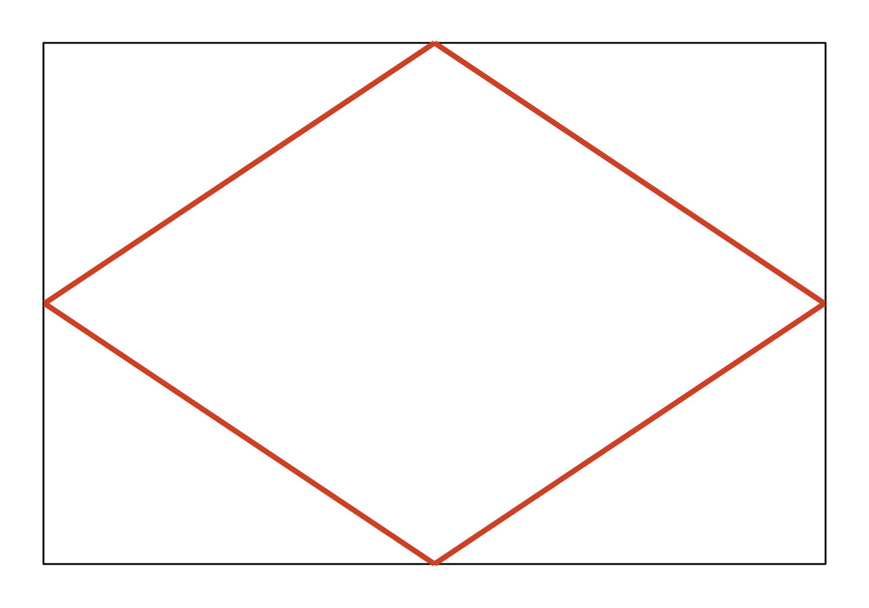
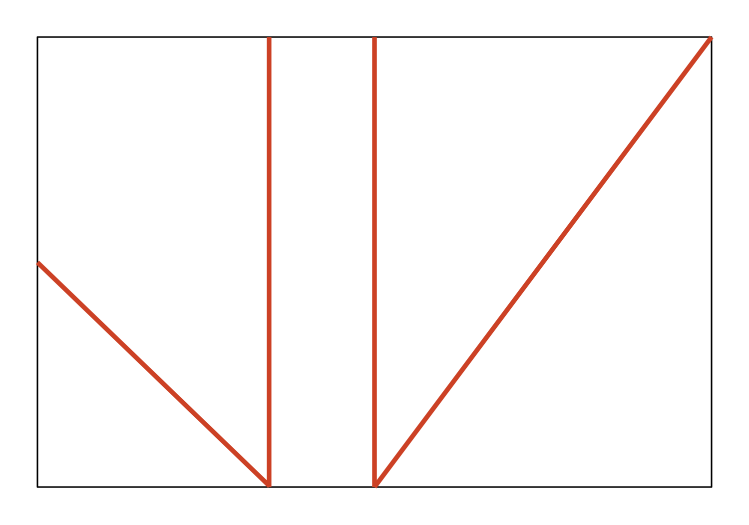

2 Lines and Line Segments

Student Task Statement
Here is a field of dots.
- Draw 5 lines, each one connecting at least 2 dots and extending as far as possible.
- Did your lines make some familiar shapes or figures—perhaps a triangle, quadrilateral, a letter, or a number?
- Identify at least one familiar shape or figure in your drawing. Trace the shape with a heavier mark or use a color pencil to make it obvious.
- Share your drawing with your group members. Discuss:
  - How are the drawings alike? What do all the shapes have in common?
  - How are the drawings different?

Images for Activity Synthesis
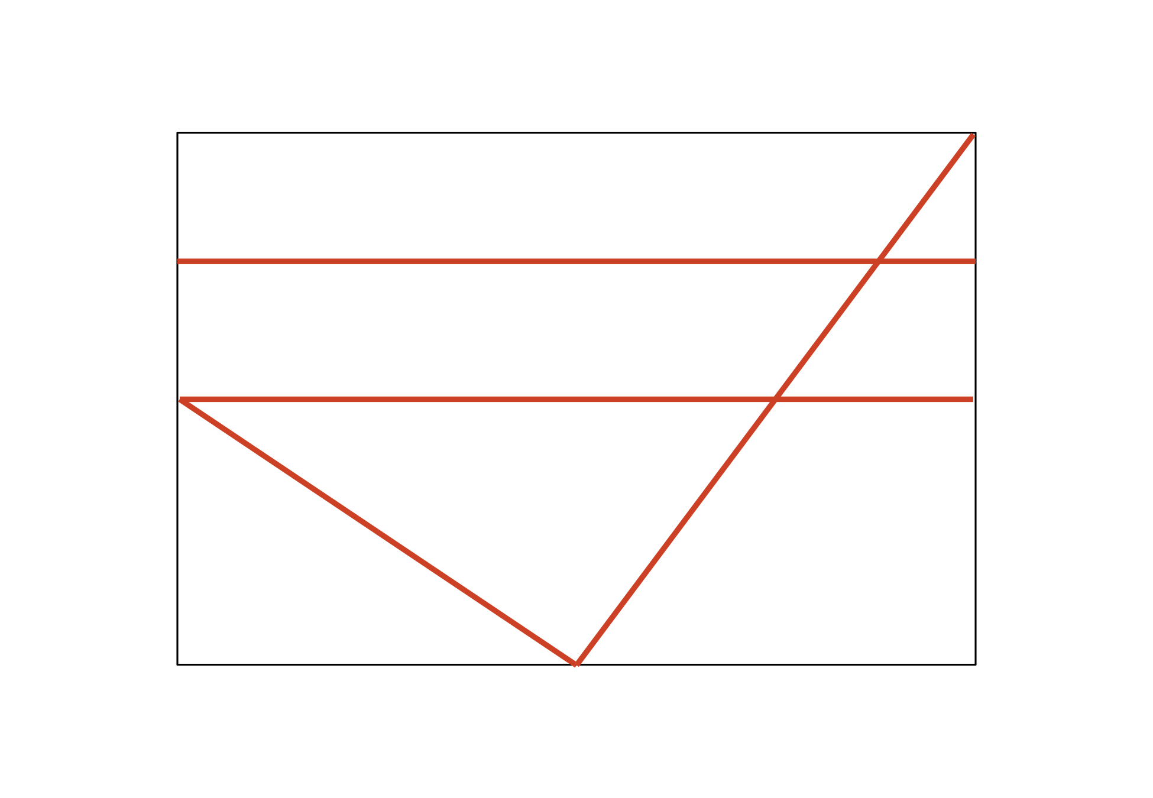
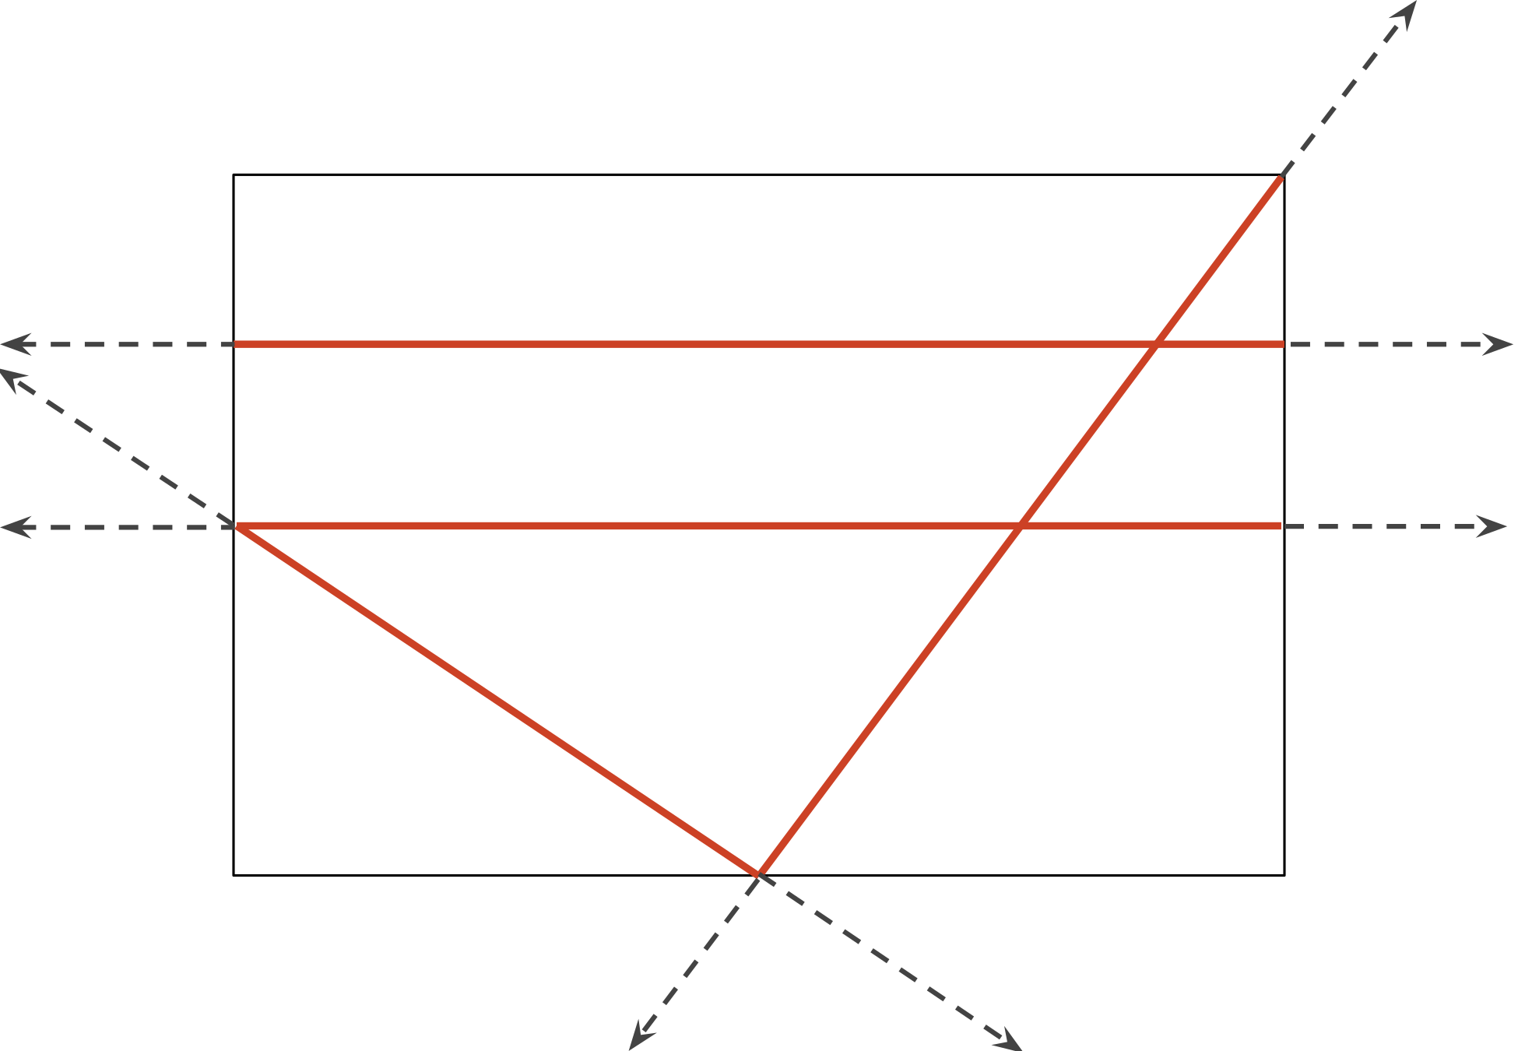
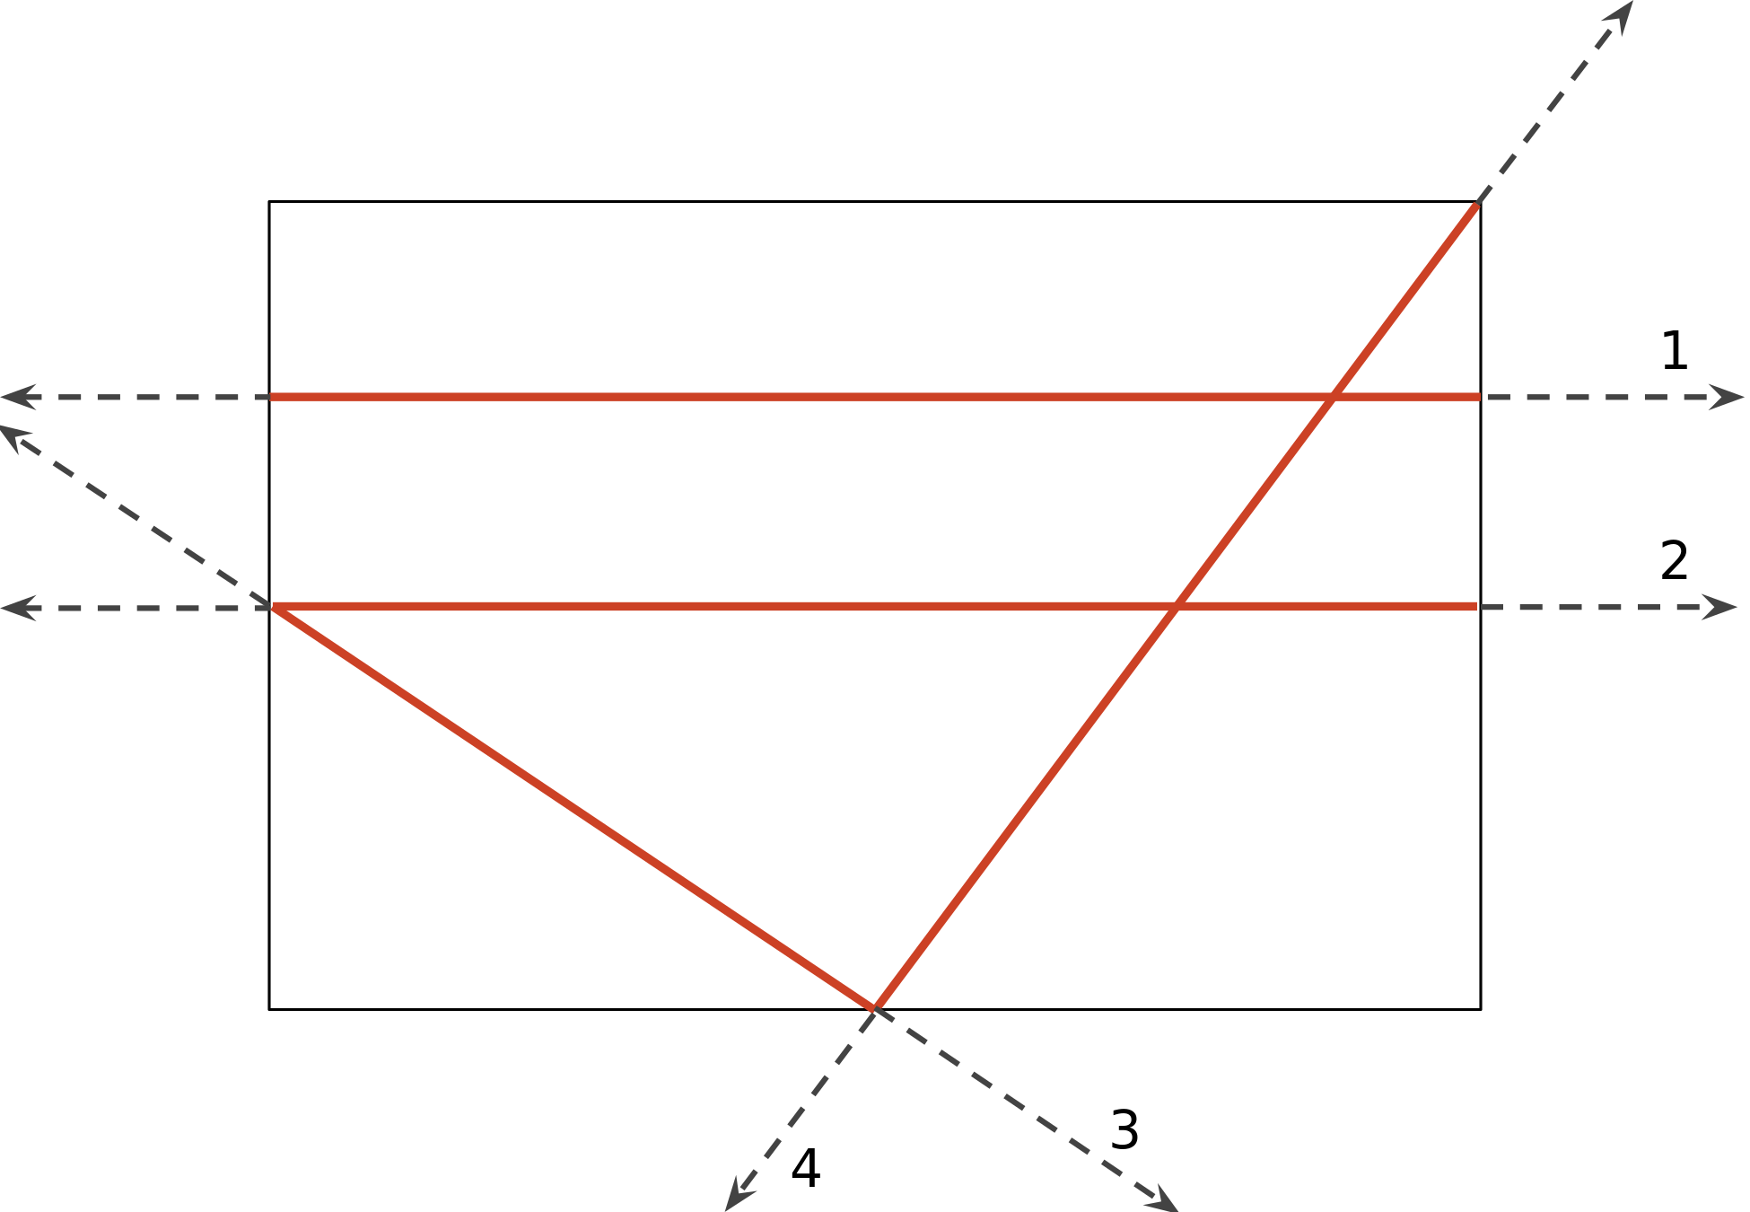
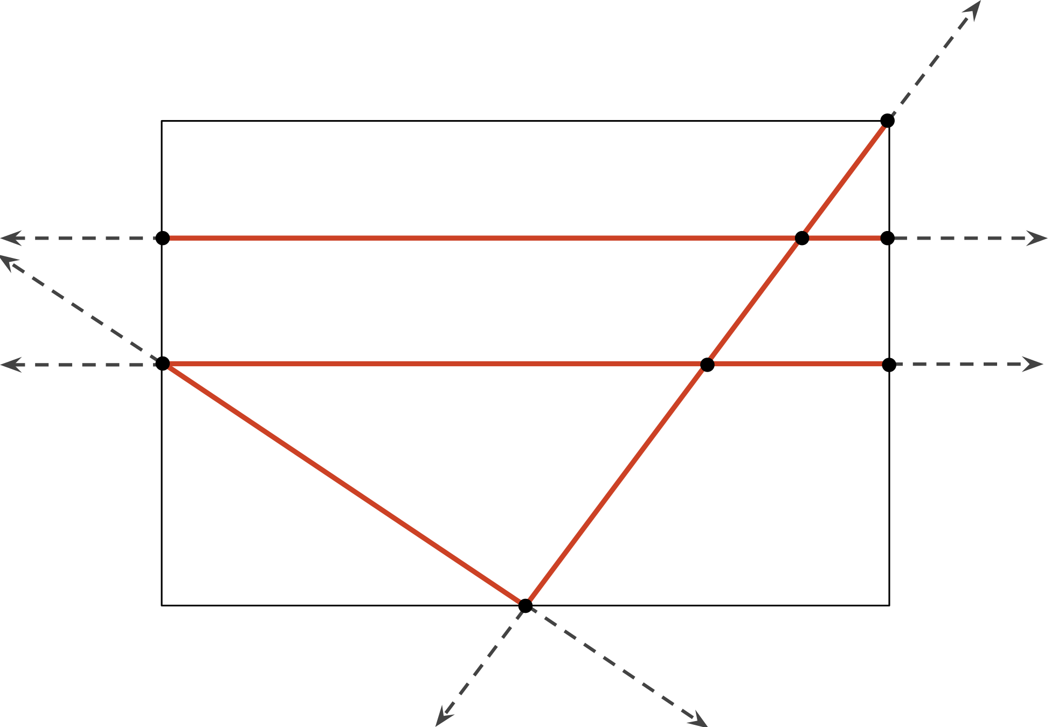
© CC BY 2021 Illustrative Mathematics®

