Lesson 4: Another Look at the Standard Algorithm

Standards Alignments
Addressing | 4.NBT.B, 4.NBT.B.4

Teacher-facing Learning Goals
- Compare different methods for subtracting multi-digit numbers.
- Subtract multi-digit numbers using the standard algorithm.

Student-facing Learning Goals
- Let’s subtract from numbers with zeros.

Lesson Purpose
The purpose of this lesson is to practice the standard algorithm for subtraction and to compare this method to other methods. Students choose a subtraction method based on the relationship between the numbers in the expression and explain their choices.
In previous units, students used the standard algorithm to subtract numbers. They interpreted and practiced ways to record 1 larger unit being decomposed and 10 being added to the unit to its right.
In this lesson, students encounter problems where they would need to decompose a series of larger units in order to subtract using the standard algorithm, such as when subtracting a number with non-zero digits from a number with multiple zeros (for example, $5,​000−741$). Students consider the merits (the efficiency, likelihood of error, or reliability) of different ways to reason about such differences. They recognize that the standard algorithm may not always be the most efficient strategy for subtracting multi-digit numbers. Students explain how they can use the relationship between the numbers in an expression to select a strategy.
If students need additional support with the concepts in this lesson, refer back to Unit 4, Section D in the curriculum materials.

Access for:

Students with Disabilities
- Engagement (Activity 1)

English Learners
- MLR7 (Activity 1)

Instructional Routines
Number Talk (Warm-up)

Materials to Gather
- Grid paper: Activity 1

Lesson Timeline
Warm-up | 10 min
Activity 1 | 15 min
Activity 2 | 20 min
Lesson Synthesis | 10 min
Cool-down | 5 min

Teacher Reflection Question
What evidence did students give that they use their understanding of place value when using the standard algorithm? What evidence did students give that they use their number sense to select a subtraction method?

Cool-down
(to be completed at the end of the lesson) 5min
A Couple of Differences

Standards Alignments
Addressing | 4.NBT.B, 4.NBT.B.4

Student-facing Task Statement
Find the value of each difference. Show your reasoning.
- $8,​050−213$
- $60,​000−1,​984$

Student Responses
- 7,837. Sample reasoning:
  - $8,​000−200=7,​800$ and $50−13=37$. Adding 7,800 and 37 gives 7,837.
  - 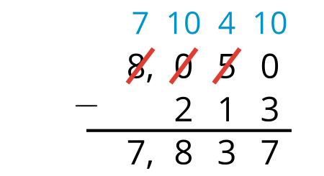
- 58,016. Sample reasoning: $1,​984+16=2,​000$ and $2,​000+58,​000=60,​000$. Adding 58,000 and 16 gives 58,016.

