Unit 7 Lesson 16: Common Factors

1 Figures Made of Squares (Warm up)

Student Task Statement
How are the pairs of figures alike? How are they different?
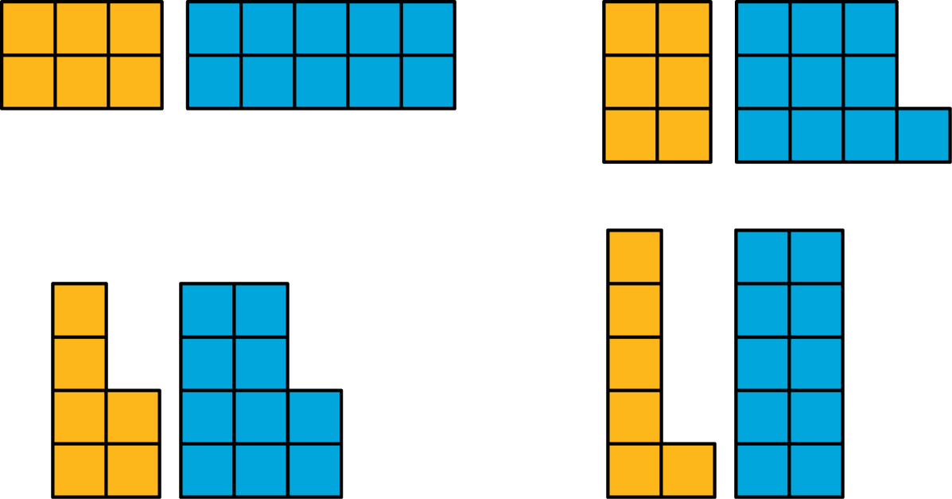

2 Diego’s Bake Sale

Student Task Statement
Diego is preparing brownies and cookies for a bake sale. He would like to make equal-size bags for selling all of the 48 brownies and 64 cookies that he has. Organize your answer to each question so that it can be followed by others.
- How can Diego package all the 48 brownies so that each bag has the same number of them? How many bags can he make, and how many brownies will be in each bag? Find all the possible ways to package the brownies.
- How can Diego package all the 64 cookies so that each bag has the same number of them? How many bags can he make, and how many cookies will be in each bag? Find all the possible ways to package the cookies.
- How can Diego package all the 48 brownies and 64 cookies so that each bag has the same combination of items? How many bags can he make, and how many of each will be in each bag? Find all the possible ways to package both items.
- What is the largest number of combination bags that Diego can make with no left over? Explain to your partner how you know that it is the largest possible number of bags.

3 Greatest Common Factor

Student Task Statement
- The greatest common factor of 30 and 18 is 6. What do you think the term “greatest common factor” means?
- Find all of the factors of 21 and 6. Then, identify the greatest common factor of 21 and 6.
- Find all of the factors of 28 and 12. Then, identify the greatest common factor of 28 and 12.
- A rectangular bulletin board is 12 inches tall and 27 inches wide. Elena plans to cover it with squares of colored paper that are all the same size. The paper squares come in different sizes; all of them have whole-number inches for their side lengths.
  - What is the side length of the largest square that Elena could use to cover the bulletin board completely without gaps and overlaps? Explain or show your reasoning.
  - How is the solution to this problem related to greatest common factor?
© CC BY Open Up Resources. Adaptations CC BY IM.

