Unit 1 Lesson 7: Scale Drawings

1 What is a Scale Drawing? (Warm up)

Student Task Statement
Here are some drawings of a school bus, a quarter, and the subway lines around Boston, Massachusetts. The first three drawings are scale drawings of these objects.
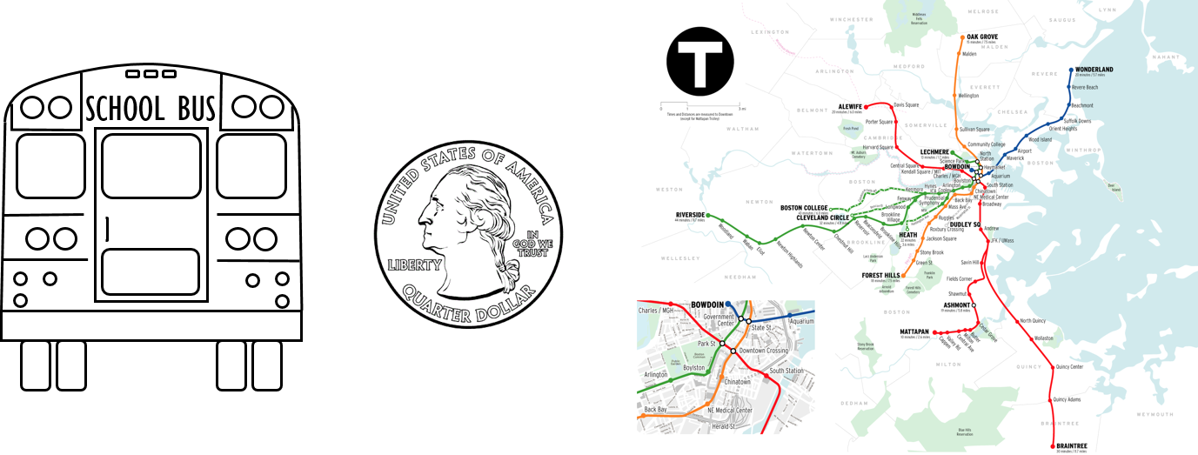
The next three drawings are not scale drawings of these objects.
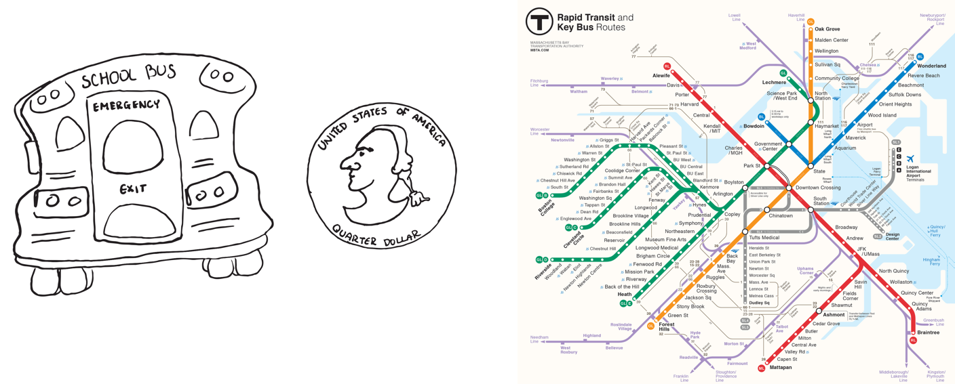
Discuss with your partner what a scale drawing is.

2 Sizing Up a Basketball Court

Student Task Statement
Your teacher will give you a scale drawing of a basketball court. The drawing does not have any measurements labeled, but it says that 1 centimeter represents 2 meters.
- Measure the distances on the scale drawing that are labeled a–d to the nearest tenth of a centimeter. Record your results in the first row of the table.
- The statement “1 cm represents 2 m” is the scale of the drawing. It can also be expressed as “1 cm to 2 m,” or “1 cm for every 2 m.” What do you think the scale tells us?
- How long would each measurement from the first question be on an actual basketball court? Explain or show your reasoning.
- measurement | - (a) length  of court | - (b) width  of court | - (c) hoop  to hoop | - (d) 3 point line  to sideline
- scale drawing
- actual court
- On an actual basketball court, the bench area is typically 9 meters long.
  - Without measuring, determine how long the bench area should be on the scale drawing.
  - Check your answer by measuring the bench area on the scale drawing. Did your prediction match your measurement?

3 Tall Structures

Student Task Statement
Here is a scale drawing of some of the world’s tallest structures.
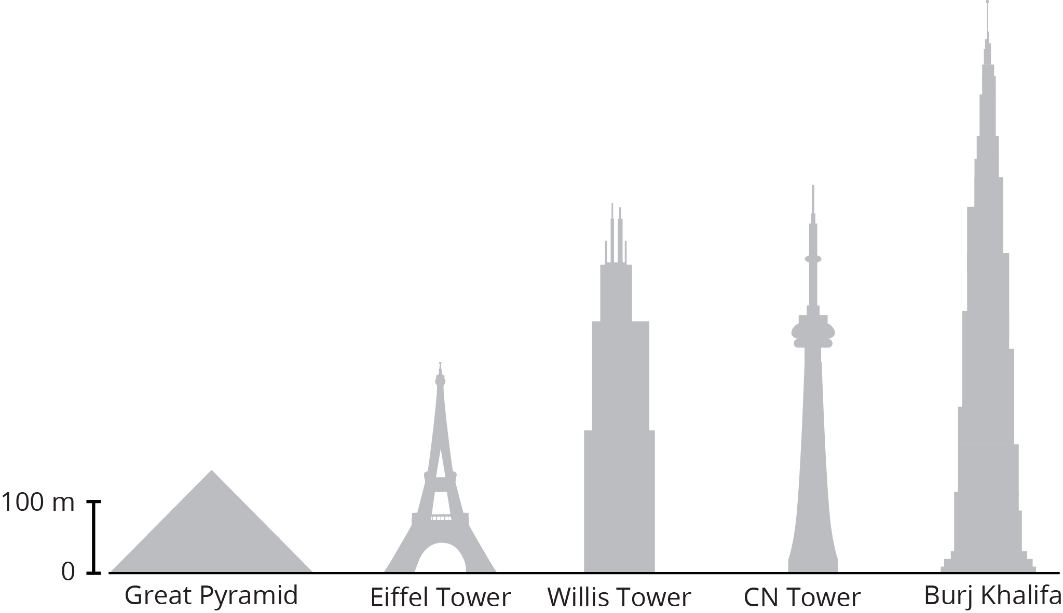
- About how tall is the actual Willis Tower? About how tall is the actual Great Pyramid? Be prepared to explain your reasoning.
- About how much taller is the Burj Khalifa than the Eiffel Tower? Explain or show your reasoning.
- Measure the line segment that shows the scale to the nearest tenth of a centimeter. Express the scale of the drawing using numbers and words.
© CC BY Open Up Resources. Adaptations CC BY IM.

