Unit 5 Lesson 19: Distinguishing Circumference and Area

1 Filling the Plate (Warm up)

Images for Launch
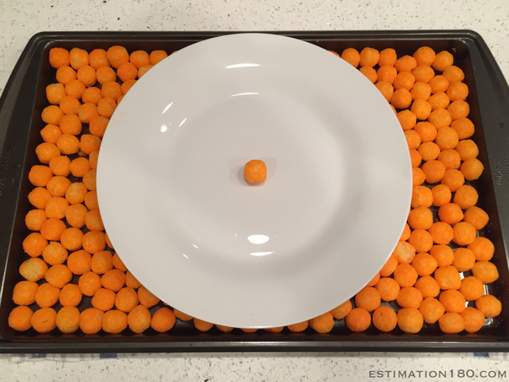

Student Task Statement
About how many cheese puffs can fit on the plate in a single layer? Be prepared to explain your reasoning.

2 Card Sort: Circle Problems

Student Task Statement
Your teacher will give you cards with questions about circles.
- Sort the cards into two groups based on whether you would use the circumference or the area of the circle to answer the question. Pause here so your teacher can review your work.
- Your teacher will assign you a card to examine more closely. What additional information would you need in order to answer the question on your card?
- Estimate measurements for the circle on your card.
- Use your estimates to calculate the answer to the question.

3 Visual Display of Circle Problem (Optional)

Student Task Statement
In the previous activity you estimated the answer to a question about circles.
Create a visual display that includes:
- The question you were answering
- A diagram of a circle labeled with your estimated measurements
- Your thinking, organized so that others can follow it
- Your answer, expressed in terms of $π$ and also expressed as a decimal approximation

4 Analyzing Circle Claims

Student Task Statement
Here are two students’ answers for each question. Do you agree with either of them? Explain or show your reasoning.
- How many feet are traveled by a person riding once around the merry-go-round?
- 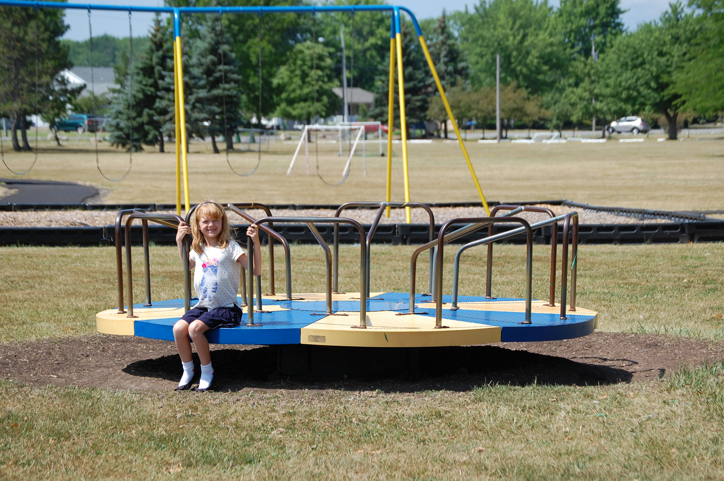
  - Clare says, “The radius of the merry-go-round is about 4 feet, so the distance around the edge is about $8π$ feet.”
  - Andre says, “The diameter of the merry-go-round is about 4 feet, so the distance around the edge is about $4π$ feet.”
- How much room is there to spread frosting on the cookie?
- 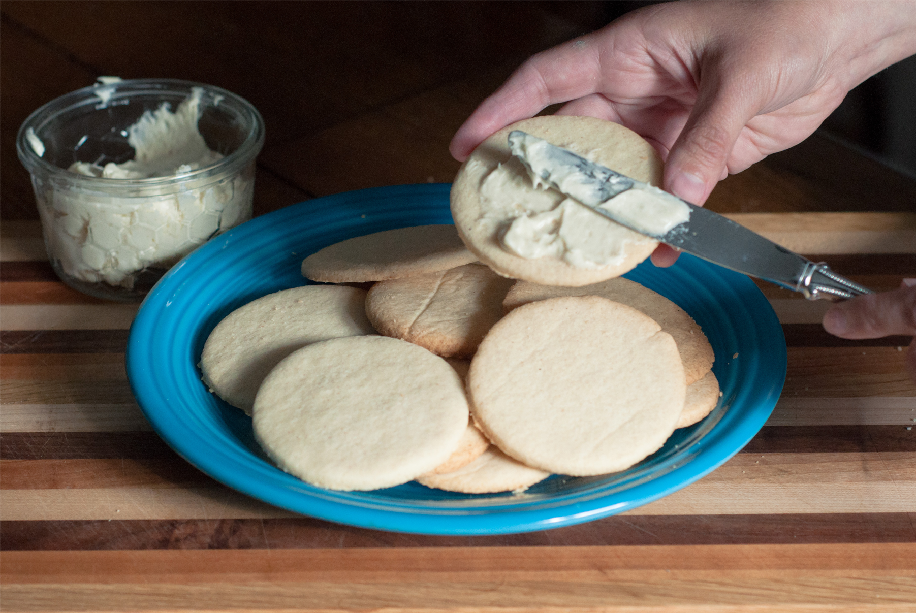
  - Clare says “The radius of the cookie is about 3 centimeters, so the space for frosting is about $6π$ cm².”
  - Andre says “The diameter of the cookie is about 3 inches, so the space for frosting is about $2.25π$ in².”
- How far does the unicycle move when the wheel makes 5 full rotations?
- 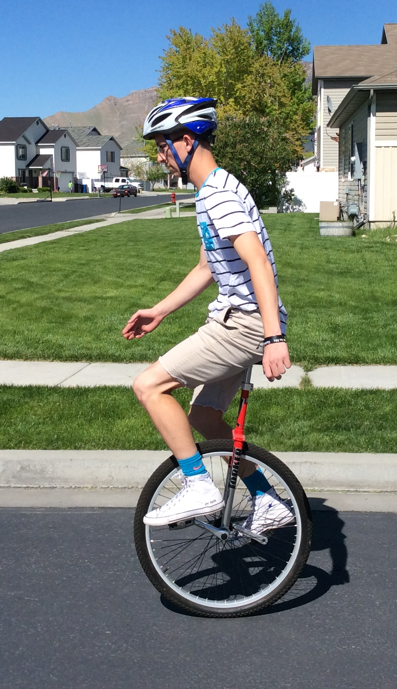
  - Clare says, “The diameter of the unicycle wheel is about 0.5 meters. In 5 complete rotations it will go about $\frac{5}{2}π$ m².”
  - Andre says, “I agree with Clare's estimate of the diameter, but that means the unicycle will go about $\frac{5}{4}π$ m.”
© CC BY Open Up Resources. Adaptations CC BY IM.

