Lesson 15: Draw Groups of Things
- Let’s figure out how many things to draw.

Warm-up: How Many Do You See: Many Ways to Show 5
How many do you see?
How do you see them?
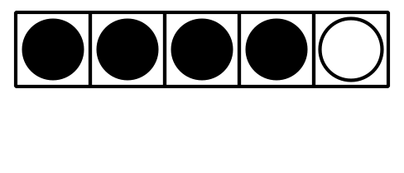

15.3: Centers: Choice Time
Choose a center.
Math Libs
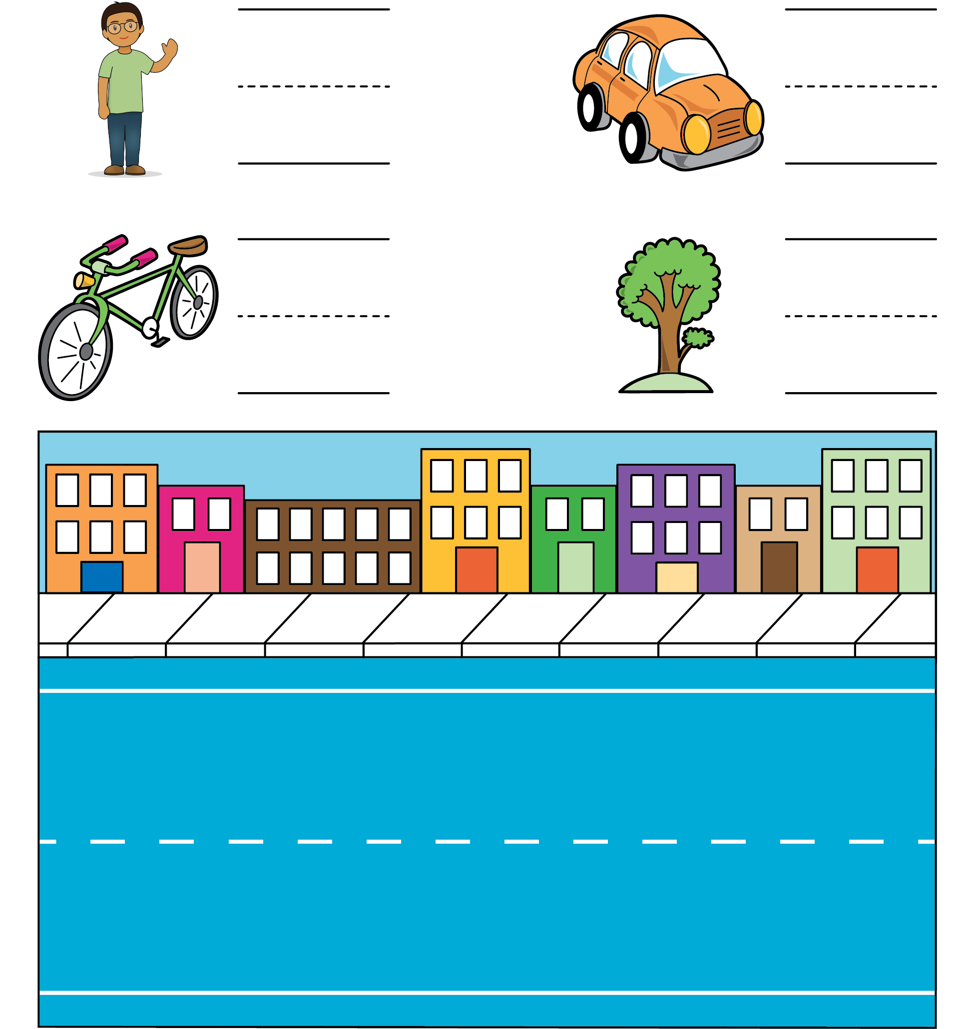
Bingo
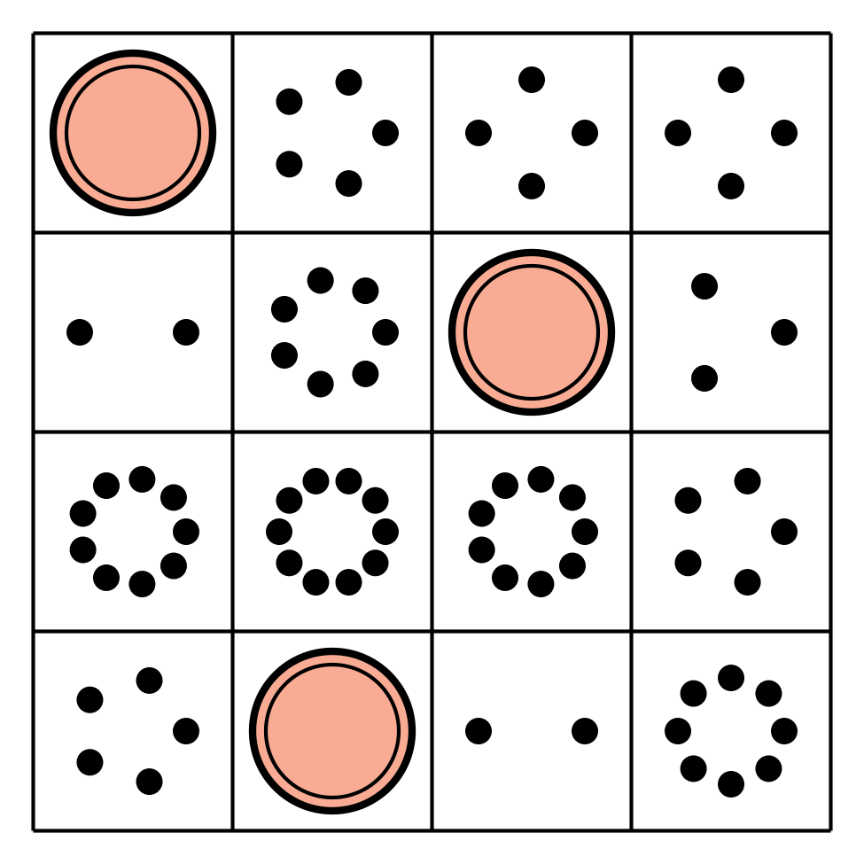
Number Race
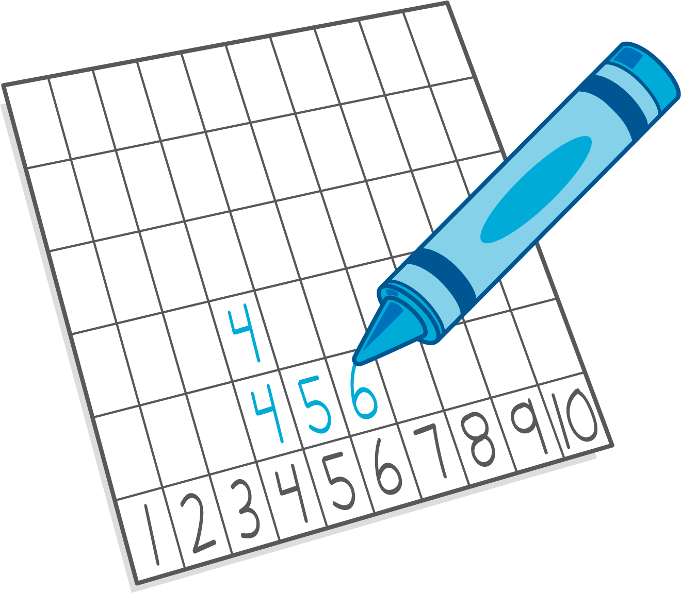
Geoblocks
Math Fingers
© CC BY 2021 Illustrative Mathematics®

