Unit 6 Lesson 9: Expressions and Equations

WU Choral Count: Recording to 19 (Warm up)

Student Task Statement

1 Organize Expressions and Numbers

Student Task Statement

2 Equations and 10-frames

Student Task Statement
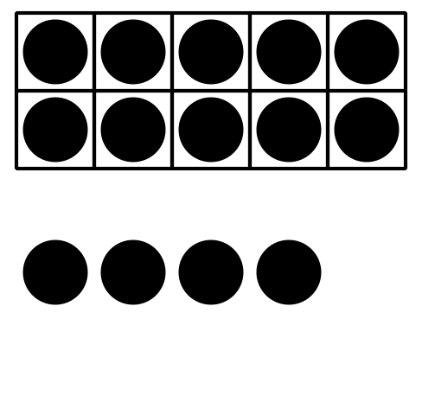
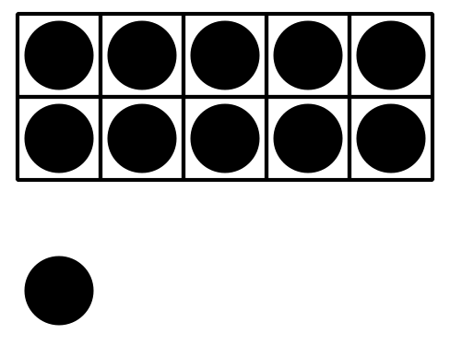
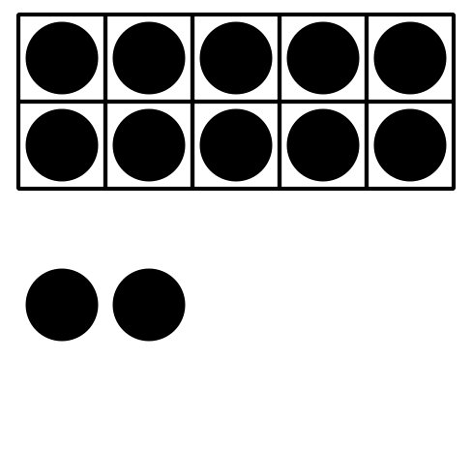
$10+9=19$
$10+1=11$
$10+4=14$
$10+8=18$
$10+5=15$
$10+2=12$
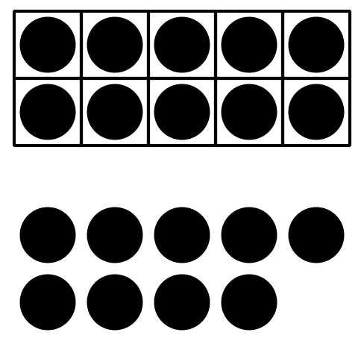
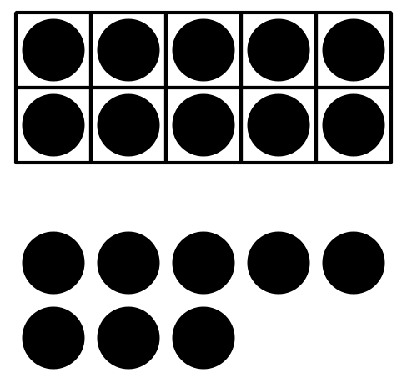
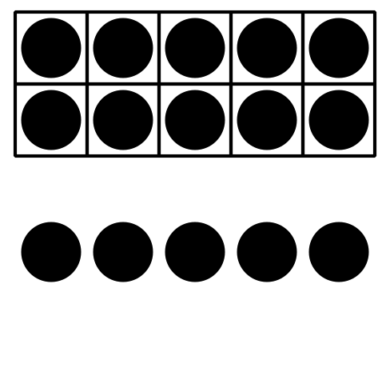

3 Introduce Make or Break Apart Numbers, Numbers 11–19

Student Task Statement
Choose a center.
Bingo
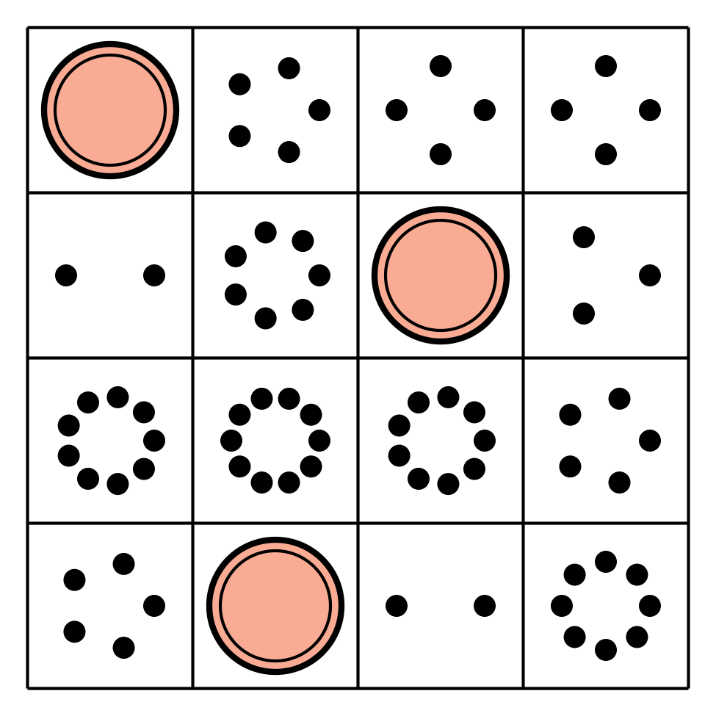
Number Race
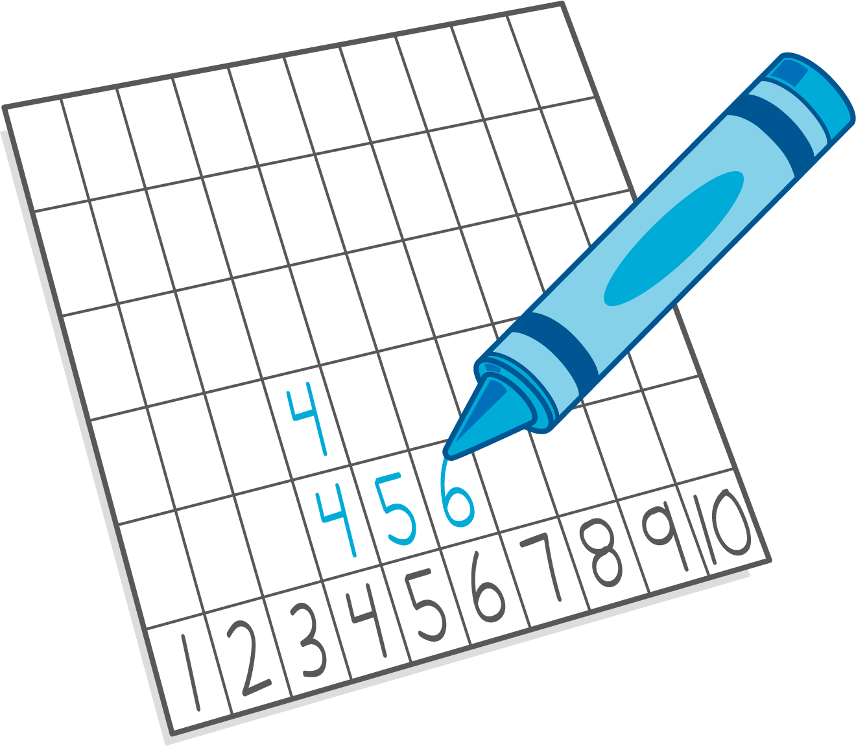
Grab and Count
Make or Break Apart Numbers
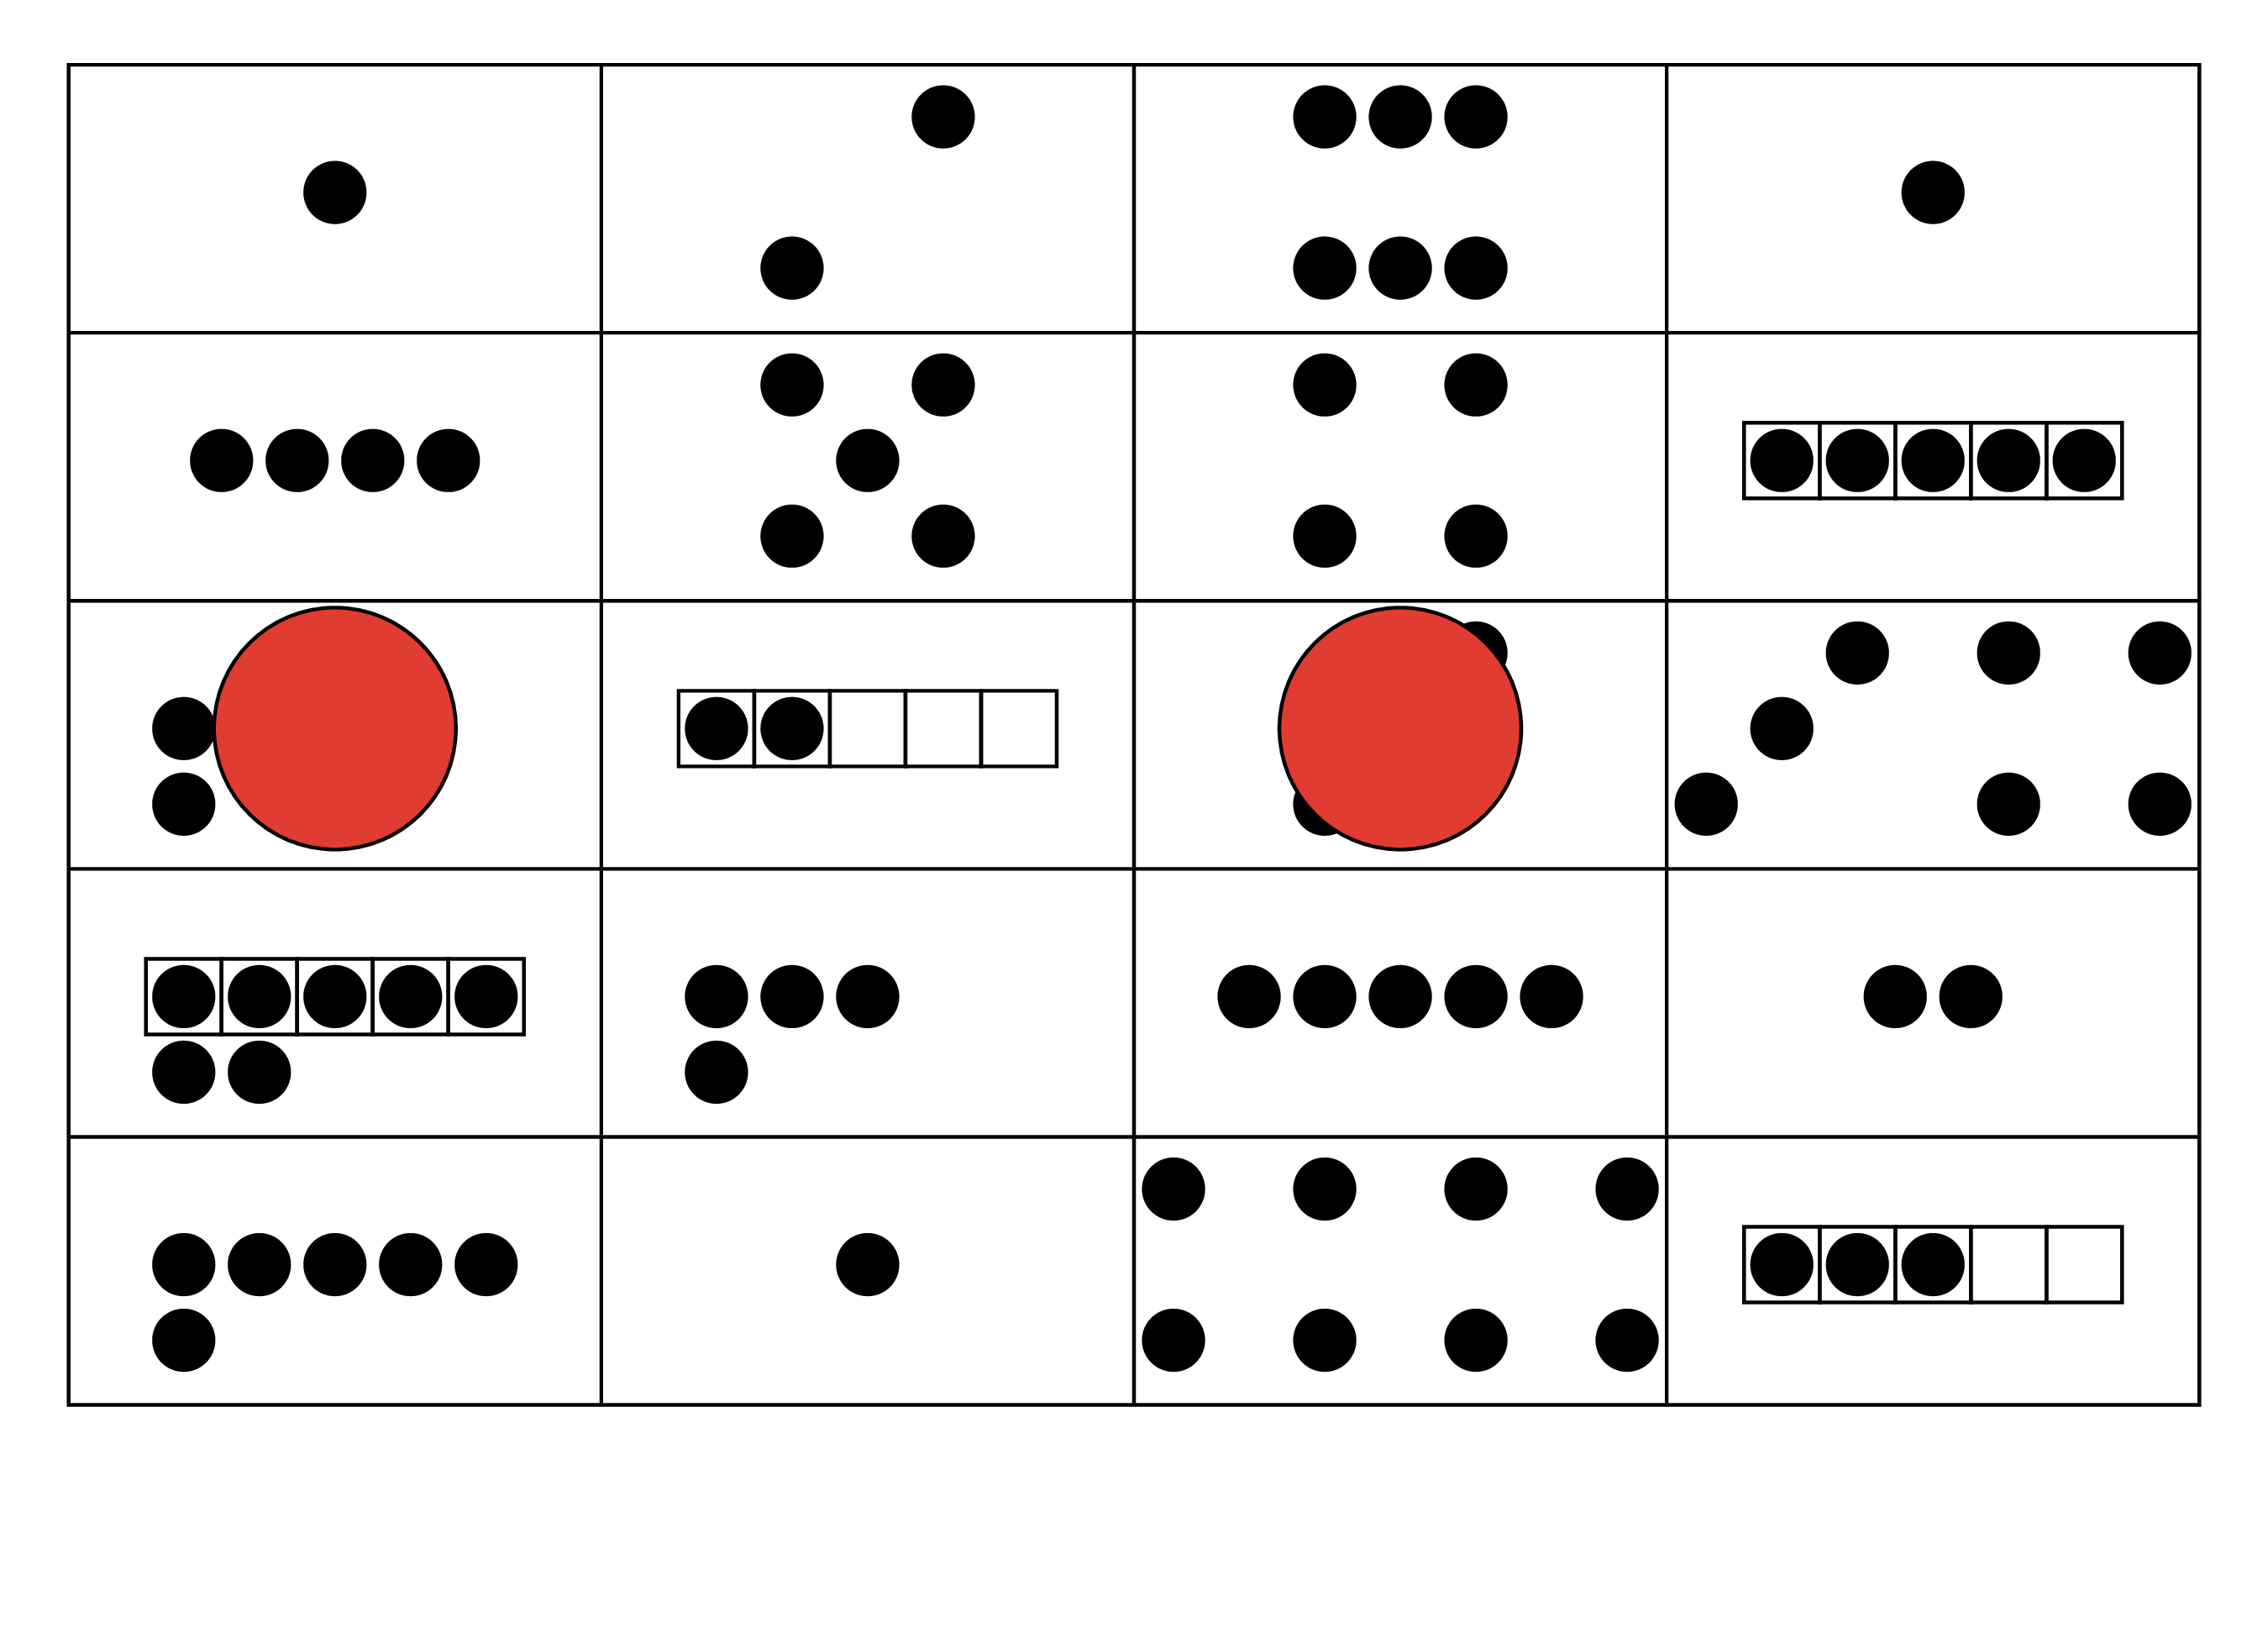
Tower Build
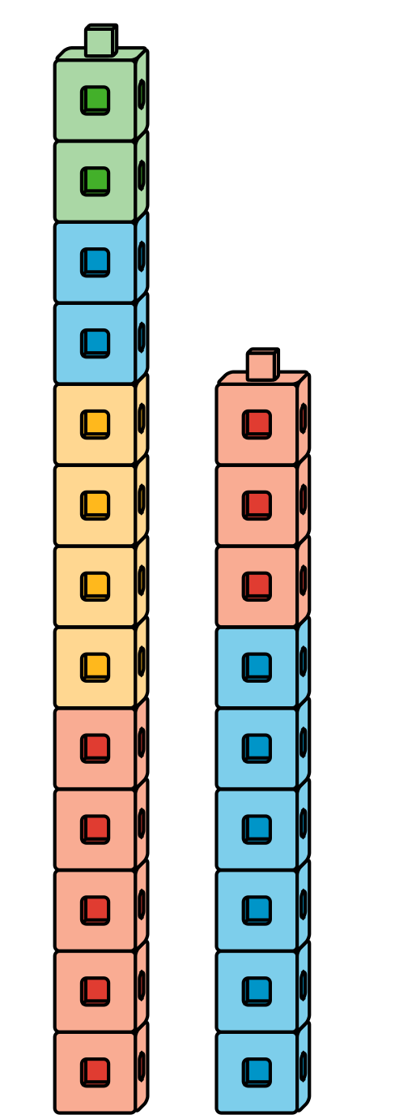
© CC BY 2021 Illustrative Mathematics®

