Lesson 6 Practice Problems
- What could be the formula used to compute the value shown in cell B3?
- 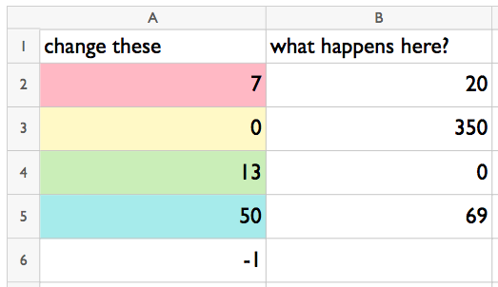
  - = B3 * B4
  - = A2 + A5
  - = A2 * A5
  - = Sum(A2:A6)
- What number will appear in cell B2 when the user presses Enter?
- 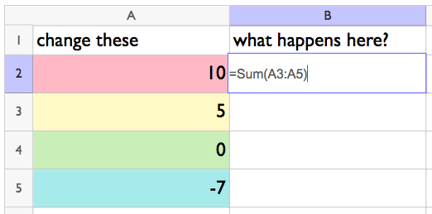

- Select all the formulas that could be used to calculate the value in cell B4.
  - =Product(A2:A6)
  - =Sum(A2:A6)
  - = A2 + A3
  - = A2 * A3
  - = A3 * A4 * A5
  - = A3 + A4 + A5
- The formula in cell B2 is = Product(A2 : A5). Describe a way to change the contents of column A so that the value in cell B2 becomes -70.
- 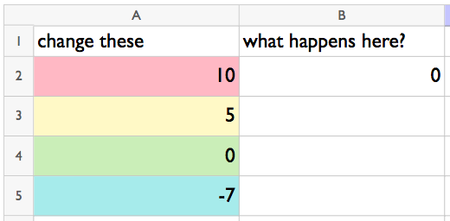

- The dot plot displays the number of books read by students during the semester.
- 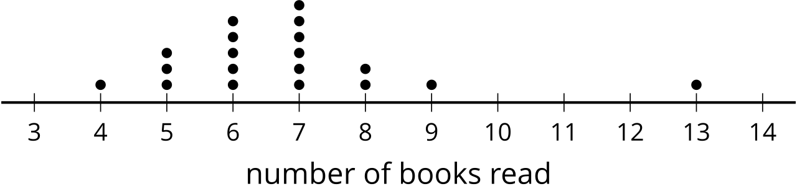
  - Which measure of center would you use given the shape of the distribution in the dot plot? Explain your reasoning.
  - Which measure of variability would you use? Explain your reasoning.
- (From Unit 1, Lesson 5.)
- The dot plot displays the number of families living in different blocks of a town.
- 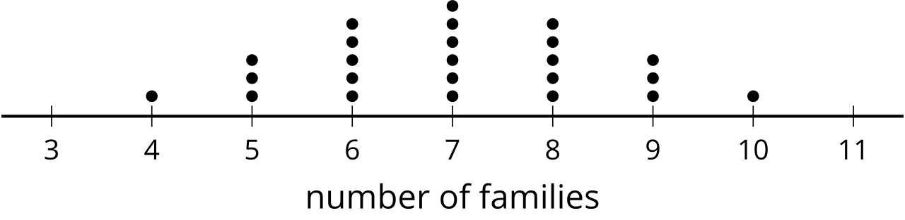
  - Which measure of center would you use, given the shape of the distribution in the dot plot? Explain your reasoning.
  - Which measure of variability would you use? Explain your reasoning.
- (From Unit 1, Lesson 5.)
© CC BY 2019 by Illustrative Mathematics®

