Unit 4 Lesson 10: World’s Record Folk Dance

WU How Many Do You See: World Record Event (Warm up)

Student Task Statement
How many do you see? How do you see them?
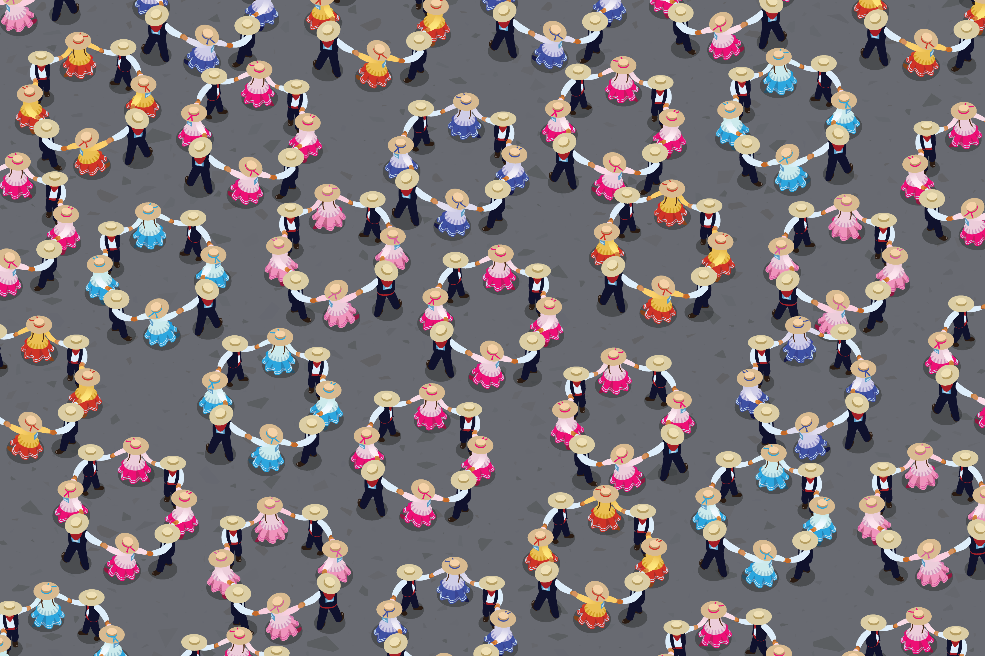

1 How Many Groups of 8 Dancers?

Student Task Statement
There were 4,704 people at the record breaking folk dance in Peru. How many groups of 8 dancers were there? Explain or show your thinking.

Activity Synthesis
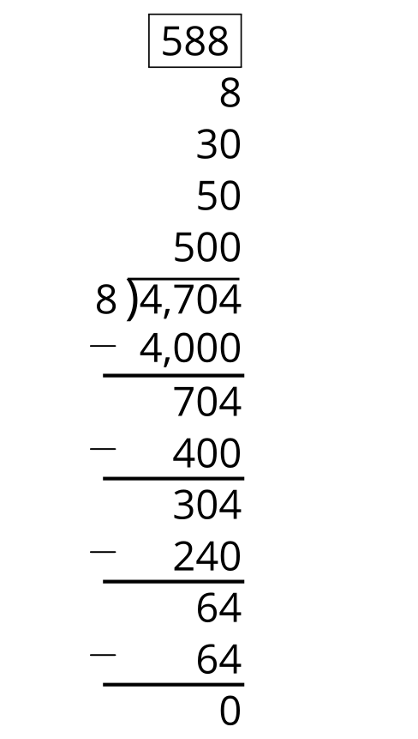

2 More Groups of Dancers

Student Task Statement
- 4,704 people participate in the Peruvian folk dance. They need to be organized into groups of 4.
  - Write a division expression to represent the situation.
  - How many groups of 4 will there be? Explain or show your thinking.
  - Compare your work with your partner’s. What is the same? What is different?
- 4,704 people participate in the Peruvian folk dance. They need to be organized into groups of 2.
  - Write a division expression to represent the situation.
  - How many groups of 2 will there be? Explain or show your thinking.
  - Compare your work with your partner’s. What is the same? What is different?
© CC BY 2021 Illustrative Mathematics®

