Unit 5 Lesson 24: Divide Decimals by Whole Numbers

WU Estimation Exploration: Divide by Whole Numbers (Warm up)

Student Task Statement
What is the value of $0.42÷5$?
Record an estimate that is:
too low | about right | too high

1 Whole Number Groups

Student Task Statement
- Find the value of the expression $0.8÷4$. Explain or show your reasoning.
- 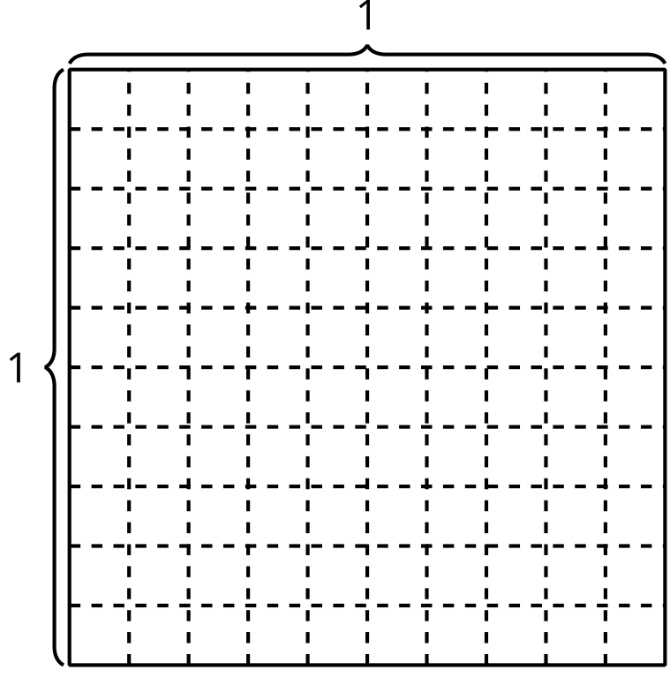
- Find the value of the expression $0.6÷3$. Explain or show your reasoning.
- Find the value of $0.5÷2$. Explain or show your reasoning.
- Find the value of $0.75÷5$. Explain or show your reasoning.

2 Evaluate Expressions

Student Task Statement
- Find the value of each expression.
  - $60÷5$
  - $6÷5$
  - $0.6÷5$
- Find the value of each expression.
  - $0.7÷2$
  - $0.45÷5$
© CC BY 2021 Illustrative Mathematics®

