Lesson 14: What is a Line Plot?

Standards Alignments
Addressing | 2.MD.A.1, 2.MD.D.9
Building Towards | 2.MD.D.9

Teacher-facing Learning Goals
- Interpret a line plot.
- Understand that a line plot is used to represent and interpret numerical data.

Student-facing Learning Goals
- Let’s learn a new way to represent data.

Lesson Purpose
The purpose of this lesson is for students to learn about the ways a line plot can be used to represent data collected from measuring objects.
In a previous unit, students created and interpreted two representations of categorical data, bar graphs and picture graphs. In a previous lesson, students measured length using metric and customary units.
In this lesson, a line plot is defined as a way to show how many of each measurement using an x for each measurement. Students collect numerical data by measuring their hand spans and create a class line plot to display their measurements. Through the lesson activities, students learn that each x on the line plot represents one measurement. They learn that the scale of the line plot shows the length units used to measure and resembles the way length units are labeled on a ruler. Students notice that the length units on the scale of the line plot are not exactly the same length as the length units used to measure (inches), but that labels can help others know what length unit was used (MP2, MP6). Students will gain experience working with line plots throughout the rest of the section. Save the class line plot you create for reference in future lessons.

Access for:

Students with Disabilities
- Engagement (Activity 1)

English Learners
- MLR8 (Activity 2)

Instructional Routines
Notice and Wonder (Warm-up)

Materials to Gather
- Rulers (inches): Activity 1
- Sticky notes: Activity 1

Lesson Timeline
Warm-up | 10 min
Activity 1 | 20 min
Activity 2 | 15 min
Lesson Synthesis | 10 min
Cool-down | 5 min

Teacher Reflection Question
In a future lesson, students will create their own line plots. What do students need to understand in order to be successful? How did this lesson prepare them to create their own line plots?

Cool-down
(to be completed at the end of the lesson) 5min
Hand Spans

Standards Alignments
Addressing | 2.MD.A.1, 2.MD.D.9

Student-facing Task Statement
- Tyler collected data about the lengths of hand spans for students in his class.
  - Three students have a hand span of 6 inches.
  - Only 1 student has a hand span of 5 inches.
  - Three students have a hand span of 7 inches.
  - Two students have a hand span of 8 inches.
  - Circle the line plot that could represent Tyler’s class’s hand spans.
  - 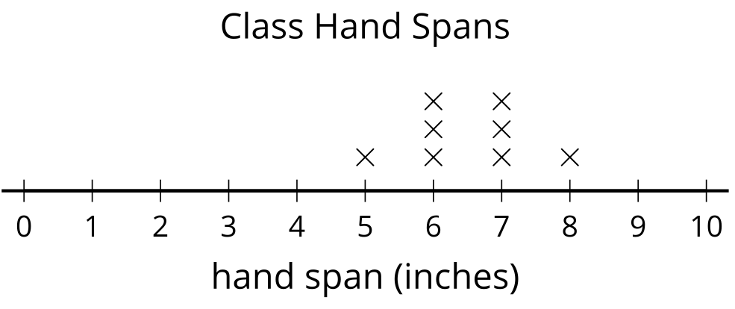
  - 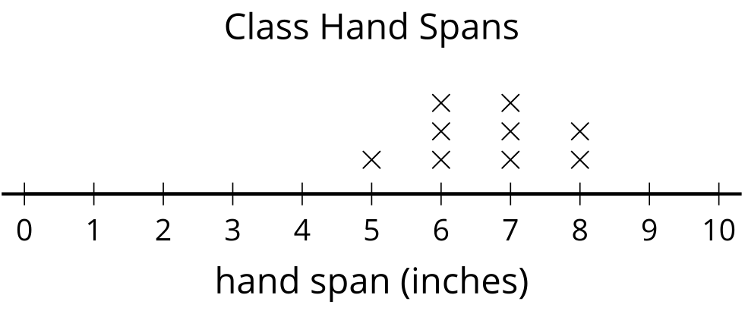
  - Explain how you know.

Student Responses

  - Students circle the second line plot.
  - Both match the first two statements, but the first line plot has 1 student with a hand span of 8 instead of 2.

