Lesson 8: Subtraction Algorithms (Part 1)

Standards Alignments
Addressing | 3.NBT.A.2

Teacher-facing Learning Goals
- Relate base-ten diagrams to written algorithms for subtraction.

Student-facing Learning Goals
- Let’s learn a new way to subtract.

Lesson Purpose
The purpose of this lesson is for students to use their knowledge of base-ten diagrams to make sense of a written subtraction algorithm.
In previous lessons, students revisited subtraction within 1,000 using strategies based on place value, properties of operations, and the relationship between addition and subtraction. In this lesson, students are introduced to a subtraction algorithm that clearly shows the subtraction of ones from ones, tens from tens, and hundreds from hundreds, and is similar to one of the initial addition algorithms in a prior lesson. Students should have access to base-ten blocks as needed.

Access for:

Students with Disabilities
- Engagement (Activity 2)

English Learners
- MLR8 (Activity 2)

Instructional Routines
Card Sort (Activity 2), Number Talk (Warm-up)

Materials to Copy
- Diagrams and Algorithms (groups of 2): Activity 2

Lesson Timeline
Warm-up | 10 min
Activity 1 | 15 min
Activity 2 | 20 min
Lesson Synthesis | 10 min
Cool-down | 5 min

Teacher Reflection Question
Reflect on how comfortable your students are asking questions of you and of each other. What can you do to encourage students to ask questions?

Cool-down
(to be completed at the end of the lesson) 5min
Connect a Diagram and an Algorithm

Standards Alignments
Addressing | 3.NBT.A.2

Student-facing Task Statement
Explain how the diagram matches the algorithm.
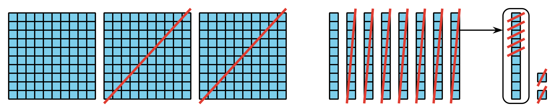
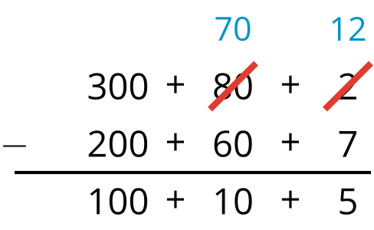

Student Responses
Sample response: I can see that there are 3 hundreds, 8 tens, and 2 ones, but one of the tens has been moved over to get more ones. In the algorithm, the 80 and 2 are crossed out to show this. The blocks that are not crossed out show the $100+10+5$ in the algorithm.

