Lesson 5: Multiplication of Multi-digit Numbers

Standards Alignments
Addressing | 4.NBT.B.5

Teacher-facing Learning Goals
- Multiply multi-digit numbers using strategies based on place value and the properties of operations.

Student-facing Learning Goals
- Let’s multiply multi-digit numbers.

Lesson Purpose
The purpose of this lesson is to deepen students’ understanding of the connections between algorithms that use partial products and the standard algorithm when multiplying a pair of two-digit numbers.
In an earlier unit, students analyzed and experimented with different ways to multiply multi-digit numbers by single-digit whole numbers. This included analyzing diagrams and series of equations, including those that represented algorithms that use partial products. Students were introduced to the standard algorithm of multiplication and its connections to other ways of reasoning about products, particularly algorithms that use partial products.
This lesson reinforces students’ awareness of the connections between the two algorithms and the role that place value plays in both (MP7). Students practice using the algorithms to multiply a one-digit number by another number up to four digits, building their fluency on multi-digit multiplication. If students need additional support with the concepts in this lesson, refer back to Unit 6, Section B in the curriculum materials.
As in the earlier unit, students are not expected to use the standard algorithm for multiplication without support, or to independently choose it to find products. They will continue to develop their facility with the standard algorithm in grade 5.

Access for:

Students with Disabilities
- Representation (Activity 1)

English Learners
- MLR8 (Activity 1)

Instructional Routines
Estimation Exploration (Warm-up)

Materials to Gather
- Grid paper: Activity 1, Activity 2

Lesson Timeline
Warm-up | 10 min
Activity 1 | 20 min
Activity 2 | 15 min
Lesson Synthesis | 10 min
Cool-down | 5 min

Teacher Reflection Question
Identify who has been sharing their ideas in class lately. Make a note of students whose ideas have not been shared and look for an opportunity for them to share their thinking in tomorrow’s lesson.

Cool-down
(to be completed at the end of the lesson) 5min
Four by One and Two by Two

Standards Alignments
Addressing | 4.NBT.B.5

Student-facing Task Statement
- Find the value of $2,​617×4$. Show your reasoning.
- Find the value of $52×14$. Show your reasoning.

Student Responses
- 10,468. Sample reasoning: $\left(2,​000×4\right)+\left(600×4\right)+\left(17×4\right)$
= $8,​000+2,​400+68$
= $10,​468$
- 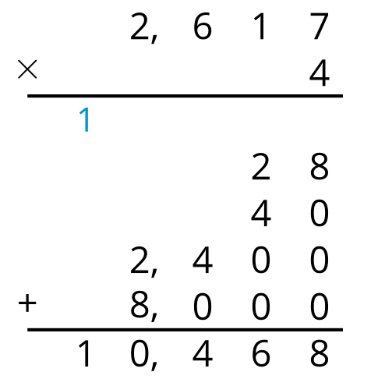
- 728. Sample reasoning:
  - $52×10=520$ and $52×4=208$. The sum of 520 and 208 is 728.
  - $14×50=700$ and $14×2=28$. The sum of 700 and 28 is 728.
  - Using algorithms:
  - 
   