Unit 1 Lesson 8: Scale Drawings and Maps

1 A Train and a Car (Warm up)

Student Task Statement
Two cities are 243 miles apart.
- It takes a train 4 hours to travel between the two cities at a constant speed.
- A car travels between the two cities at a constant speed of 65 miles per hour.
Which is traveling faster, the car or the train? Be prepared to explain your reasoning.

2 Driving on I-90 (Optional)

Student Task Statement
- A driver is traveling at a constant speed on Interstate 90 outside Chicago. If she traveled from Point A to Point B in 8 minutes, did she obey the speed limit of 55 miles per hour? Explain your reasoning.
- 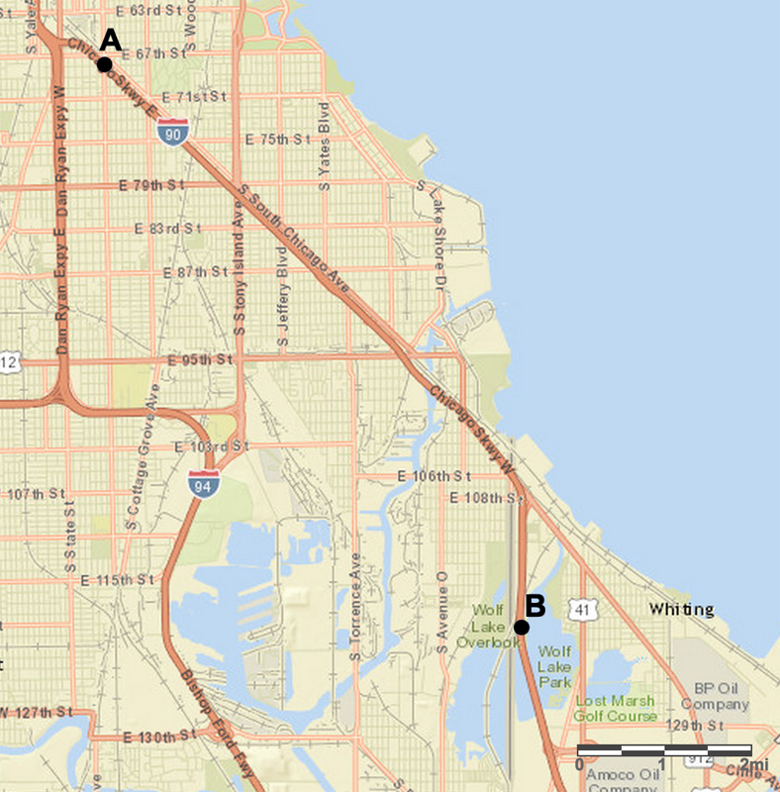
- A traffic helicopter flew directly from Point A to Point B in 8 minutes. Did the helicopter travel faster or slower than the driver? Explain or show your reasoning.

3 Biking through Kansas (Optional)

Student Task Statement
A cyclist rides at a constant speed of 15 miles per hour. At this speed, about how long would it take the cyclist to ride from Garden City to Dodge City, Kansas?
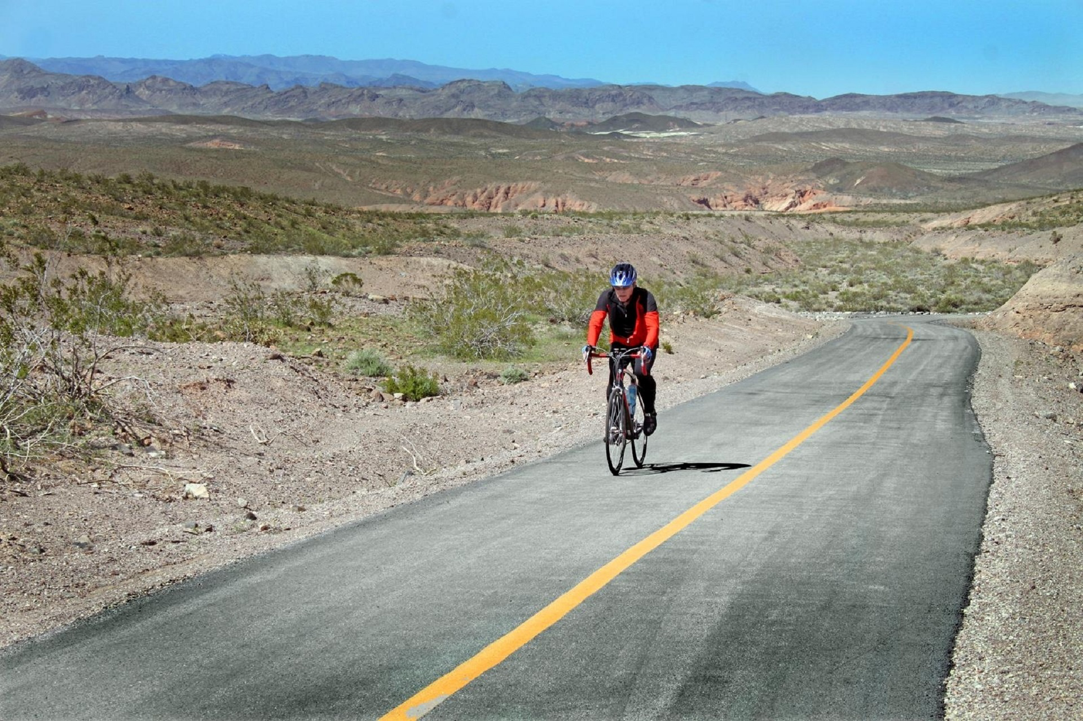
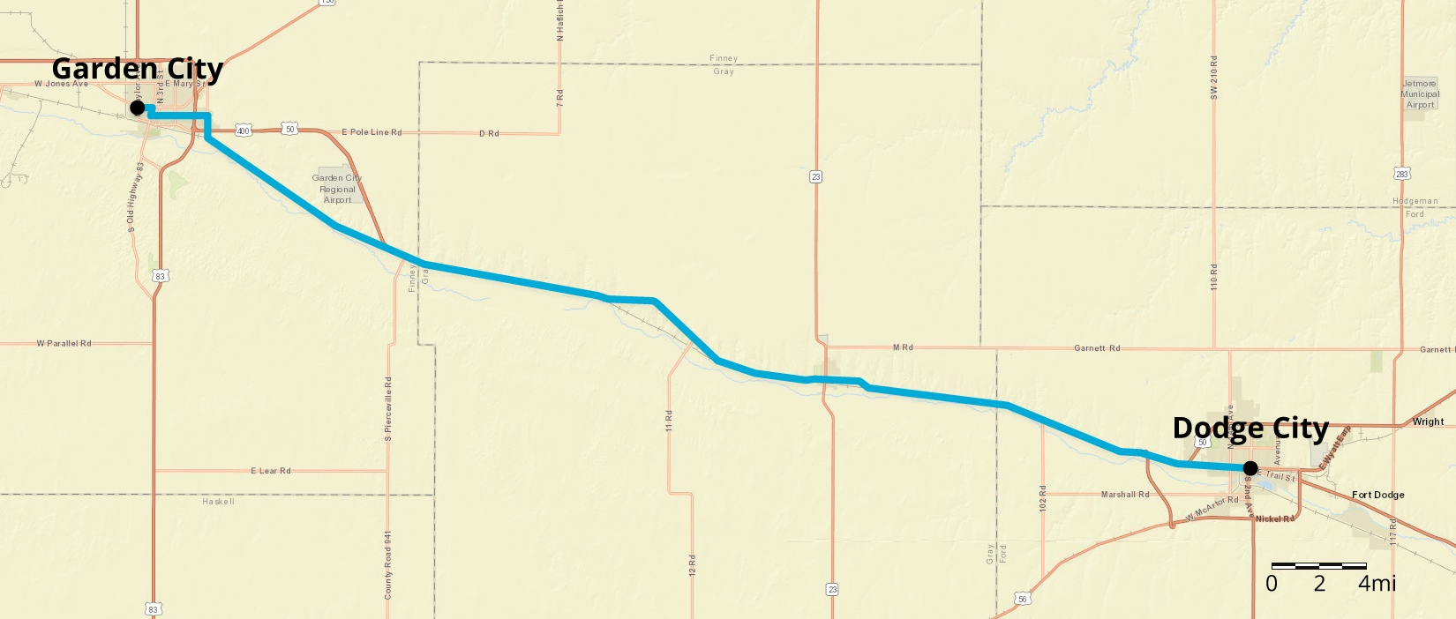

© CC BY Open Up Resources. Adaptations CC BY IM.

