Lesson 13: Expressions with Rational Numbers
Let’s develop our signed number sense.

13.1: True or False: Rational Numbers
Decide if each statement is true or false. Be prepared to explain your reasoning.
- $\left(\text{-}38.76\right)\left(\text{-}15.6\right)$ is negative
- $10,000−99,999<0$
- $\left(\frac{3}{4}\right)\left(\text{-}\frac{4}{3}\right)=0$
- $\left(30\right)\left(\text{-}80\right)−50=50−\left(30\right)\left(\text{-}80\right)$

13.2: Card Sort: The Same But Different
Your teacher will give you a set of cards. Group them into pairs of expressions that have the same value.

13.3: Near and Far From Zero
$a$ | $b$ | $\text{-}a$ | $\text{-}4b$ | $\text{-}a+b$ | $a÷\text{-}b$ | $a^{2}$ | $b^{3}$
$\text{-}\frac{1}{2}$ | 6
$\frac{1}{2}$ | -6
-6 | $\text{-}\frac{1}{2}$
- For each set of values for $a$ and $b$, evaluate the given expressions and record your answers in the table.
- When $a=\text{-}\frac{1}{2}$ and $b=6$, which expression:
- has the largest value?
- has the smallest value?
- is the closest to zero?
- When $a=\frac{1}{2}$ and $b=\text{-}6$, which expression:
- has the largest value?
- has the smallest value?
- is the closest to zero?
- When $a=\text{-}6$ and $b=\text{-}\frac{1}{2}$, which expression:
- has the largest value?
- has the smallest value?
- is the closest to zero?

Are you ready for more?
Are there any values could you use for $a$ and $b$ that would make all of these expressions have the same value? Explain your reasoning.

13.4: Seagulls and Sharks Again
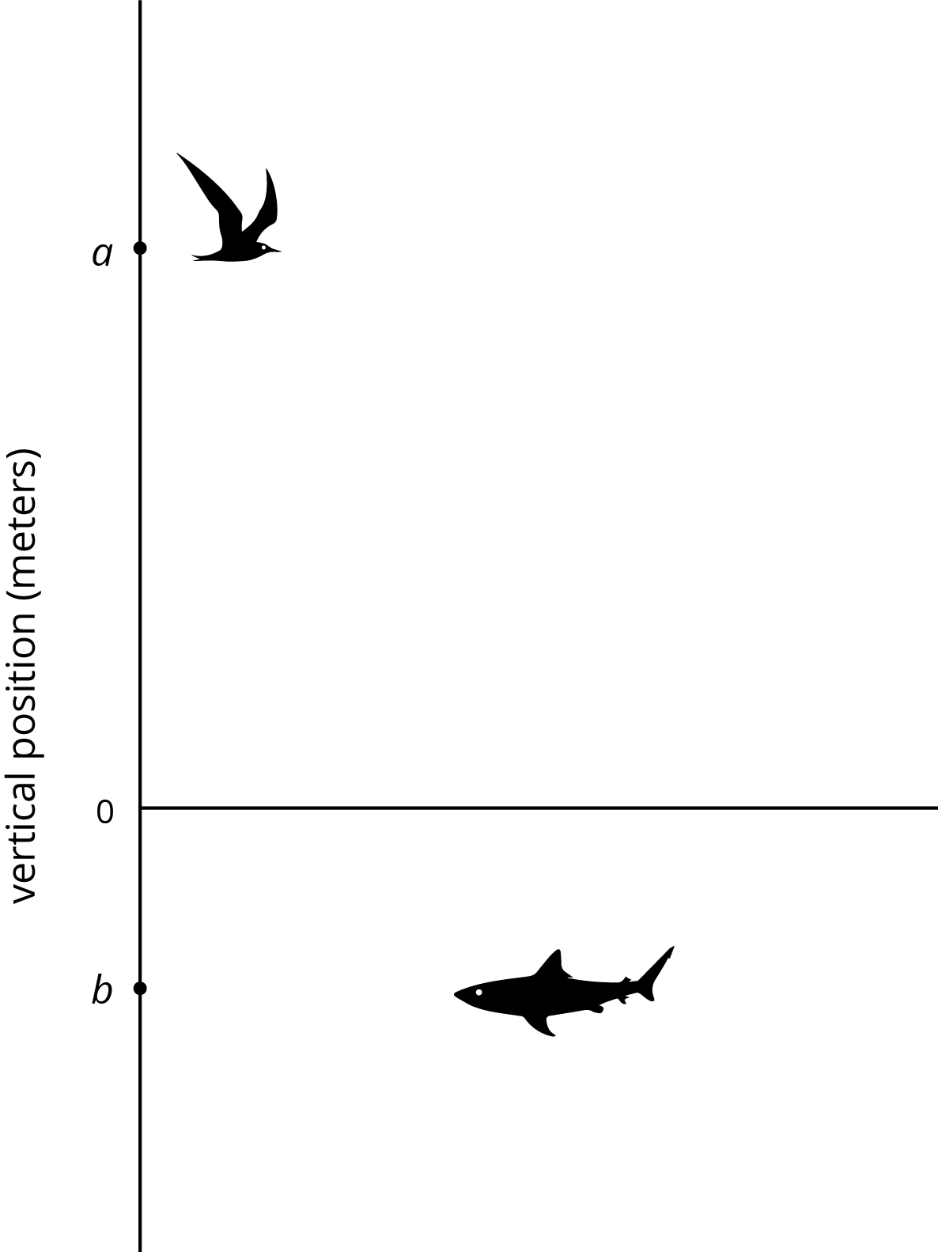
A seagull has a vertical position $a$, and a shark has a vertical position $b$. Draw and label a point on the vertical axis to show the vertical position of each new animal.
- A dragonfly at $d$, where $d=\text{-}b$
- A jellyfish at $j$, where $j=2b$
- An eagle at $e$, where $e=\frac{1}{4}a$.
- A clownfish at $c$, where $c=\frac{\text{-}a}{2}$
- A vulture at $v$, where $v=a+b$
- A goose at $g$, where $g=a−b$

Lesson 13 Summary
We can represent sums, differences, products, and quotients of rational numbers, and combinations of these, with numerical and algebraic expressions.
Sums:
$\frac{1}{2}+\text{-}9$
$\text{-}8.5+x$
Differences:
$\frac{1}{2}−\text{-}9$
$\text{-}8.5−x$
Products:
$\left(\frac{1}{2}\right)\left(\text{-}9\right)$
$\text{-}8.5x$
Quotients:
$\frac{1}{2}÷\text{-}9$
$\frac{\text{-}8.5}{x}$
We can write the product of two numbers in different ways.
- By putting a little dot between the factors, like this: $\text{-}8.5⋅x$.
- By putting the factors next to each other without any symbol between them at all, like this: $\text{-}8.5x$.
We can write the quotient of two numbers in different ways as well.
- By writing the division symbol between the numbers, like this: $\text{-}8.5÷x$.
- By writing a fraction bar between the numbers like this: $\frac{\text{-}8.5}{x}$.
When we have an algebraic expression like $\frac{\text{-}8.5}{x}$ and are given a value for the variable, we can find the value of the expression. For example, if $x$ is 2, then the value of the expression is -4.25, because $\text{-}8.5÷2=\text{-}4.25$.
© CC BY Open Up Resources. Adaptations CC BY IM.

