Lesson 15: Escribamos horas

Standards Alignments
Addressing | 1.MD.B.3, 1.NBT.A.1, 1.OA.D.7

Teacher-facing Learning Goals
- Tell and write time in hours and half hours.

Student-facing Learning Goals
- Escribamos horas en punto y horas y media.

Lesson Purpose
The purpose of this lesson is for students to understand that times called half past are represented as ___:30. Students write time in hours and half hours to match analog clocks.
In the previous lesson, students connected “half past” the hour to half of an analog clock face. They told time in hours and half hours on clocks that only had an hour hand. At the end of the lesson, they learned that when it is half past the hour, the minute hand points to the 6.
In this lesson, students connect half of an hour to the digital form ___:30. Students write time in hours and half hours based on analog clocks. They add the digital form to the half past clock cards.

Access for:

Students with Disabilities
- Engagement (Activity 2)

English Learners
- MLR8 (Activity 2)

Instructional Routines
True or False (Warm-up)

Materials to Gather
- Materials from a previous lesson: Activity 2

Lesson Timeline
Warm-up | 10 min
Activity 1 | 10 min
Activity 2 | 25 min
Lesson Synthesis | 10 min
Cool-down | 5 min

Teacher Reflection Question
If you were to teach this lesson over again, what activity would you redo? How would your proposed changes support student learning?

Cool-down
(to be completed at the end of the lesson) 5min
Tiempo en horas y media y en horas en punto

Standards Alignments
Addressing | 1.MD.B.3

Student-facing Task Statement
¿Qué hora se muestra en cada reloj?
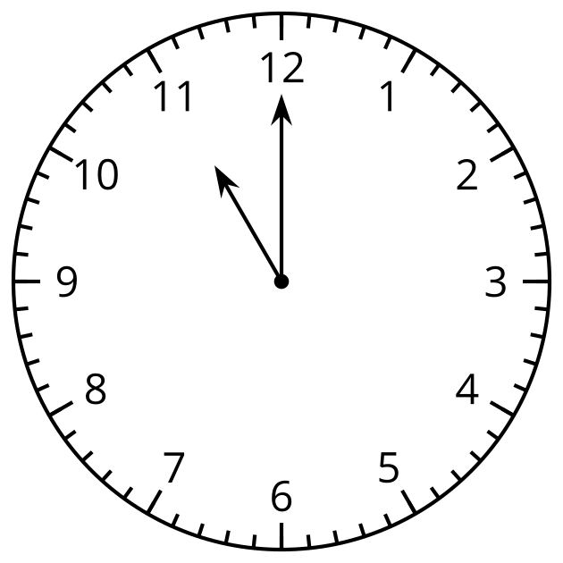
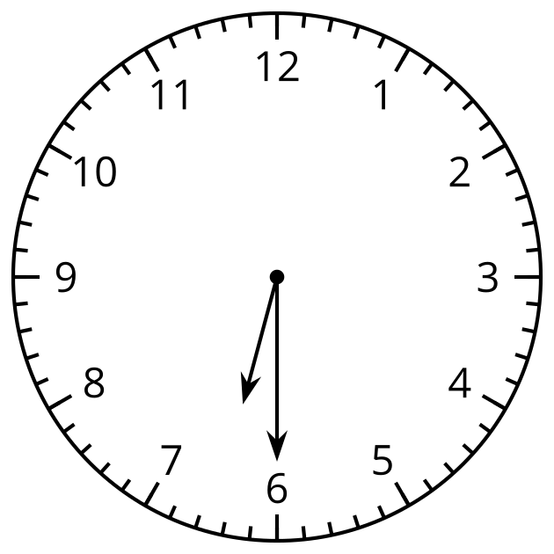

Student Responses
11:00 and 6:30

