Unit 8 Lesson 5: Finding Side Lengths of Triangles

1 Which One Doesn’t Belong: Triangles (Warm up)

Student Task Statement
Which triangle doesn’t belong?
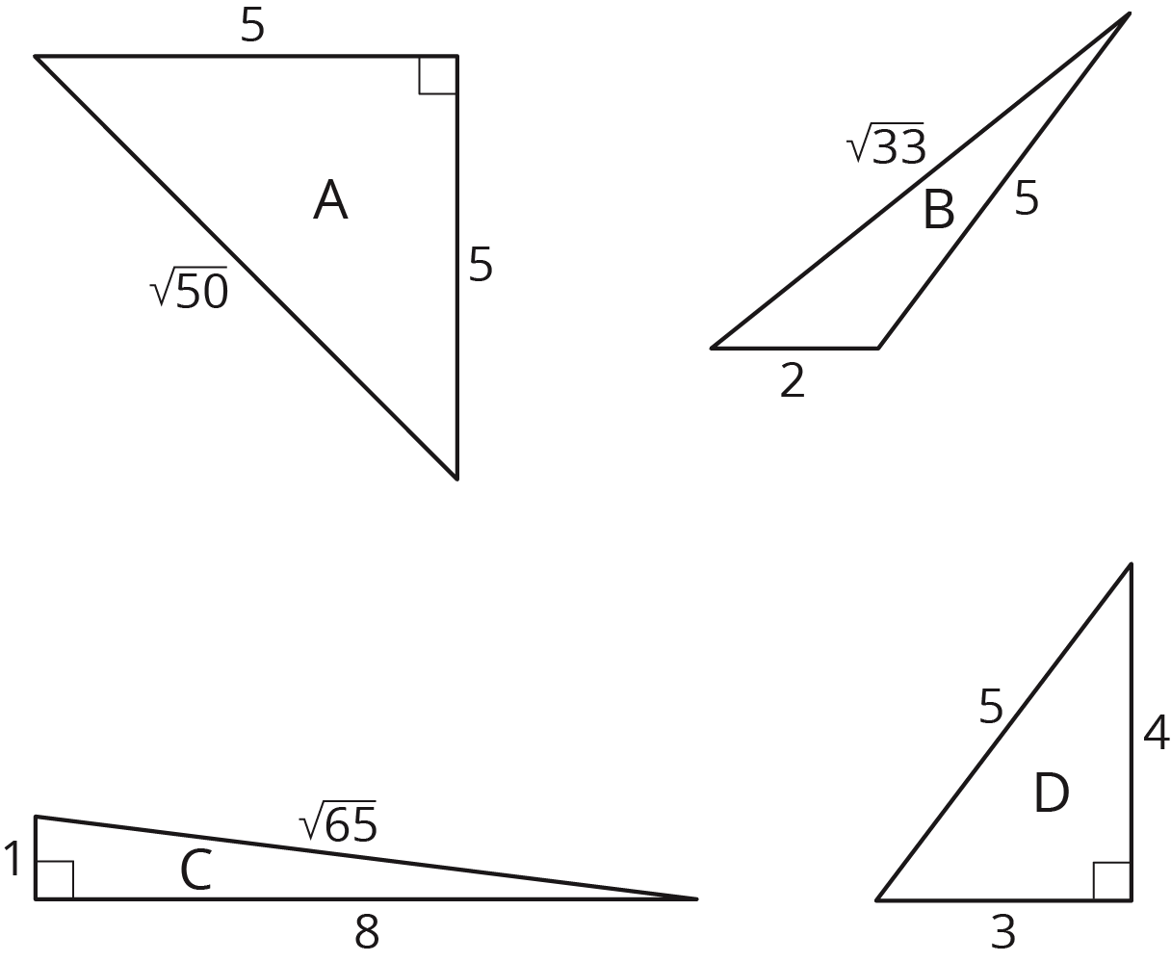

2 A Table of Triangles

Images for Launch
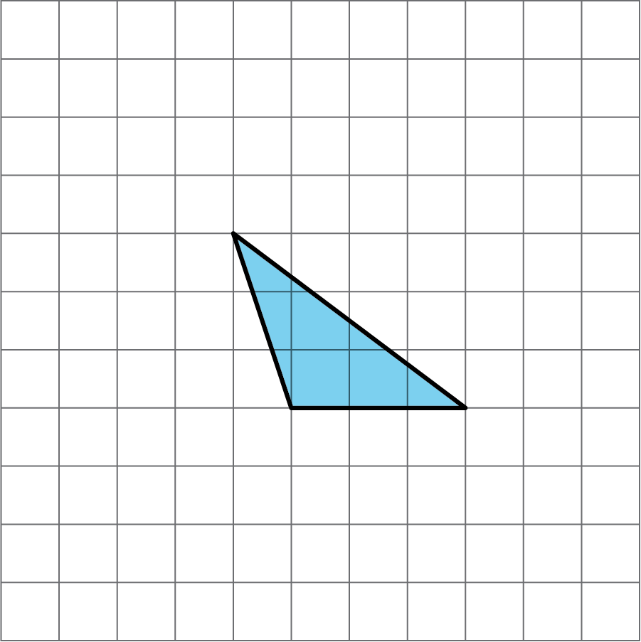
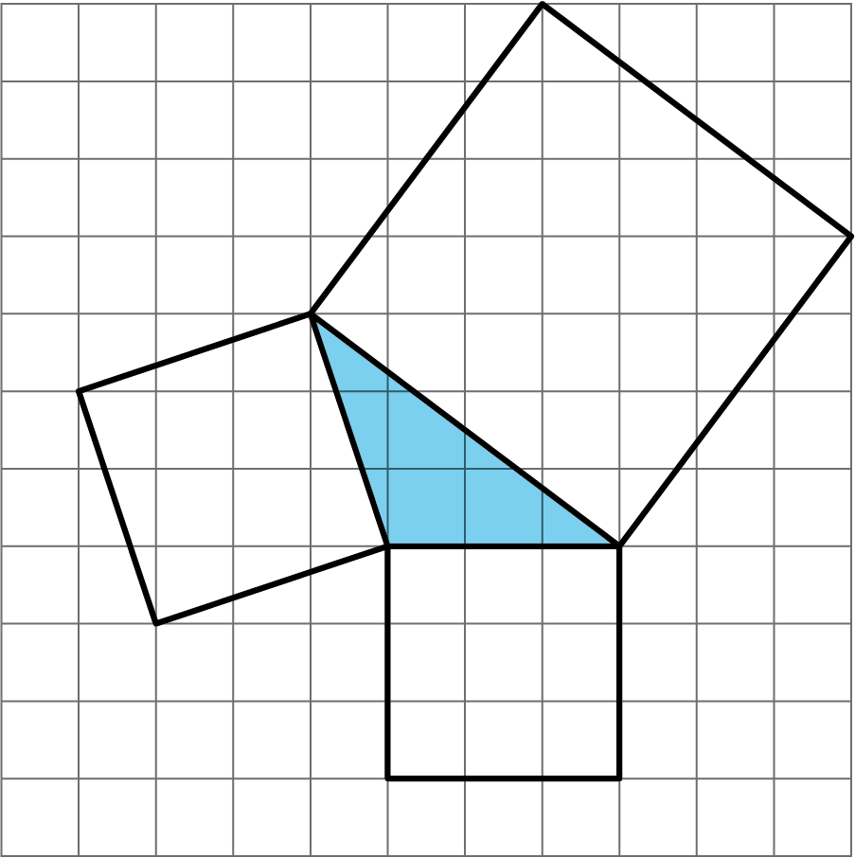

Student Task Statement
- Complete the tables for these three triangles:
- 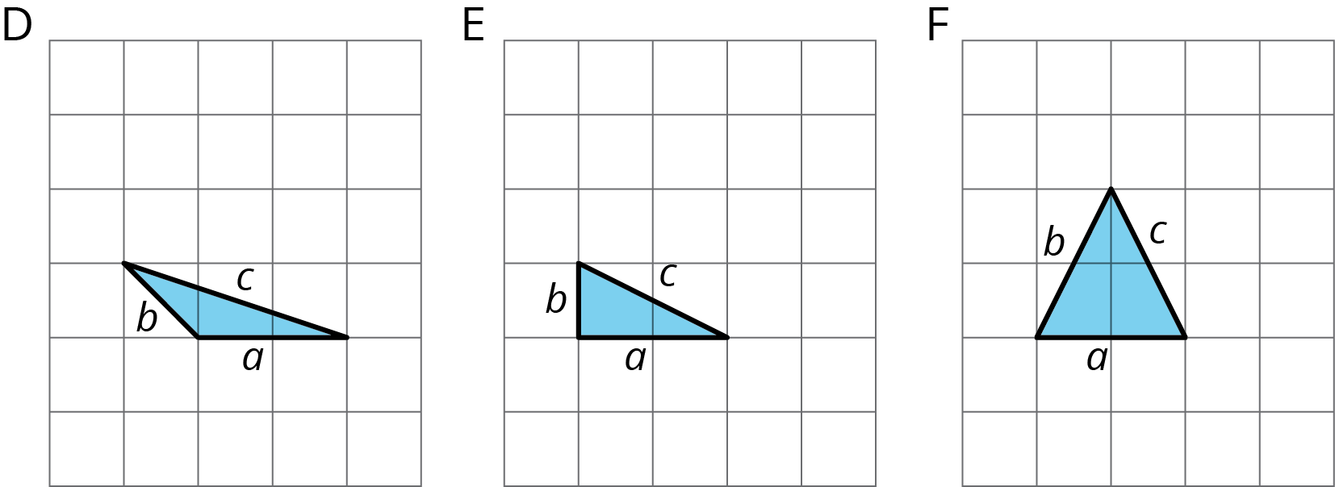
- triangle | - $a$ | - $b$ | - $c$
- D
- E
- F
- triangle | - $a^{2}$ | - $b^{2}$ | - $c^{2}$
- D
- E
- F
- What do you notice about the values in the table for Triangle E but not for Triangles D and F?
- Complete the tables for these three more triangles:
- 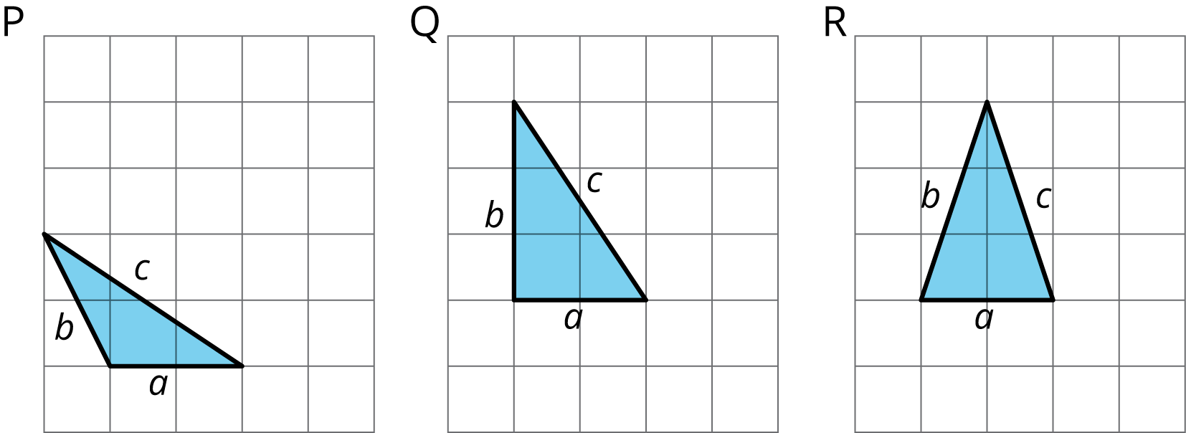
- triangle | - $a$ | - $b$ | - $c$
- P
- Q
- R
- triangle | - $a^{2}$ | - $b^{2}$ | - $c^{2}$
- P
- Q
- R
- What do you notice about the values in the table for Triangle Q but not for Triangles P and R?
- What do Triangle E and Triangle Q have in common?

3 Meet the Pythagorean Theorem

Student Task Statement
- Find the missing side lengths. Be prepared to explain your reasoning.
- For which triangles does $a^{2}+b^{2}=c^{2}$?
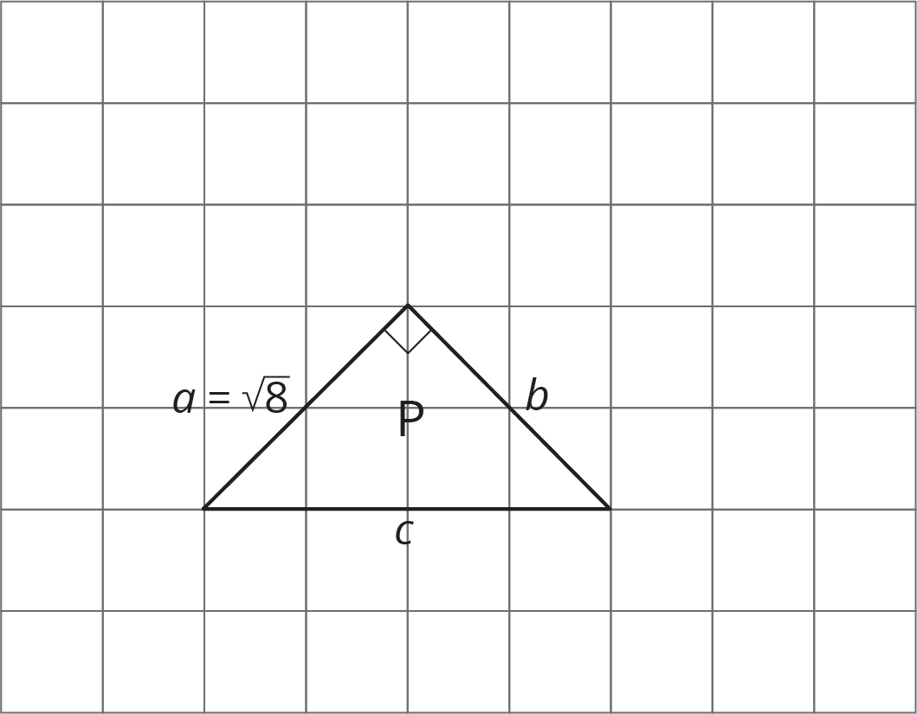

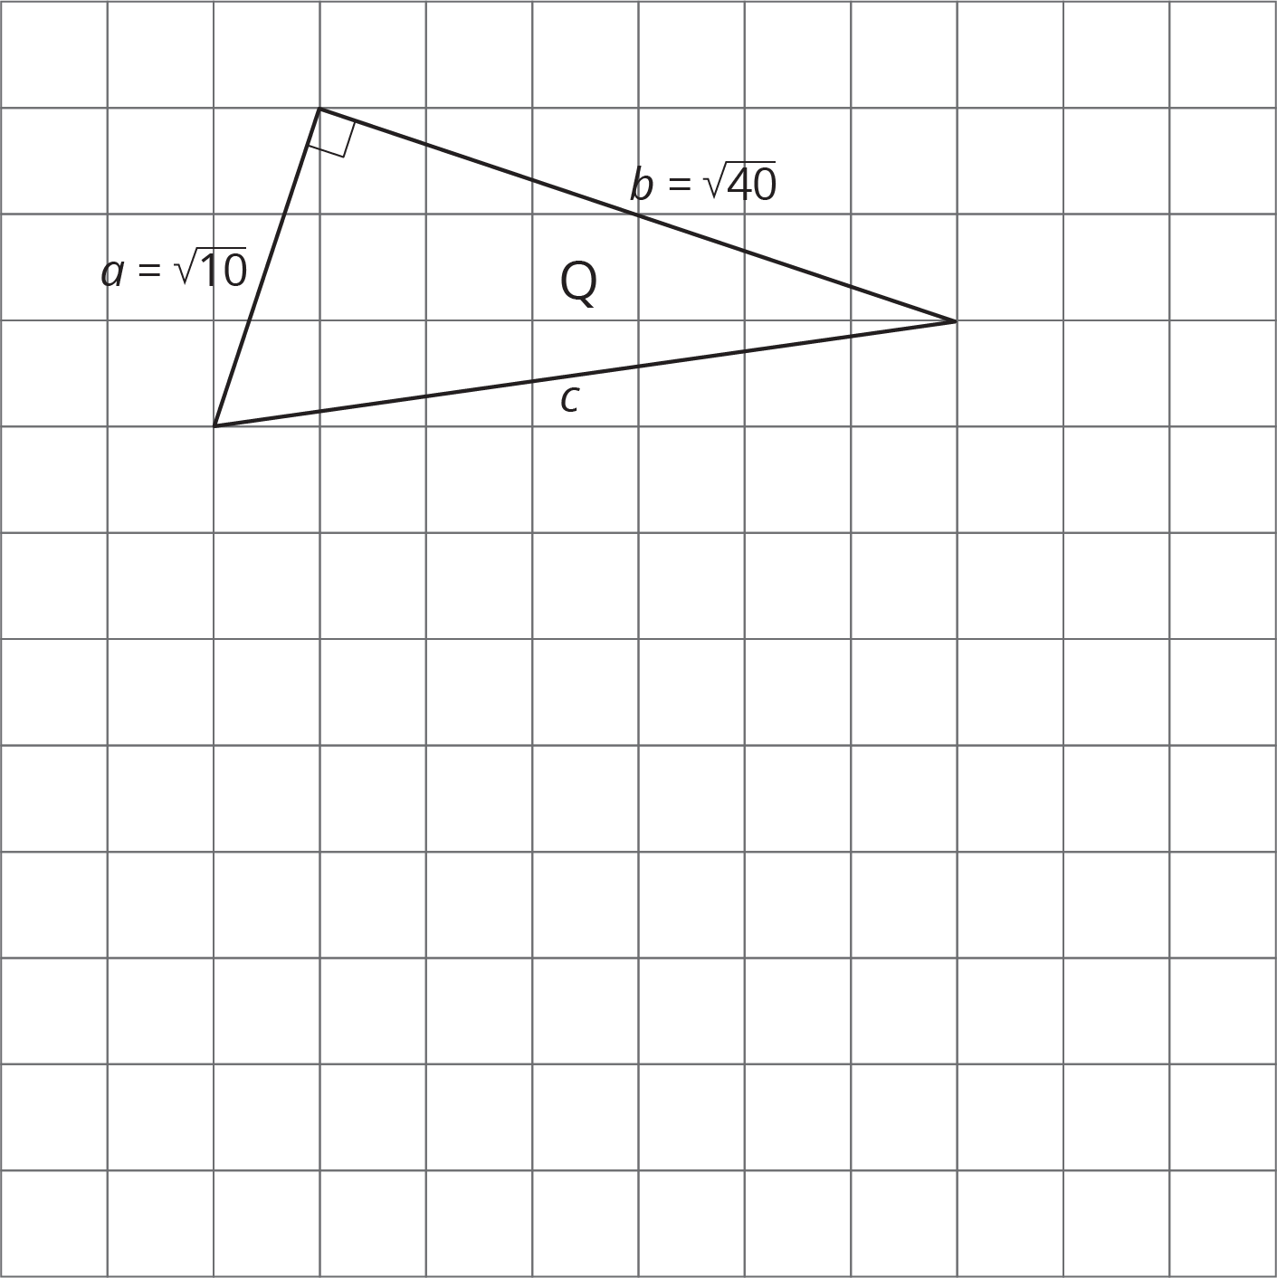

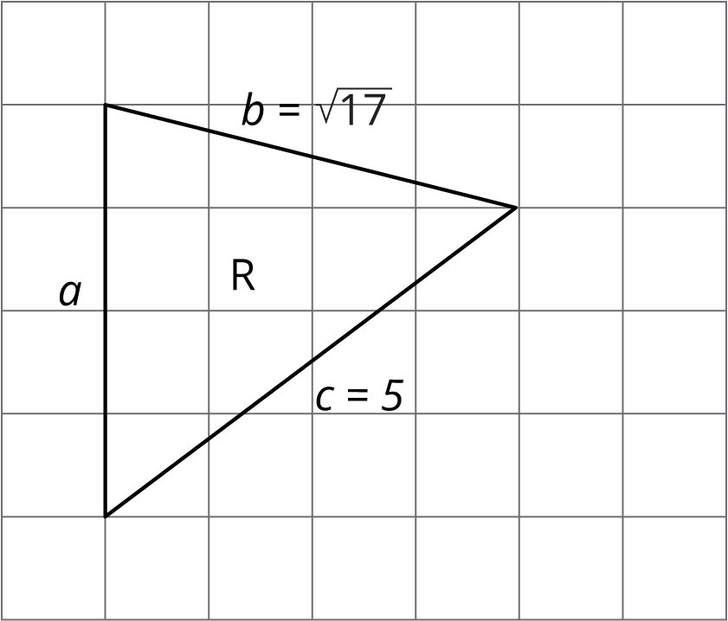
© CC BY Open Up Resources. Adaptations CC BY IM.

