Lesson 16: Horas difíciles

Standards Alignments
Addressing | 1.MD.B.3, 1.NBT.C.4

Teacher-facing Learning Goals
- Relate time to a daily schedule.
- Tell and write time in hours and half hours.

Student-facing Learning Goals
- Mostremos horas en punto y horas y media.

Lesson Purpose
The purpose of this lesson is for students to show and write times in hours and half hours.
In previous lessons, students wrote times based on analog clocks showing time in hours and half hours.
In this lesson, they continue working with telling time from clocks, with special attention to times where students may mix-up the minute and hour hands (for example, 6:30, 12:30, 12:00, 6:00). Students also practice writing times and drawing the hands on the clock as they create their ideal Sunday schedule.
This lesson has a Student Section Summary.

Access for:

Students with Disabilities
- Action and Expression (Activity 3)

English Learners
- MLR8 (Activity 1)

Instructional Routines
Number Talk (Warm-up)

Materials to Gather
- Materials from a previous lesson: Activity 1

Lesson Timeline
Warm-up | 10 min
Activity 1 | 15 min
Activity 2 | 10 min
Activity 3 | 10 min
Lesson Synthesis | 10 min
Cool-down | 5 min

Teacher Reflection Question
Think about a recent time from class when your students were confused. What did you do to support them in reasoning about their confusion together as a community of learners?

Cool-down
(to be completed at the end of the lesson) 5min
Marca la hora

Standards Alignments
Addressing | 1.MD.B.3

Student-facing Task Statement
- Muestra la hora en cada reloj.
- 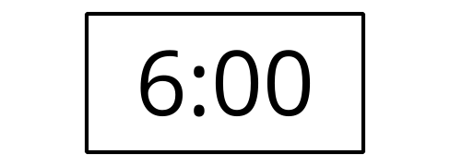
- 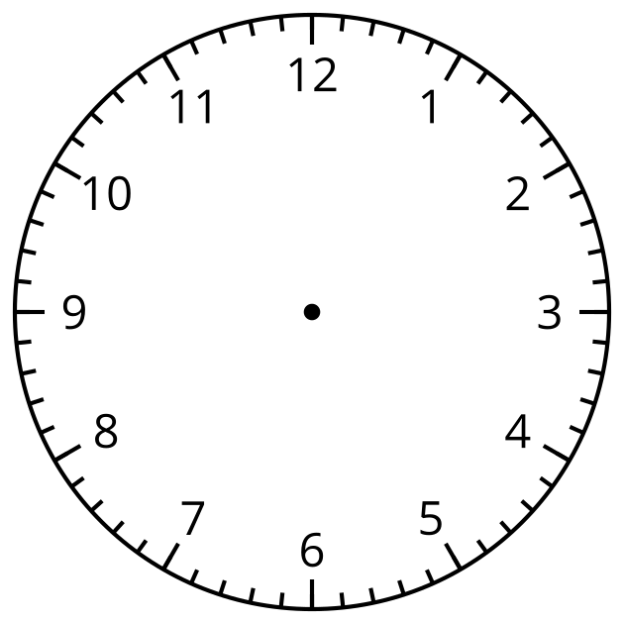
- 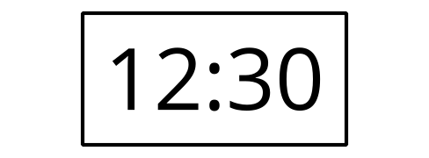
- Escribe la hora.
- 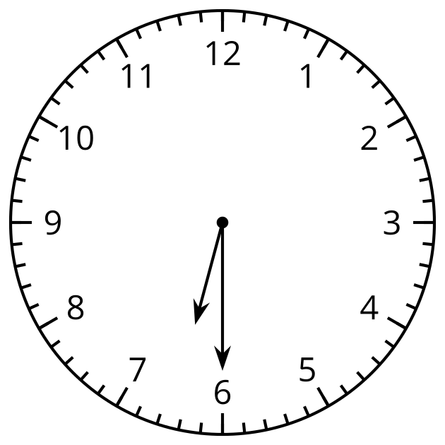

Student Responses
- 6:00, hour hand points to the 6 and minute hand points to the 12.
- 12:30, hour hand points between the 12 and the 1 and the minute hand points to the 6.
- 6:30

