Unit 7 Lesson 6: What about Other Bases?

1 True or False: Comparing Expressions with Exponents (Warm up)

Student Task Statement
Is each statement true or false? Be prepared to explain your reasoning.
- $3^{5}<4^{6}$
- ${\left(\text{-}3\right)}^{2}<3^{2}$
- ${\left(\text{-}3\right)}^{3}=3^{3}$
- ${\left(\text{-}5\right)}^{2}>\text{-}5^{2}$

2 What Happens with Zero and Negative Exponents?

Student Task Statement
Complete the table to show what it means to have an exponent of zero or a negative exponent.
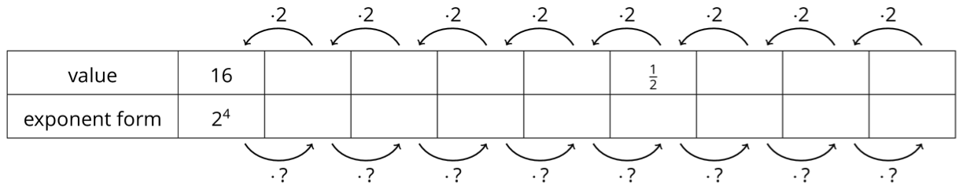
- As you move toward the left, each number is being multiplied by 2. What is the multiplier as you move toward the right?
- Use the patterns you found in the table to write $2^{\text{-}6}$ as a fraction.
- Write $\frac{1}{32}$ as a power of 2 with a single exponent.
- What is the value of $2^{0}$?
- From the work you have done with negative exponents, how would you write $5^{\text{-}3}$ as a fraction?
- How would you write $3^{\text{-}4}$ as a fraction?

3 Exponent Rules with Bases Other than 10

Student Task Statement
Lin, Noah, Diego, and Elena decide to test each other’s knowledge of exponents with bases other than 10. They each chose an expression to start with and then came up with a new list of expressions; some of which are equivalent to the original and some of which are not.
Choose 2 of the 4 lists to analyze. For each list of expressions you choose to analyze, decide which expressions are not equivalent to the original. Be prepared to explain your reasoning.
- Lin’s original expression is $5^{\text{-}9}$ and her list is:
- ${\left(5^{3}\right)}^{\text{-}3}$
- $\text{-}5^{9}$
- $\frac{5^{\text{-}6}}{5^{3}}$
- ${\left(5^{3}\right)}^{\text{-}2}$
- $\frac{5^{\text{-}4}}{5^{\text{-}5}}$
- $5^{\text{-}4}⋅5^{\text{-}5}$
- Noah’s original expression is $3^{10}$ and his list is:
- $3^{5}⋅3^{2}$
- ${\left(3^{5}\right)}^{2}$
- $\left(3⋅3\right)\left(3⋅3\right)\left(3⋅3\right)\left(3⋅3\right)\left(3⋅3\right)$
- ${\left(\frac{1}{3}\right)}^{\text{-}10}$
- $3^{7}⋅3^{3}$
- $\frac{3^{20}}{3^{10}}$
- $\frac{3^{20}}{3^{2}}$
- Diego’s original expression is $x^{4}$ and his list is:
- $\frac{x^{8}}{x^{4}}$
- $x⋅x⋅x⋅x$
- $\frac{x^{\text{-}4}}{x^{\text{-}8}}$
- $\frac{x^{\text{-}4}}{x^{8}}$
- ${\left(x^{2}\right)}^{2}$
- $4⋅x$
- $x⋅x^{3}$
- Elena’s original expression is $8^{0}$ and her list is:
- 1
- 0
- $8^{3}⋅8^{\text{-}3}$
- $\frac{8^{2}}{8^{2}}$
- ${10}^{0}$
- ${11}^{0}$
© CC BY Open Up Resources. Adaptations CC BY IM.

