Lesson 17: Order Towers and Numbers
- Let’s put numbers and cube towers in order from 1–10.

Warm-up: Act It Out: Family Dinner
Han is helping his grandfather set the table for dinner.
Han puts 8 plates on the table.

17.3: Centers: Choice Time
Choose a center.
Math Stories
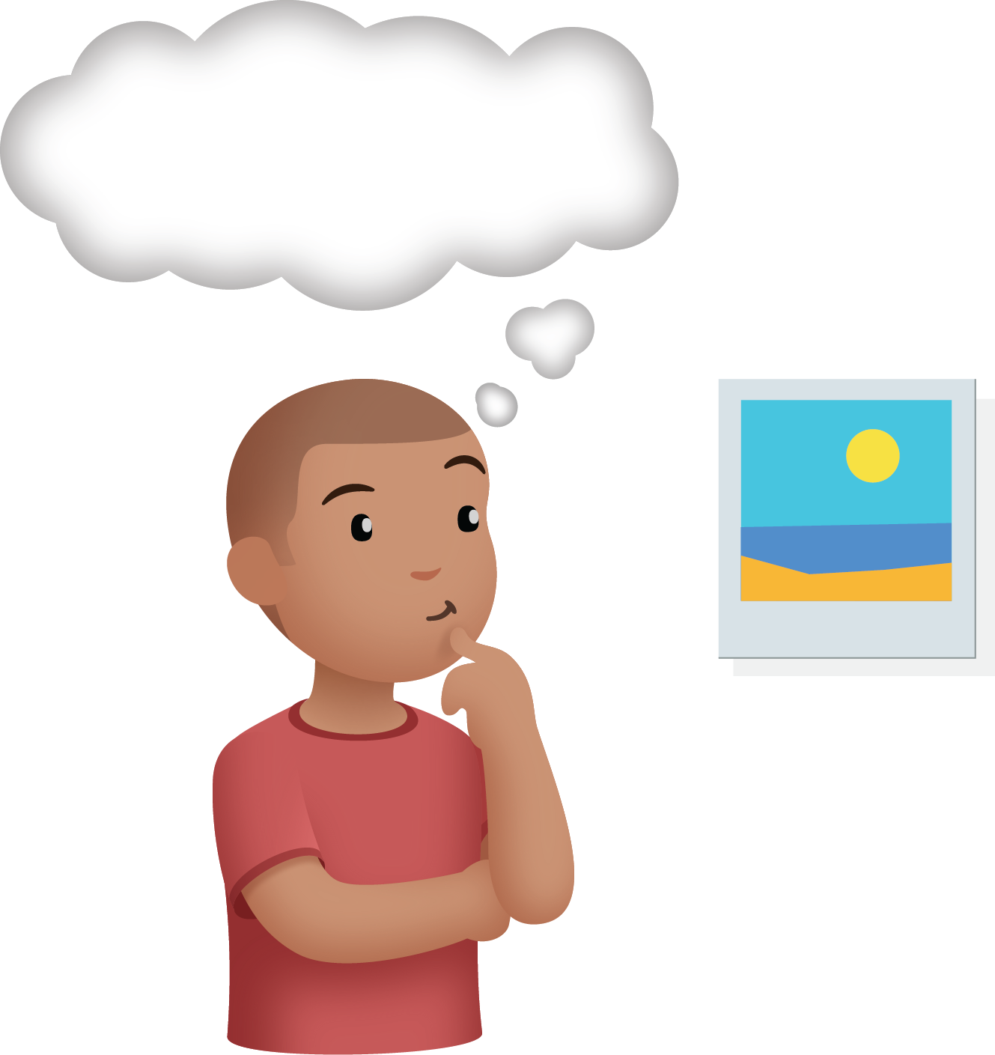
Math Libs
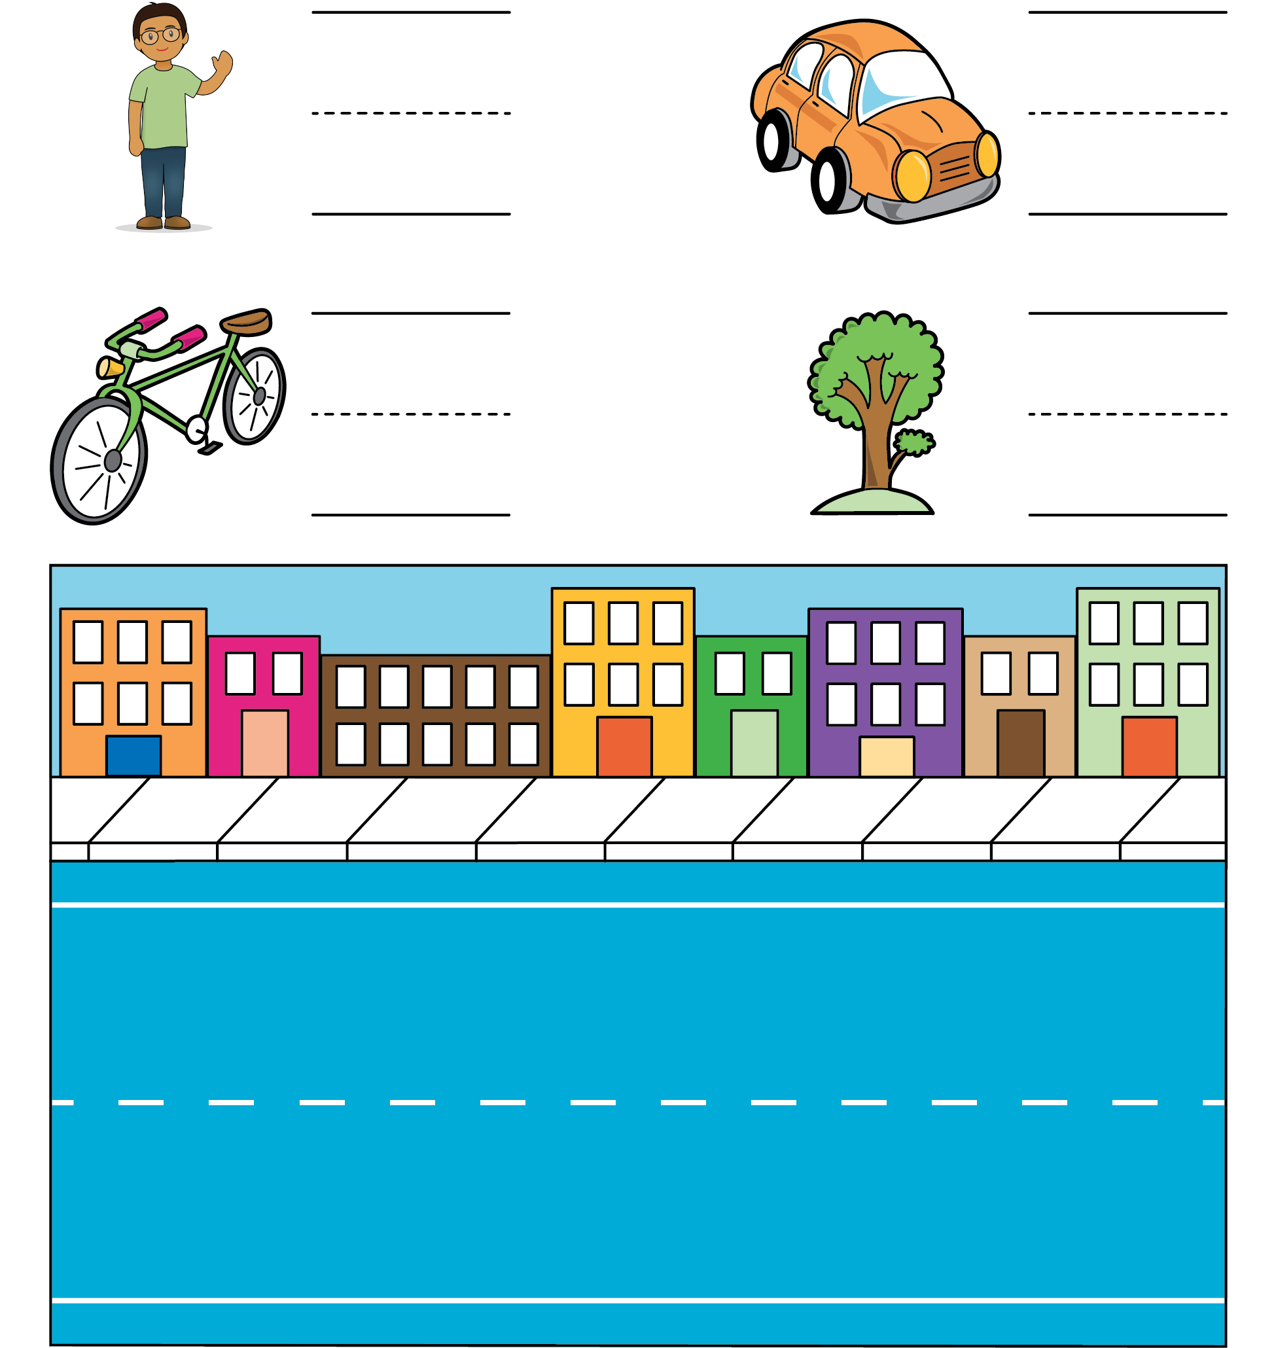
Number Race
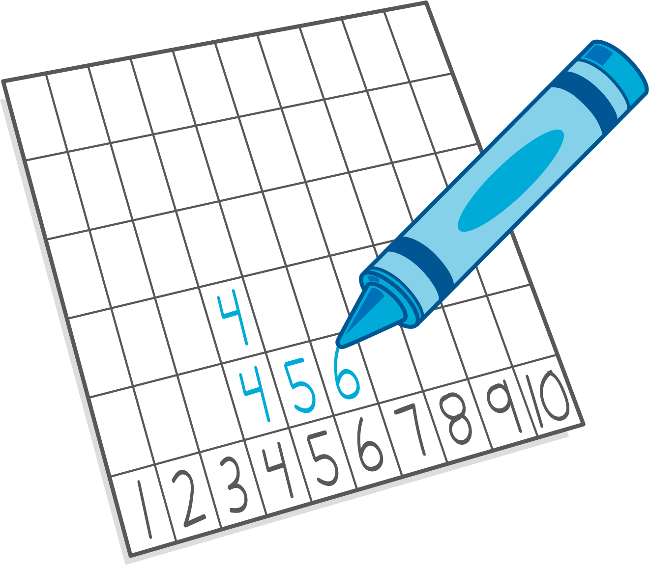
© CC BY 2021 Illustrative Mathematics®

