Unit 6 Lesson 11: Count Images (Part 1)

WU Choral Count: Count to 90 and Count On (Warm up)

Student Task Statement

1 Find 10 Ones to Count

Student Task Statement
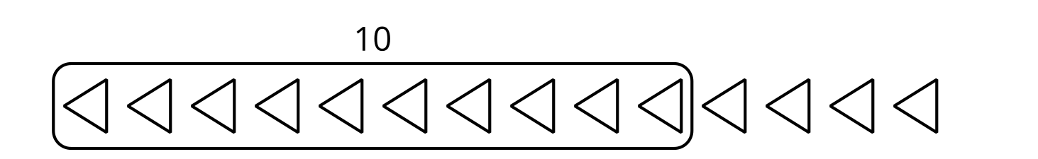

- There are _______________ squares.

- 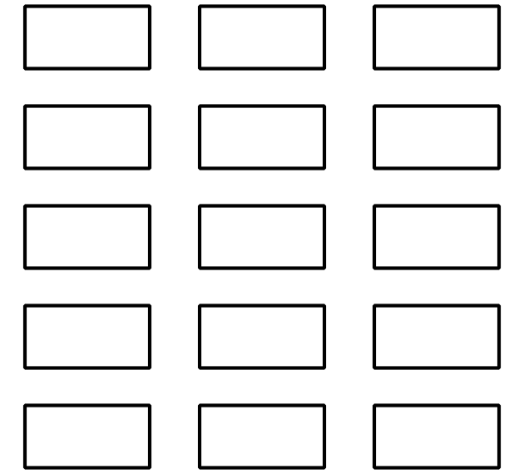
- There are _______________ rectangles.

- 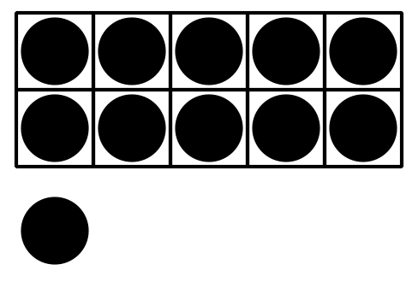
- There are _______________ dots.

- 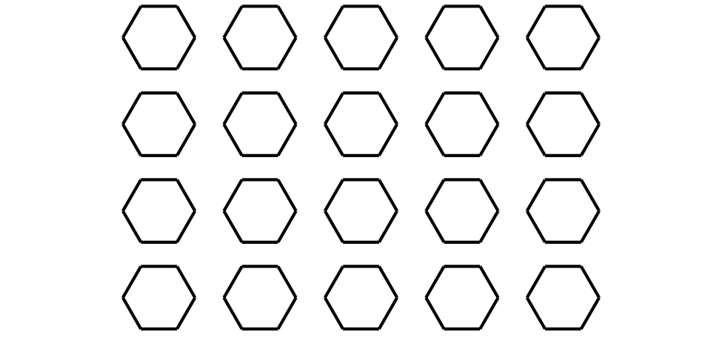
- There are _______________ hexagons.

- 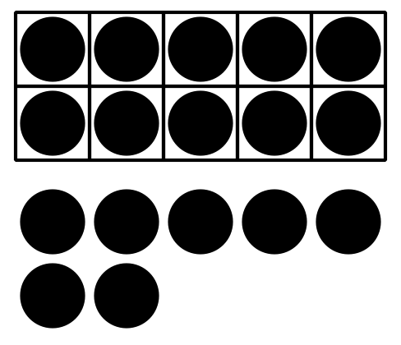
- There are _______________ dots.

- 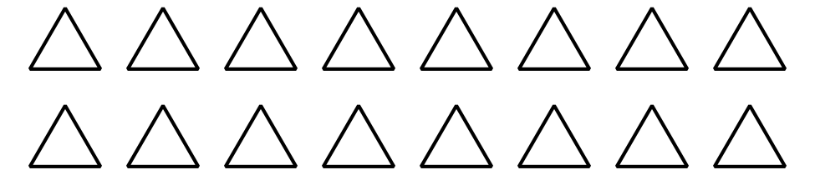
- There are _______________ triangles.

2 Color to Match Expressions

Student Task Statement
- Color the squares to show $10+2$.
- 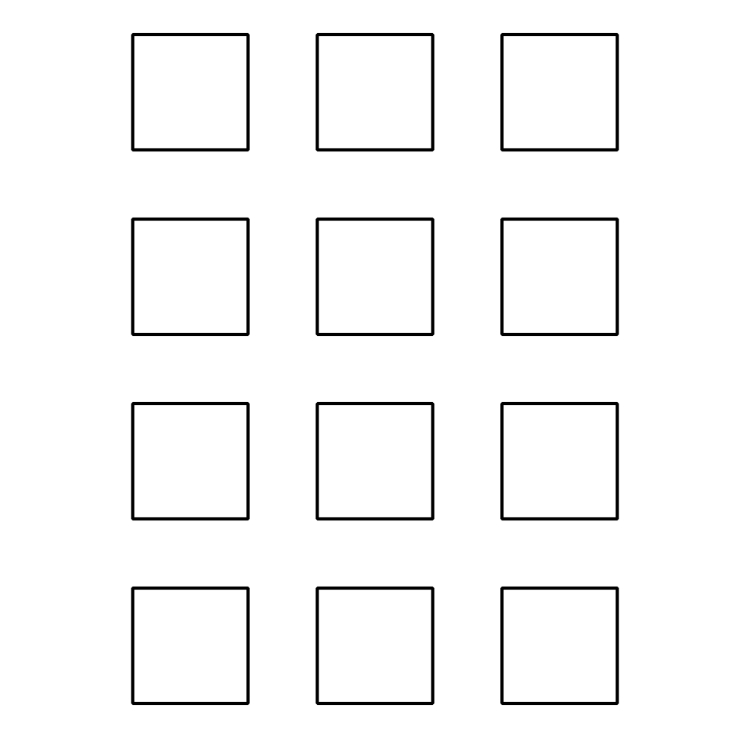
- $10+2=\underset{_}{}$
- Color the triangles to show $10+8$.
- 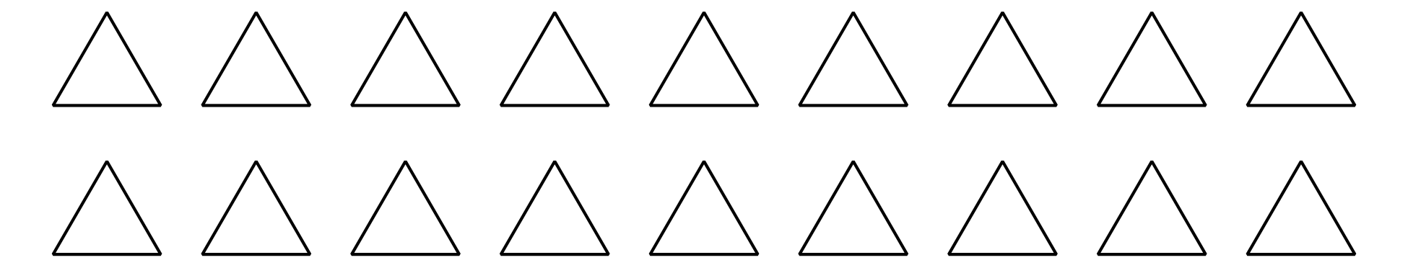
- $10+8=\underset{_}{}$
- Color the hexagons to show $10+4$.
- 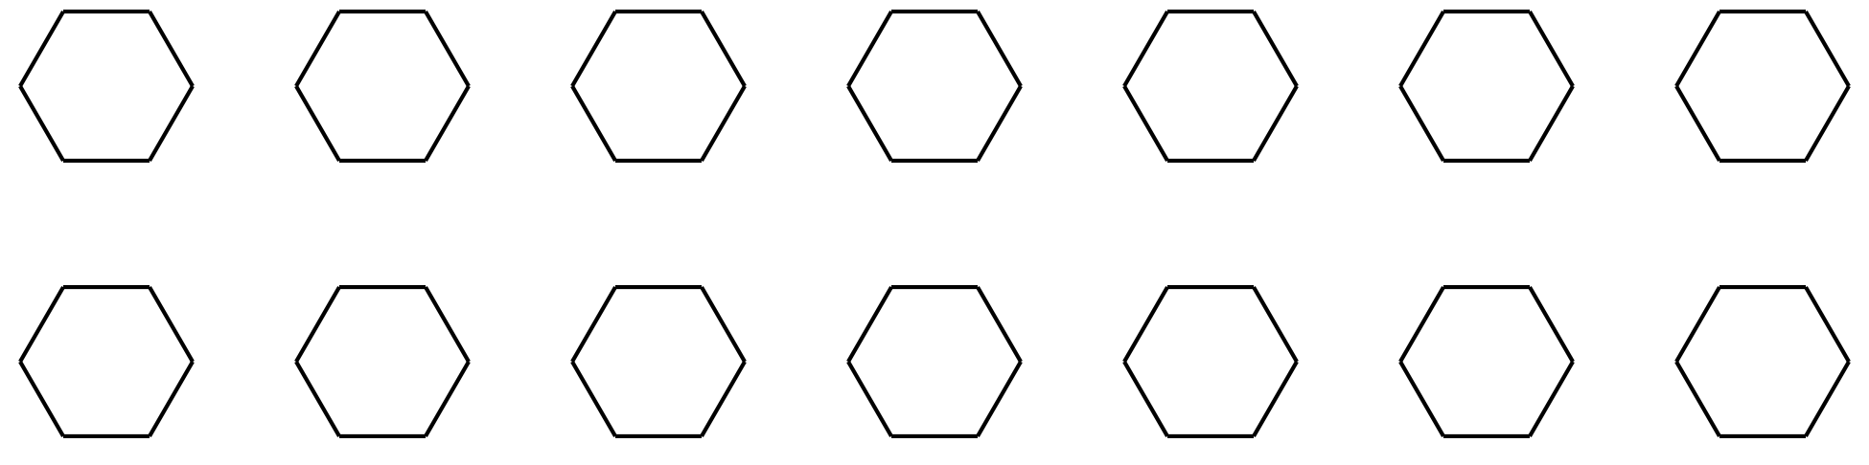
- $10+4=\underset{_}{}$
- Color the circles to show $10+9$.
- 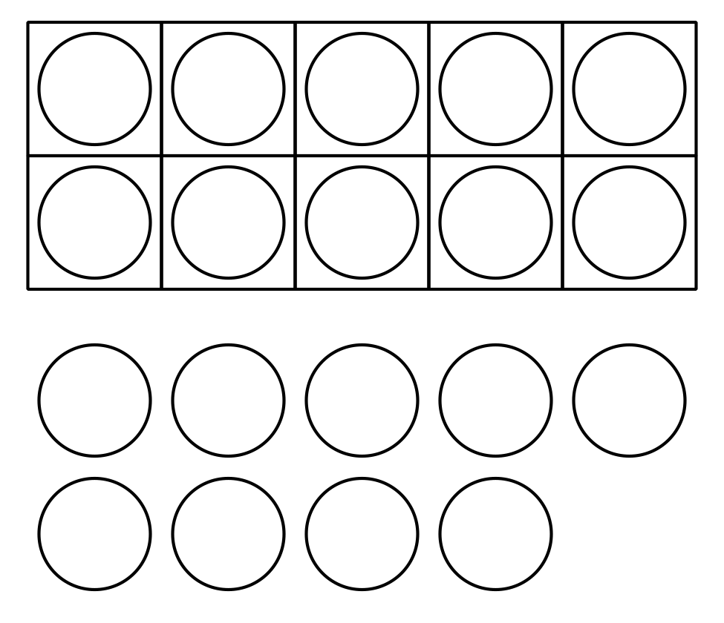
- $10+9=\underset{_}{}$

3 Centers: Choice Time

Student Task Statement
Choose a center.
Find the Value of the Expressions
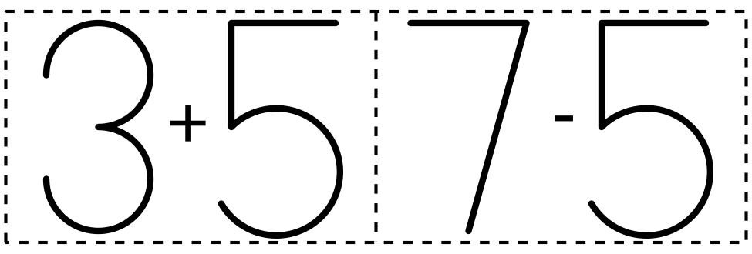
Make or Break Apart Numbers
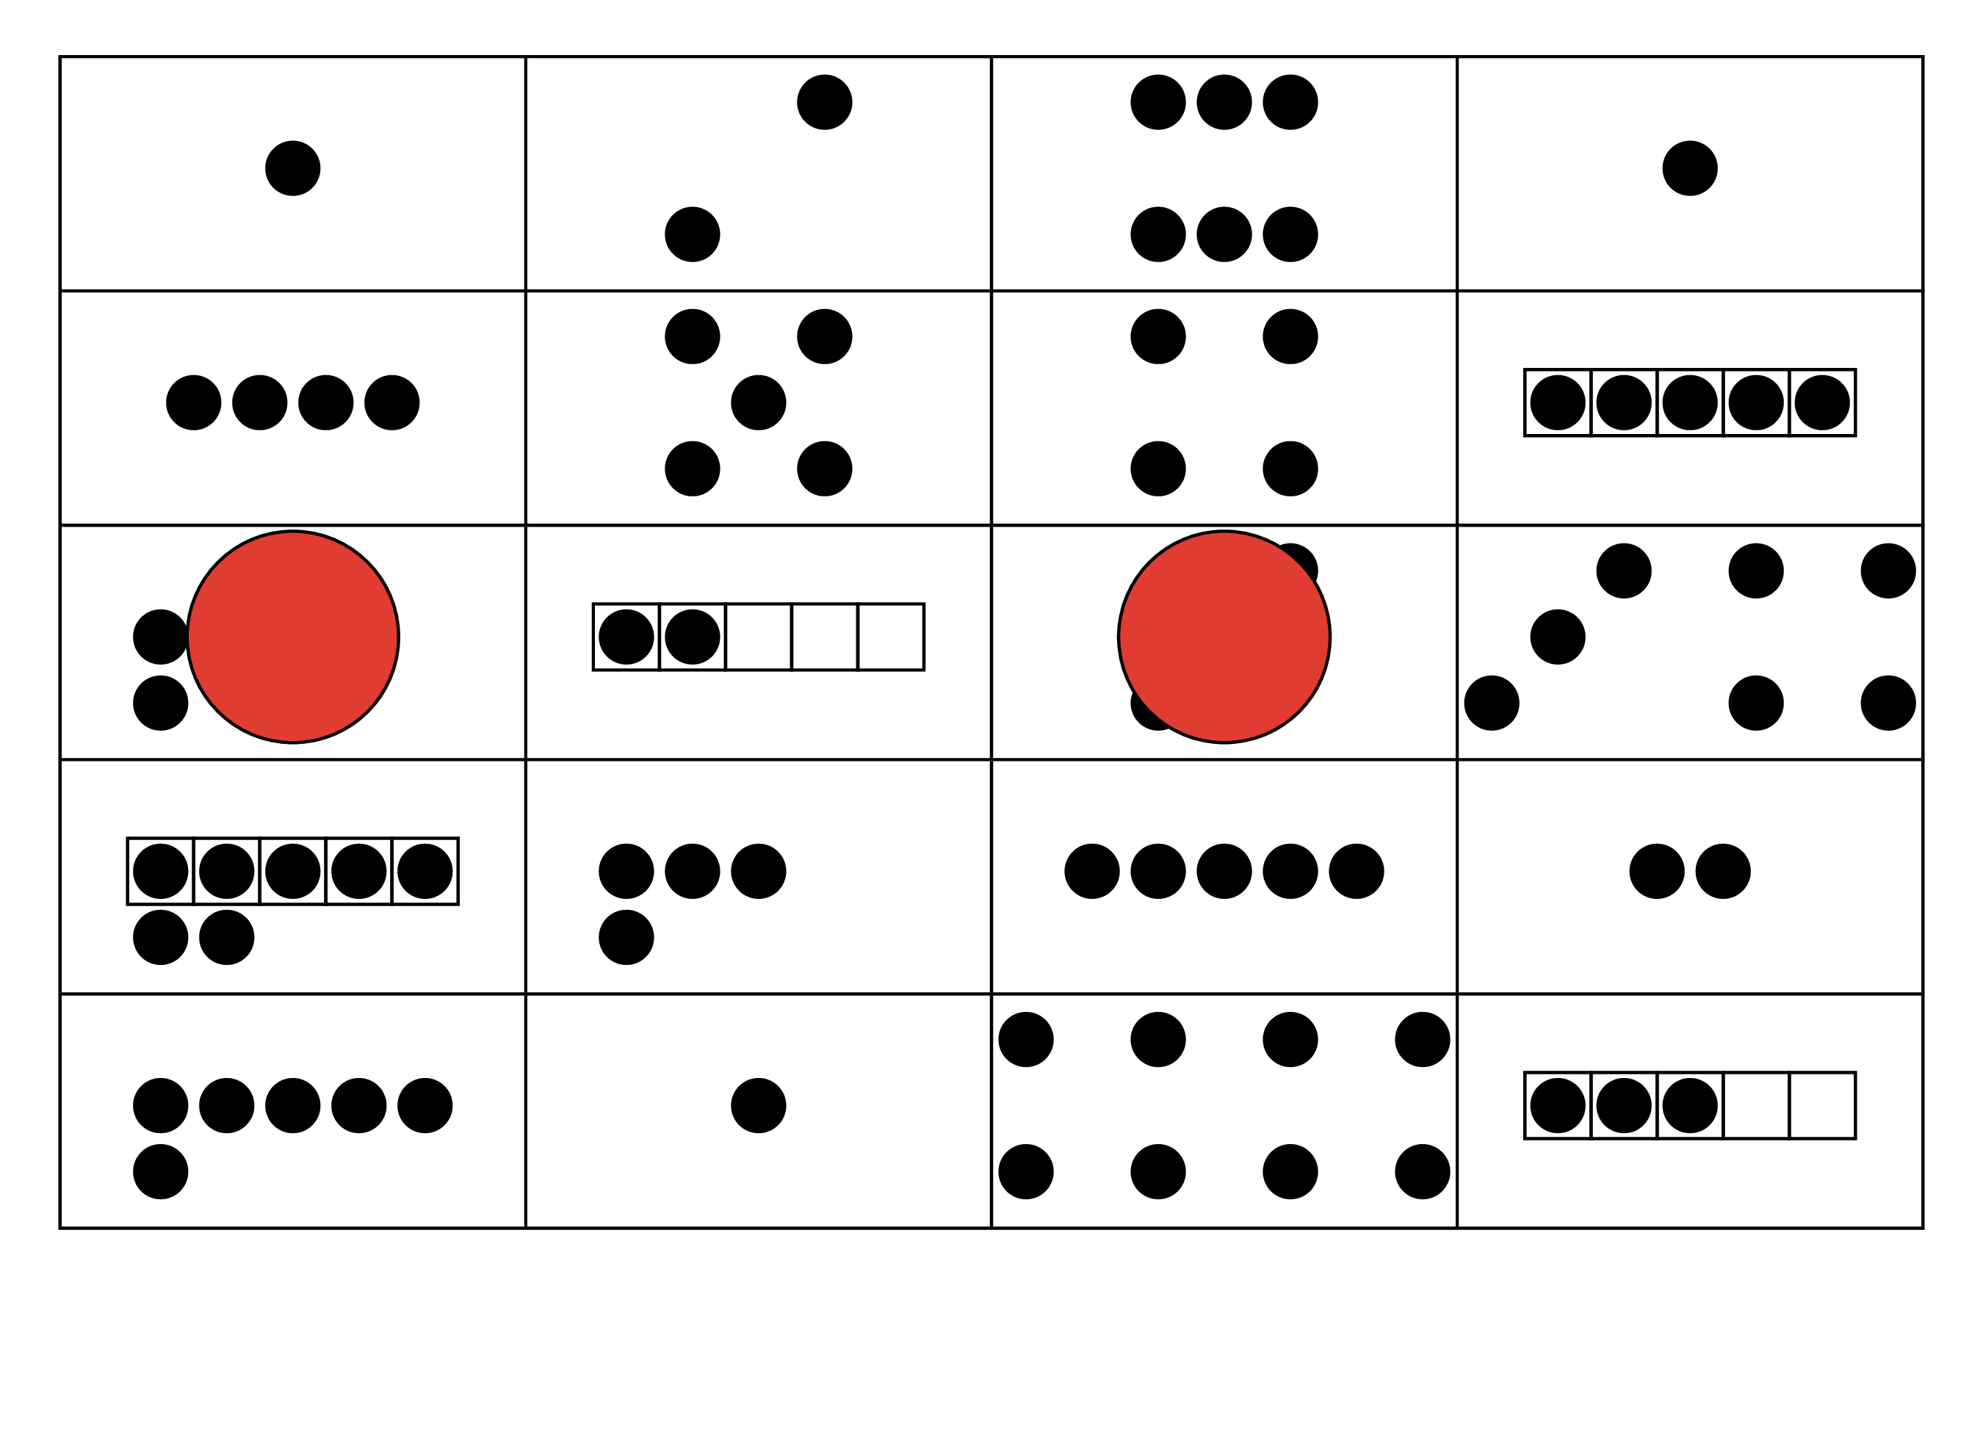
Bingo
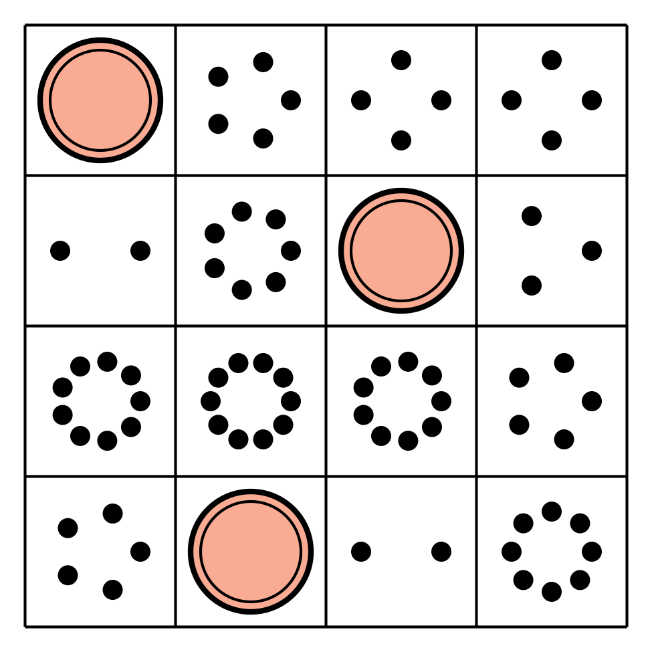
© CC BY 2021 Illustrative Mathematics®

