Lesson 8 Practice Problems
- Technology required. Open a blank spreadsheet. Use "fill down" to recreate this table of equivalent ratios. You should not need to type anything in rows 3–10.
- 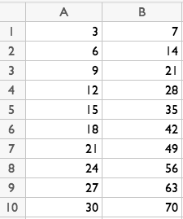
- A list of numbers is made with the pattern: Start with 11, and subtract 4 to find the next number.
- Here is the beginning of the list: 11, 7, 3, . . .
- Explain how you could use "fill down" in a spreadsheet to find the tenth number in this list. (You do not need to actually find this number.)
- Here is a spreadsheet showing the computations for a different version of the birthday trick:
- 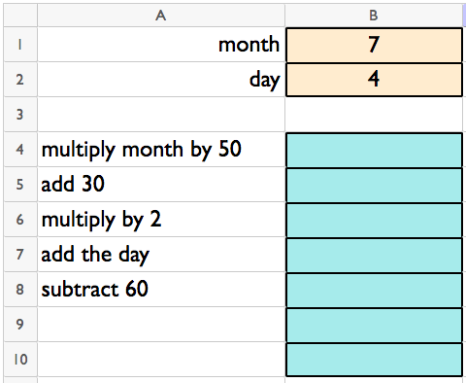
- Explain what formulas you would enter in cells B4 through B8 so that cell B8 shows a number representing the month and day. (In this example, cell B8 should show 704.) If you have access to a spreadsheet, try your formulas with a month and day to see whether it works.
- Write a formula you could type into a spreadsheet to compute the value of each expression.
  - $\frac{2}{5}$ of 35
  - $25÷\frac{5}{3}$
  - ${\left(\frac{1}{11}\right)}^{4}$
  - The average of 0, 3, and 17
- (From Unit 1, Lesson 7.)
- The data set represents the number of cars in a town given a speeding ticket each day for 10 days.
- 2 | - 4 | - 5 | - 5 | - 7 | - 7 | - 8 | - 8
- 8 | - 12

  - What is the median? Interpret this value in the situation.
  - What is the IQR?
- (From Unit 1, Lesson 5.)
- The data set represents the most recent sale price, in thousands of dollars, of ten homes on a street.
- 85 | - 91 | - 93 | - 99 | - 99 | - 99 | - 102 | - 108
- 110 | - 115

  - What is the mean?
  - What is the MAD?
- (From Unit 1, Lesson 5.)
© CC BY 2019 by Illustrative Mathematics®

