Lesson 8: Speaking of Scaling
- Let’s practice moving back and forth between scale factors for lengths, surface areas, and volumes.

8.1: Going Backwards
The image shows a cone that has a base with area $36π$ square centimeters. The cone has been dilated using the top vertex as a center. The area of the dilated cone’s base is $729π$ square centimeters.
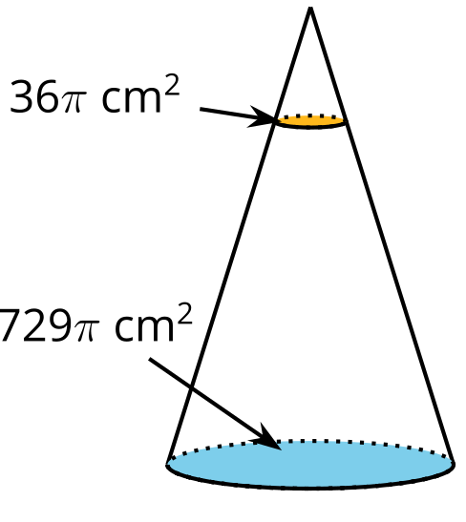
What was the scale factor of the dilation?

8.2: Info Gap: Originals and Dilations
Your teacher will give you either a problem card or a data card. Do not show or read your card to your partner.
If your teacher gives you the data card:
- Silently read the information on your card.
- Ask your partner “What specific information do you need?” and wait for your partner to ask for information. Only give information that is on your card. (Do not figure out anything for your partner!)
- Before telling your partner the information, ask “Why do you need to know (that piece of information)?”
- Read the problem card, and solve the problem independently.
- Share the data card, and discuss your reasoning.
If your teacher gives you the problem card:
- Silently read your card and think about what information you need to answer the question.
- Ask your partner for the specific information that you need.
- Explain to your partner how you are using the information to solve the problem.
- When you have enough information, share the problem card with your partner, and solve the problem independently.
- Read the data card, and discuss your reasoning.

8.3: Jumbo Can
A beverage company manufactures and fills juice cans. They spend $0.04 on materials for each can, and fill each can with $0.27 worth of juice.
The marketing team wants to make a jumbo version of the can that’s a dilated version of the original. They can spend at most $0.16 on materials for the new can. There’s no restriction on how much they can spend on the juice to fill each can. The team wants to make the new can as large as possible given their budget.
- By what factor will the height of the can increase? Explain your reasoning.
- By what factor will the radius of the can increase? Explain your reasoning.
- Create drawings of the original and jumbo cans.
- What geometric solid do the cans resemble? What are some possible differences between the geometric solid and the actual can?
- What will be the total cost for materials and juice fill for the jumbo can? Explain or show your reasoning.
- Describe any other factors that might cause the total cost to be different from your answer.

Are you ready for more?
As of 2019, the Burj Khalifa, located in Dubai, was the tallest building in the world. Suppose a scale model of the Burj Khalifa (without antennae) is 30 inches tall.
- To what scale is this model? You will need to use the internet or another resource to find the actual height of the building.
- How tall would a model of the Eiffel tower be at this scale?

Lesson 8 Summary
Suppose a solid is dilated. If we know the factor by which the surface area or volume scale changed, we can work backwards to find the scale factor of dilation. Then we can use that information to solve problems.
A company sells 10 inch by 10 inch by 14 inch 5-gallon aquariums, but a museum wants to buy a 135-gallon aquarium with the same shape. The company needs to know the dimensions of the new tank and by what factor the surface area will change.
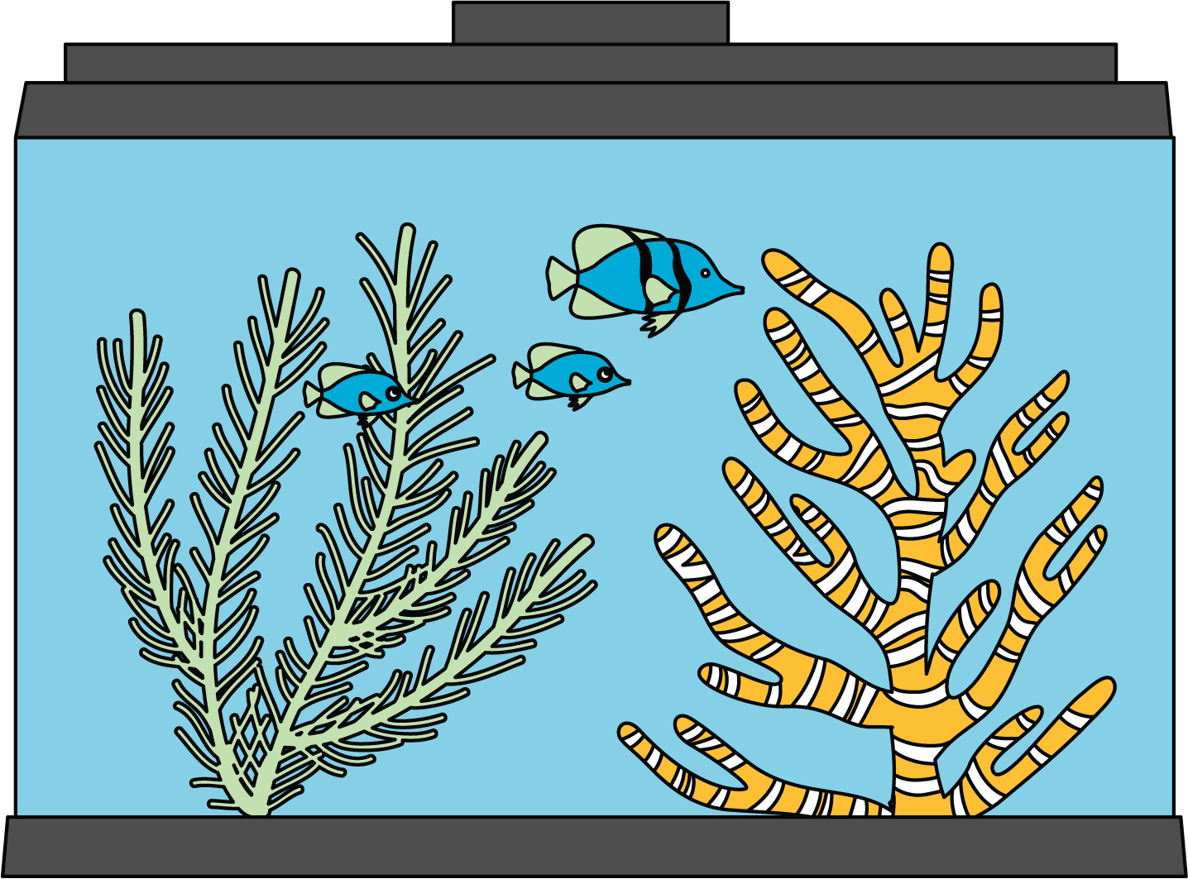
Gallons are a measure of volume. So, the volume of the tank increases by a factor of $135÷5=27$. To find the scale factor for the dimensions of the tank, calculate the cube root of 27, or 3. This tells us that the height, length, and width of the tank will each be multiplied by 3. Next, we can square the scale factor of 3 to find that the tank’s surface area will increase by a factor of 3² = 9.
 | original aquarium | dilated aquarium
height (inches) | 10 | $10⋅3=30$
length (inches) | 14 | $14⋅3=42$
width (inches) | 10 | $10⋅3=30$
surface area (square inches) | 760 | $760⋅9=6,​840$
volume (gallons) | 5 | $5⋅27=135$
© CC BY 2019 by Illustrative Mathematics®

