Unit 4 Lesson 12: An Algorithm Using Partial Quotients

WU Notice and Wonder: Incomplete Solution (Warm up)

Student Task Statement
What do you notice? What do you wonder?
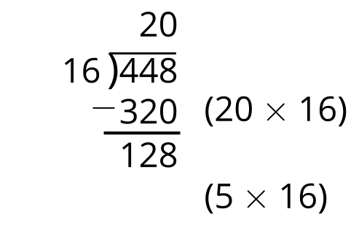

1 Elena’s Work

Student Task Statement
- Find the value of $448÷16$. Show your thinking. Organize it so it can be followed by others.
- (Pause for teacher directions.)
- This is Elena’s work. Describe the steps Elena took to find the value of $448÷16$.
- 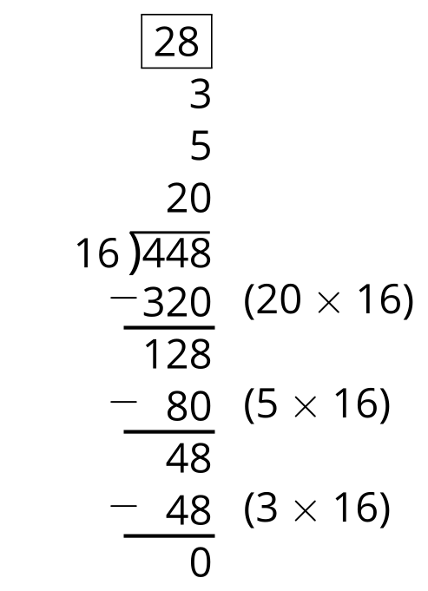

2 Complete the Solution

Student Task Statement
Use Elena’s strategy to complete the following problems:
1.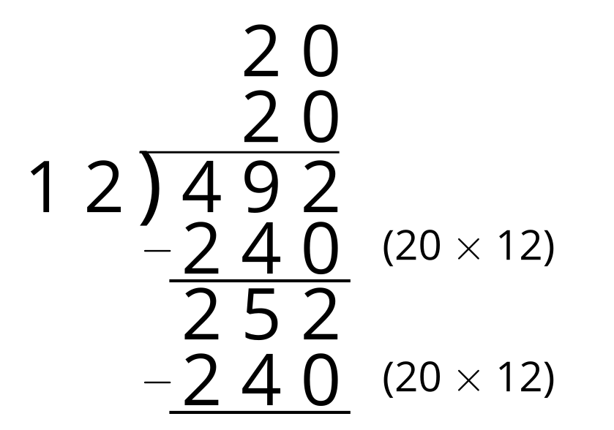
2.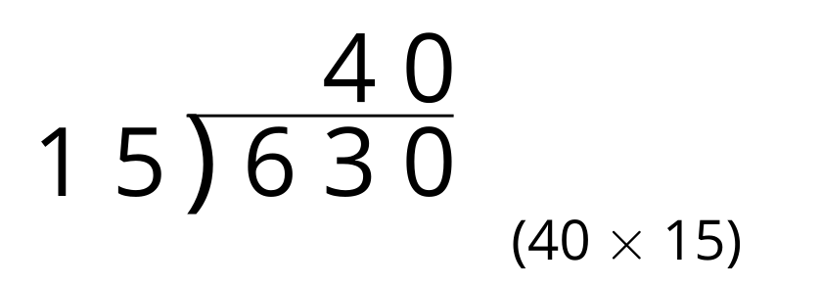
3.
© CC BY 2021 Illustrative Mathematics®

