Lesson 4: Use Layers to Determine Volume

Standards Alignments
Addressing | 5.MD.C.5.a, 5.OA.A.2
Building Towards | 5.MD.C.5.a

Teacher-facing Learning Goals
- Describe and represent the volume of a rectangular prism as the product of the number of cubes in one layer and the number of layers.
- Write and interpret expressions and equations in the context of the volume of rectangular prisms.

Student-facing Learning Goals
- Let's relate multiplication to how we use layers to find volume.

Lesson Purpose
The purpose of this lesson is for students to apply their understanding of the layered structure of rectangular prisms to find the volume of a prism when they cannot see all of the cubes.
In previous lessons, students used the layered structure to determine the volume of rectangular prisms that were filled with cubes. The purpose of this lesson is to extend their understanding of the structure of rectangular prisms by conceptualizing a base layer in a rectangular prism and utilizing it to find the volume in a fully- or partially-filled prism. Students connect the layered structure to multiplication when they write and interpret expression that represent the volume of rectangular prisms (MP2, MP7). This is a conceptual way for students to make sense of the associative property of multiplication. Students do not, however, need to name or identify the property.
This lesson has a Student Section Summary.

Access for:

Students with Disabilities
- Action and Expression (Activity 1)

English Learners
- MLR7 (Activity 2)

Instructional Routines
Estimation Exploration (Warm-up)

Materials to Gather
- Connecting cubes: Activity 1, Activity 2

Lesson Timeline
Warm-up | 10 min
Activity 1 | 20 min
Activity 2 | 15 min
Lesson Synthesis | 10 min
Cool-down | 5 min

Teacher Reflection Question
In the upcoming section, students will connect multiplying the area of the base and the height to multiplying all three edge lengths when finding volume. Based on this lesson, what understandings do your students now have that will allow them to make that connection?

Cool-down
(to be completed at the end of the lesson) 5min
Use Expressions

Standards Alignments
Addressing | 5.MD.C.5.a

Student-facing Task Statement
- If the rectangular prism was filled completely, how many cubes could it hold?
- 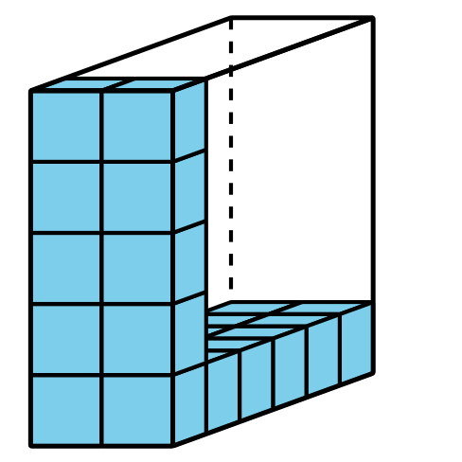
- Explain or show how the expression $3×8$ represents the volume of the prism.
- 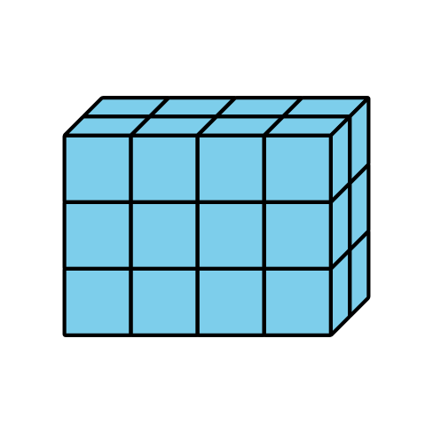

Student Responses
- The volume is 60 cubes.
- One of the layers has 8 cubes in it and there are 3 of those layers.

