Unit 6 Lesson 7: Building Quadratic Functions to Describe Situations (Part 3)

1 Which One Doesn’t Belong: Graphs of Four Functions (Warm up)

Student Task Statement
Which one doesn’t belong?

A
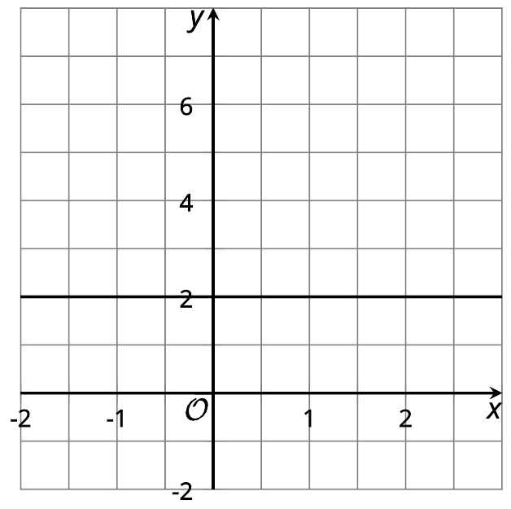

B
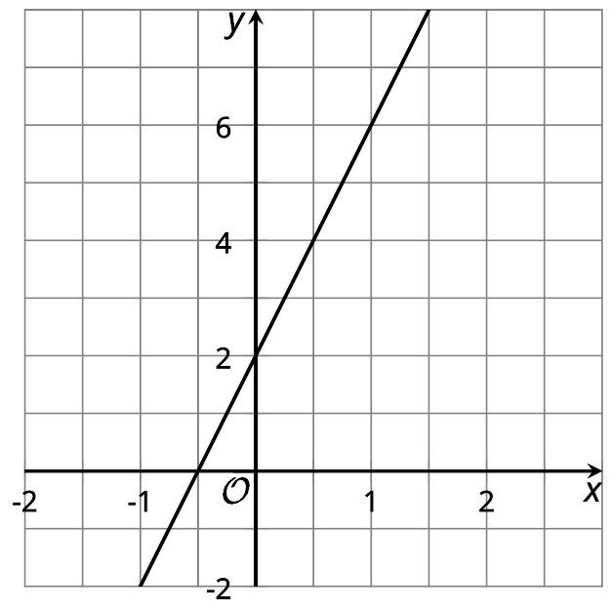

C
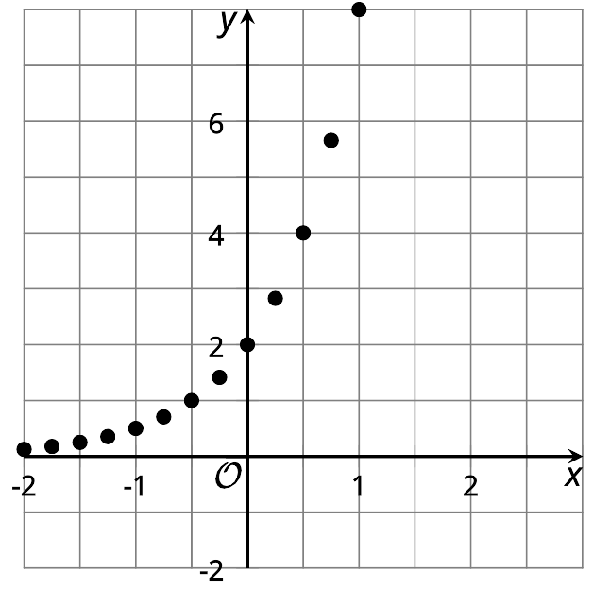

D
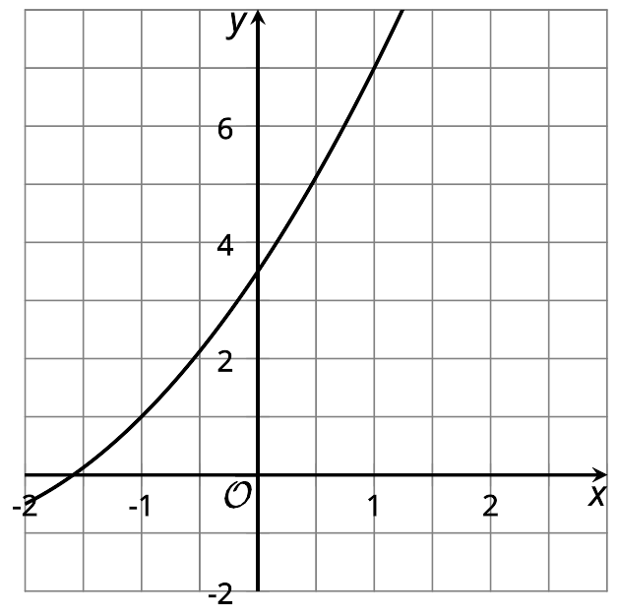

2 What Price to Charge?

Student Task Statement
A company that sells movies online is deciding how much to charge customers to download a new movie. Based on data from previous sales, the company predicts that if they charge $x$ dollars for each download, then the number of downloads, in thousands, is $18−x$.
- Complete the table to show the predicted number of downloads at each listed price. Then, find the revenue at each price. The first row has been completed for you.
- price (dollars per download) | - number of downloads (thousands) | - revenue (thousands of dollars)
- 3 | - 15 | - 45
- 5
- 10
- 12
- 15
- 18
- $x$
- Is the relationship between the price of the movie and the revenue (in thousands of dollars) quadratic? Explain how you know.
- Plot the points that represent the revenue, $r$, as a function of the price of one download in dollars, $x$.
- 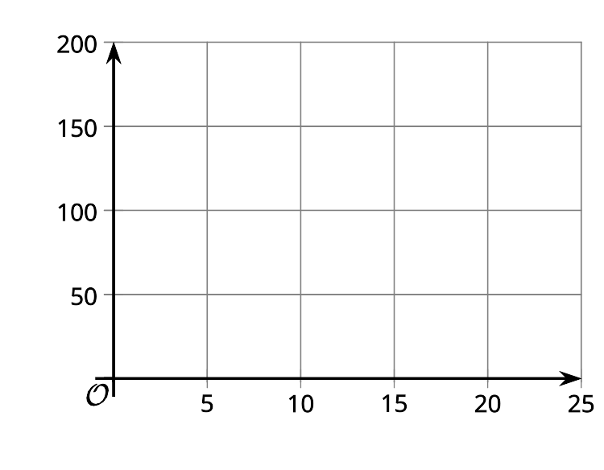
- What price would you recommend the company charge for a new movie? Explain your reasoning.

3 Domain, Vertex, and Zeros

Images for Launch
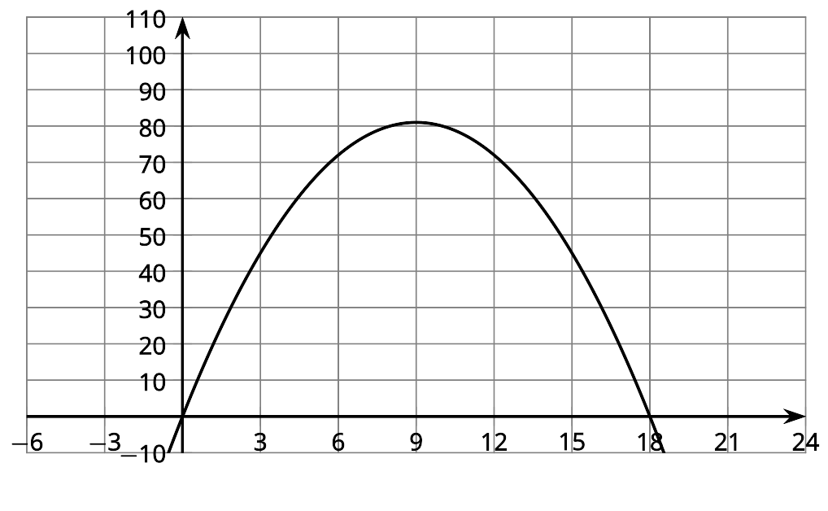

Student Task Statement
Here are 4 sets of descriptions and equations that represent some familiar quadratic functions. The graphs show what a graphing technology may produce when the equations are graphed. For each function:
- Describe a domain that is appropriate for the situation. Think about any upper or lower limits for the input, as well as whether all numbers make sense as the input. Then, describe how the graph should be modified to show the domain that makes sense.
- Identify or estimate the vertex on the graph. Describe what it means in the situation.
- Identify or estimate the zeros of the function. Describe what it means in the situation.
1. The area of rectangle with a perimeter of 25 meters and a side length $x$: $A(x)=x⋅\frac{(25−2x)}{2}$
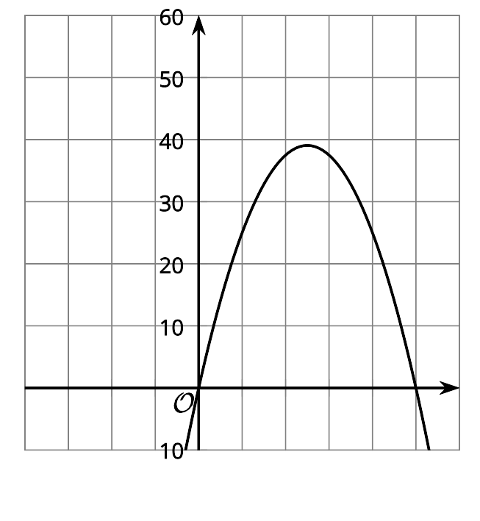
- Domain:
- Vertex:
- Zeros:
2. The number of squares as a function of step number $n$: $f(n)=n^{2}+4$
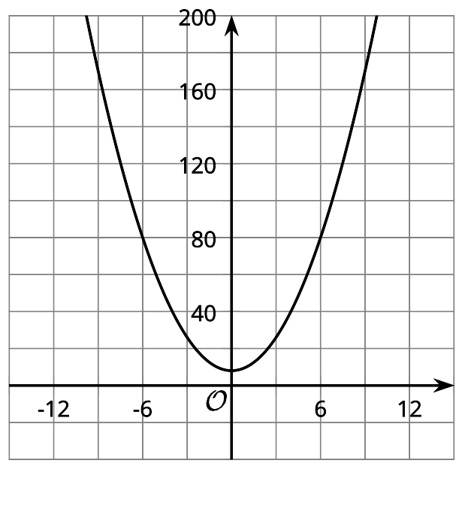
- Domain:
- Vertex:
- Zeros:​​​
3. The distance in feet that an object has fallen $t$ seconds after being dropped: $g(t)=16t^{2}$
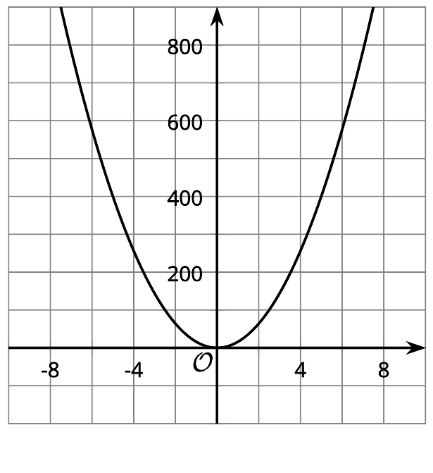
- Domain:
- Vertex:
- Zeros:
4. The height in feet of an object $t$ seconds after being dropped: $h(t)=576−16t^{2}$
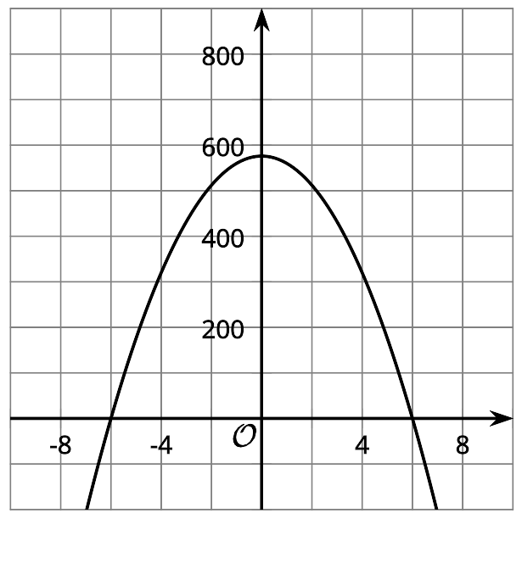
- Domain:
- Vertex:
- Zeros:

Activity Synthesis
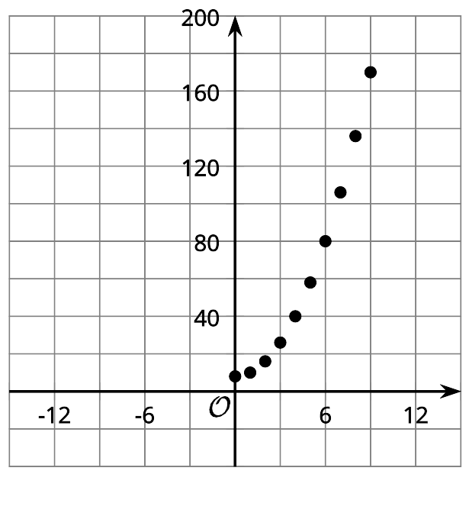
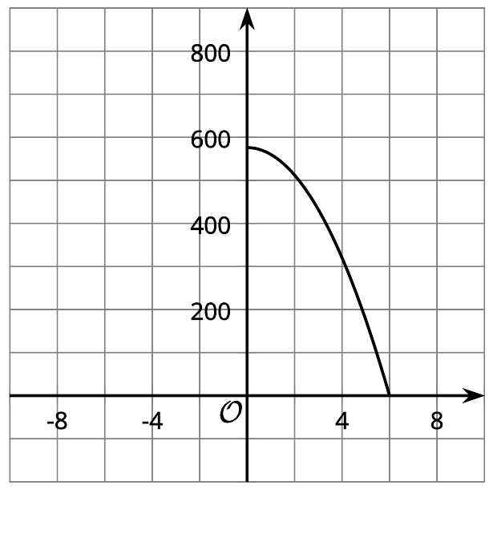
© CC BY 2019 by Illustrative Mathematics

