Unit 7 Lesson 1: What Attributes Do You See?

WU Which One Doesn’t Belong: Who’s in the Group? (Warm up)

Student Task Statement
Which one doesn’t belong?
A
B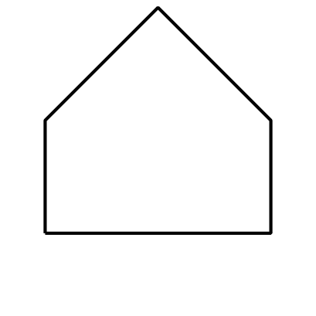
C
D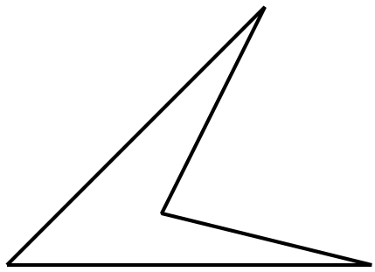

1 Card Sort: Shapes

Student Task Statement
Your teacher will give you a set of cards that show shapes.
- Work with your partner to sort the cards into categories. Be prepared to explain your categories.
- Take turns sorting the cards into two new categories. Don’t tell your partner how you sorted them. Your partner will then guess how you sorted your shapes.
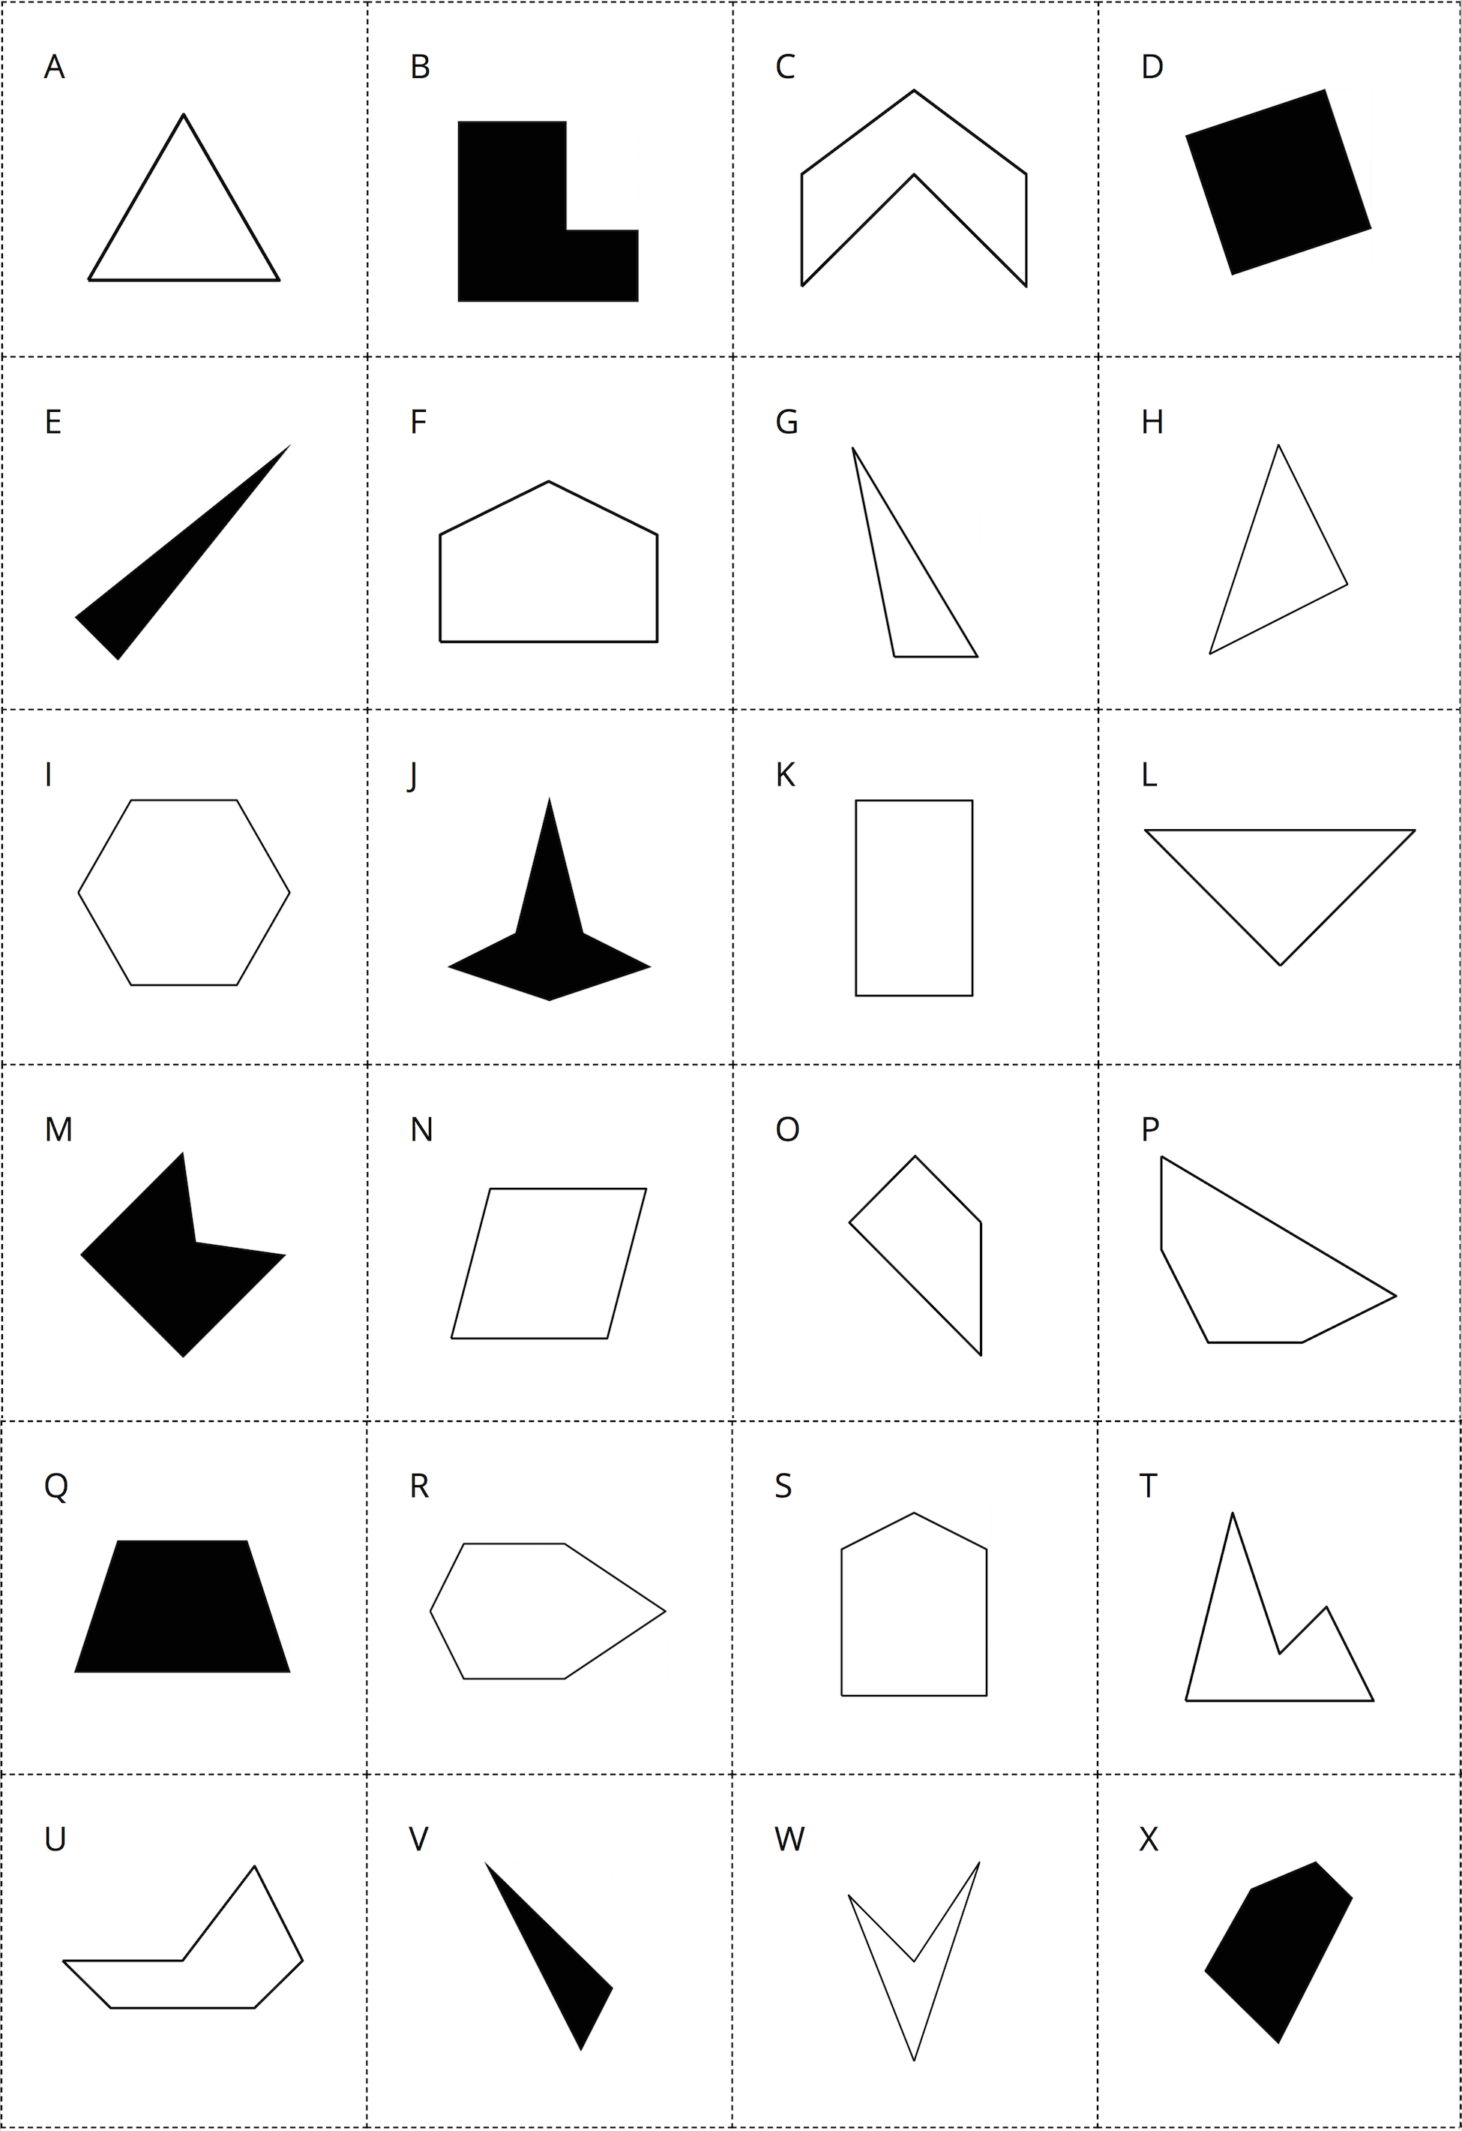
© CC BY 2021 Illustrative Mathematics®

