Unit 6 Lesson 11: Solve Problems Involving Time (Part 2)

WU Notice and Wonder: Band Practice (Warm up)

Student Task Statement
What do you notice? What do you wonder?
Han ate his dinner before he caught a bus.
When he got off the bus, he had to hurry to get to band practice on time.
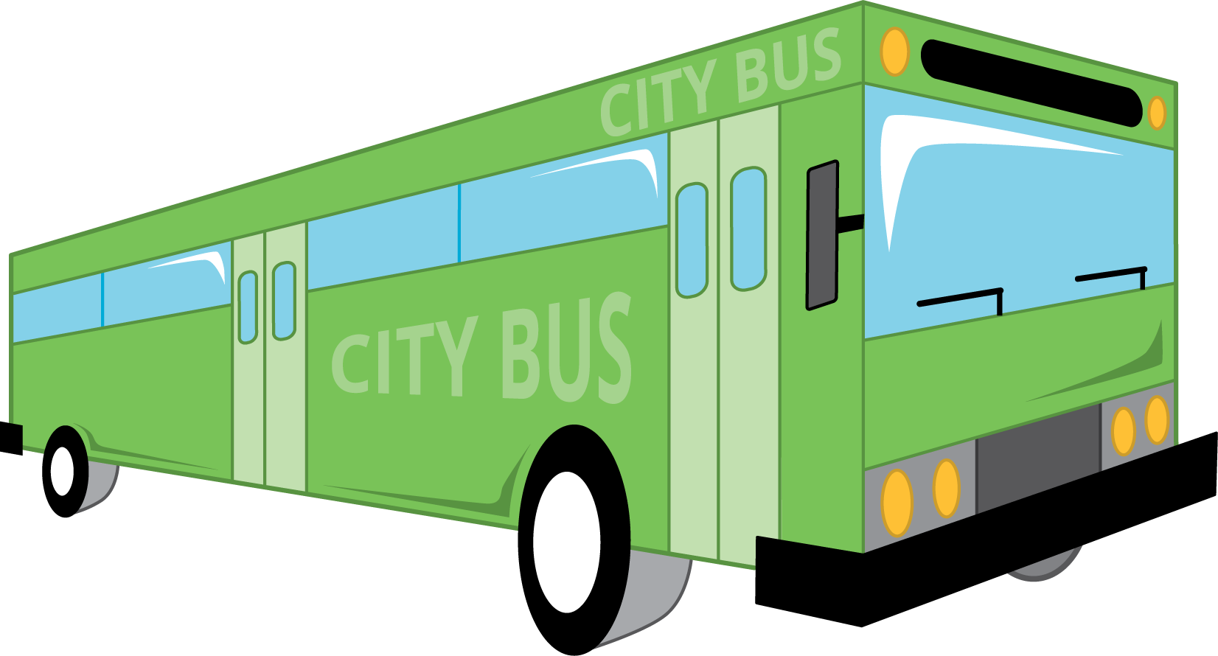

1 On the Bus Again

Student Task Statement
- For how many minutes was Han on the bus? Explain or show your reasoning.
- the time Han got on the bus:
- 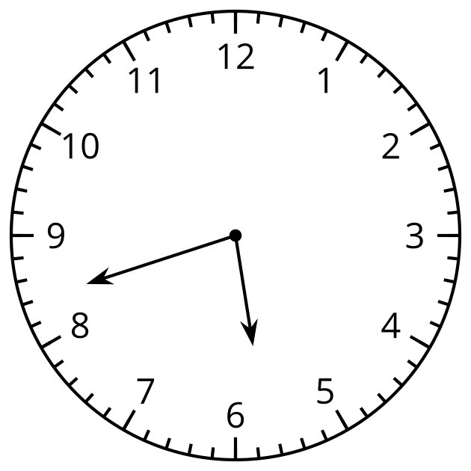
- the time Han got off the bus:
- 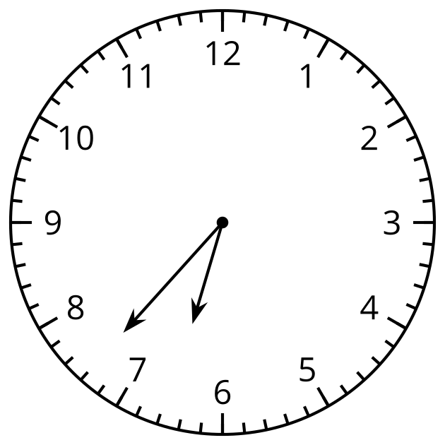
- Draw the minute hand to show that Elena waited for the bus for 32 minutes.
- the time Elena started waiting:
- 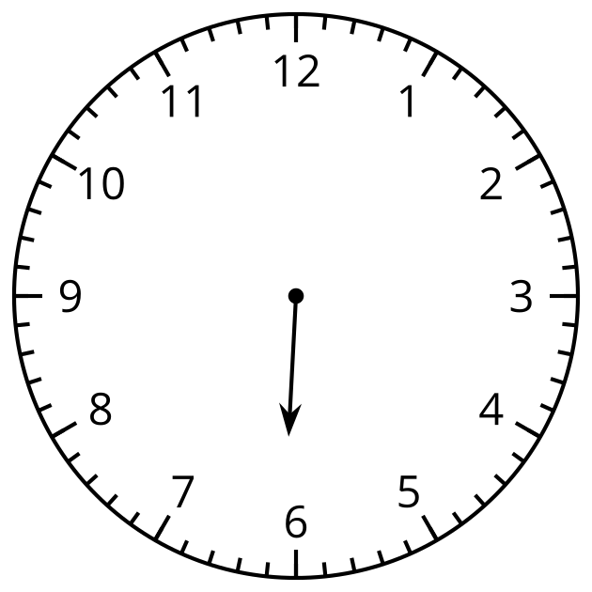
- the time Elena got on the bus:
- 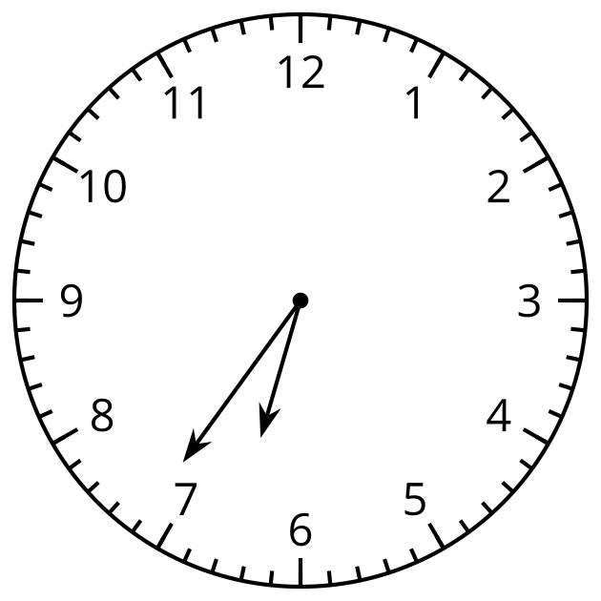

2 Math Libs Time

Student Task Statement
For each problem, fill in a name and an activity, and then solve the problem. Show your thinking. Organize it so it can be followed by others.
- $\underset{_}{}$ started $\underset{_}{}$ at 8:25 a.m. and finished at 8:50 a.m. How much time was spent doing that activity?
- $\underset{_}{}$ finished $\underset{_}{}$ at 5:38 p.m, after spending 20 minutes. What was the start time?
- $\underset{_}{}$ started $\underset{_}{}$ at 10:45 a.m. and finished at 11:18 a.m. How much time was spent on it?
- $\underset{_}{}$ started $\underset{_}{}$ at 3:30 p.m and took 45 minutes to complete it. What was the finish time?
© CC BY 2021 Illustrative Mathematics®

