Lesson 2 Practice Problems
- In 1990, the value of a home is $170,000. Since then, its value has increased 5% per year.
  - What is the approximate value of the home in the year 1993?
  - Write an equation, in function notation, to represent the value of the home as a function of time in years since 1990, $t$.
  - Will the value of the home be more than $500,000 in 2020 (assuming that the trend continues)? Show your reasoning.
- The graph shows a wolf population which has been growing exponentially.
  - What was the population when it was first measured?
  - By what factor did the population grow in the first year?
  - Write an equation relating the wolf population, $w$, and the number of years since it was measured, $t$.
- Here is the graph of an exponential function $f$.
- 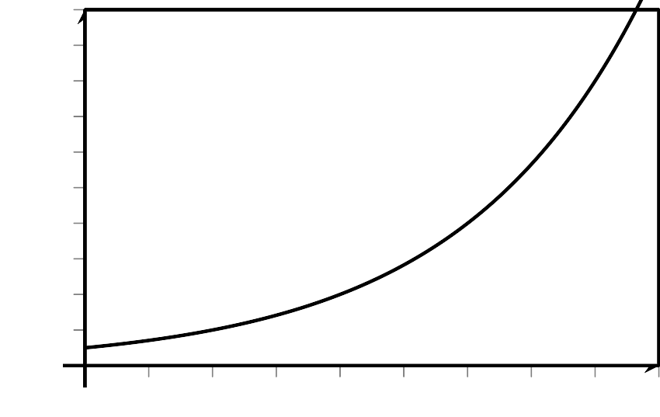
- Find an equation defining $f$. Explain your reasoning.
- The equation $f(t)=24,​500⋅(0.88)^{t}$ represents the value of a car, in dollars, $t$ years after it was purchased.
  - What do the numbers 24,500 and 0.88 mean?
  - What does $f(9)$ represent?
  - Sketch a graph that represents the function $f$ and shows $f(0),$ $f(1),$ and $f(2)$.
- The first two terms of an exponential sequence are 18 and 6. What are the next 3 terms of this sequence?
- (From Unit 4, Lesson 1.)
- A bacteria population has been doubling each day for the last 5 days. It is currently 100,000. What was the bacterial population 5 days ago? Explain how you know.
- (From Unit 4, Lesson 1.)
- Select all expressions that are equivalent to ${27}^{\frac{1}{3}}$.
  - 9
  - 3
  - $\sqrt{27}$
  - $\sqrt[3]{27}$
  - $\sqrt[3]{3^{3}}$
  - $\frac{1}{27}$
  - $\frac{1}{{27}^{3}}$
- (From Unit 3, Lesson 3.)
© CC BY 2019 by Illustrative Mathematics®

