Unit 6 Lesson 2: Transformations as Functions

1 Math Talk: Transforming a Point (Warm up)

Student Task Statement
Mentally find the coordinates of the image of $A$ under each transformation.
- Translate $A$ by the directed line segment from $(0,0)$ to $(0,2)$.
- Translate $A$ by the directed line segment from $(0,0)$ to $(\text{-}4,0)$.
- Reflect $A$ across the $x$-axis.
- Rotate $A$ 180 degrees clockwise using the origin as a center.

2 Inputs and Outputs

Student Task Statement
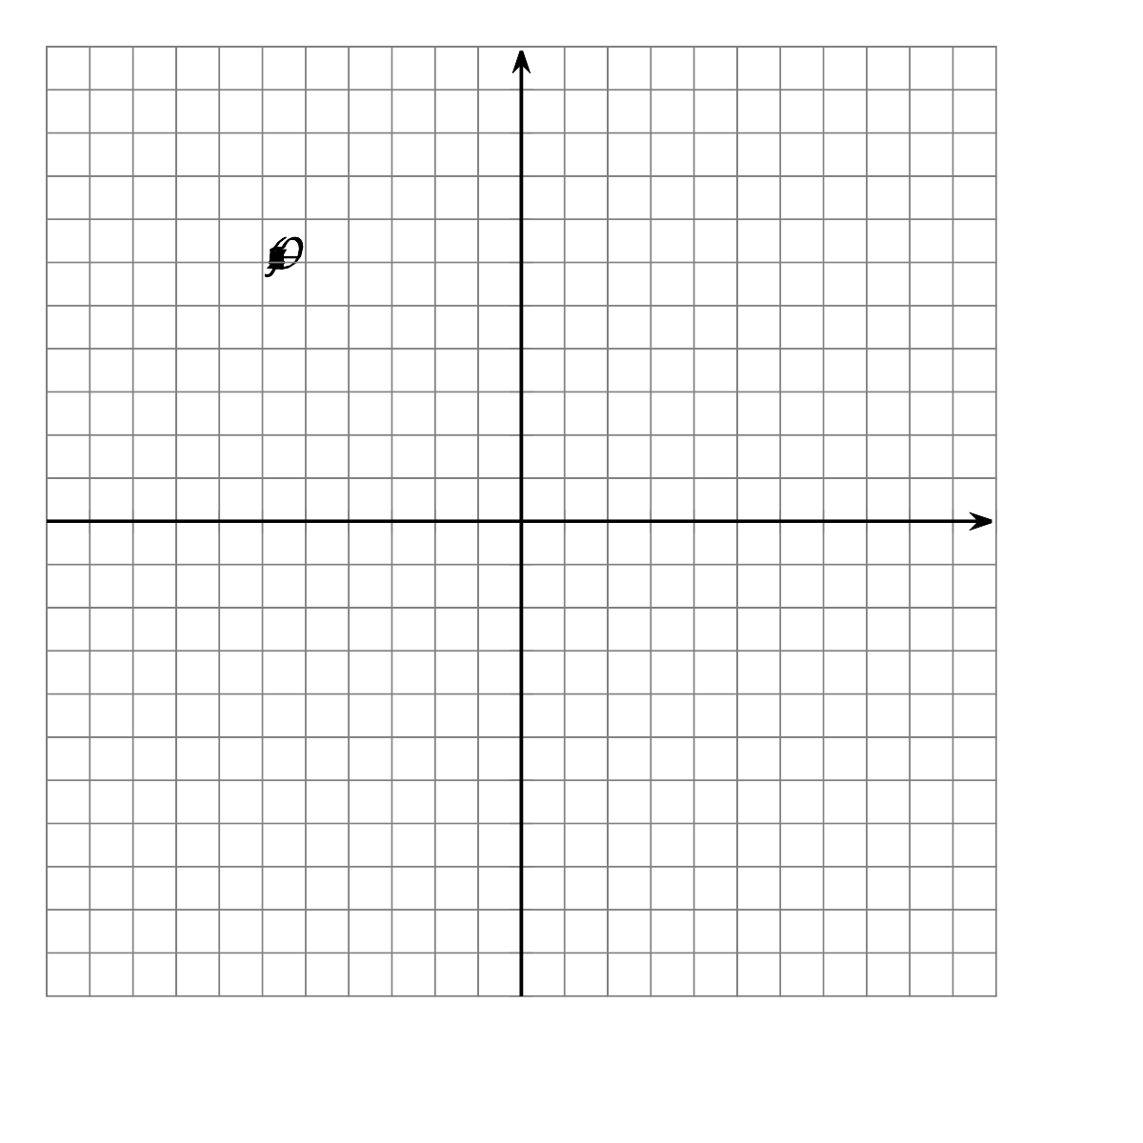
- For each point $(x,y)$, find its image under the transformation $(x+12,y−2)$.
  - $A=(\text{-}10,5)$
  - $B=(\text{-}4,9)$
  - $C=(\text{-}2,6)$
- Next, sketch triangle $ABC$ and its image on the grid. What transformation is $(x,y)→(x+12,y−2)$?
- For each point $(x,y)$ in the table, find $(2x,2y)$.
- $(x,y)$ | - $(2x,2y)$
- $(\text{-}1,\text{-}3)$
- $(\text{-}1,1)$
- $(5,1)$
- $(5,\text{-}3)$
- Next, sketch the original figure (the $(x,y)$ column) and image (the ($2x,2y)$ column). What transformation is $(x,y)→(2x,2y)$?

3 What Does it Do?

Student Task Statement
- Here are some transformation rules. Apply each rule to quadrilateral $ABCD$ and graph the resulting image. Then describe the transformation.
  - Label this transformation $Q$: $(x,y)→(2x,y)$
  - Label this transformation $R$: $(x,y)→(x,\text{-}y)$
  - Label this transformation $S$: $(x,y)→(y,\text{-}x)$
© CC BY 2019 by Illustrative Mathematics®

