Lesson 18: 1 More or 1 Less with Towers and Numbers
- Let’s find 1 more or 1 less than a number.

Warm-up: Act It Out: Forks for Dinner
Mai is helping hand out the forks for dinner.
There are 9 people sitting at the table.
Mai has 7 forks.
Are there enough forks for each person to get one?

18.2: One Less, One More
my tower
my partner’s tower
my tower
my partner’s tower
my tower
my partner’s tower
my tower
my partner’s tower

18.3: Centers: Choice Time
Choose a center.
Math Stories
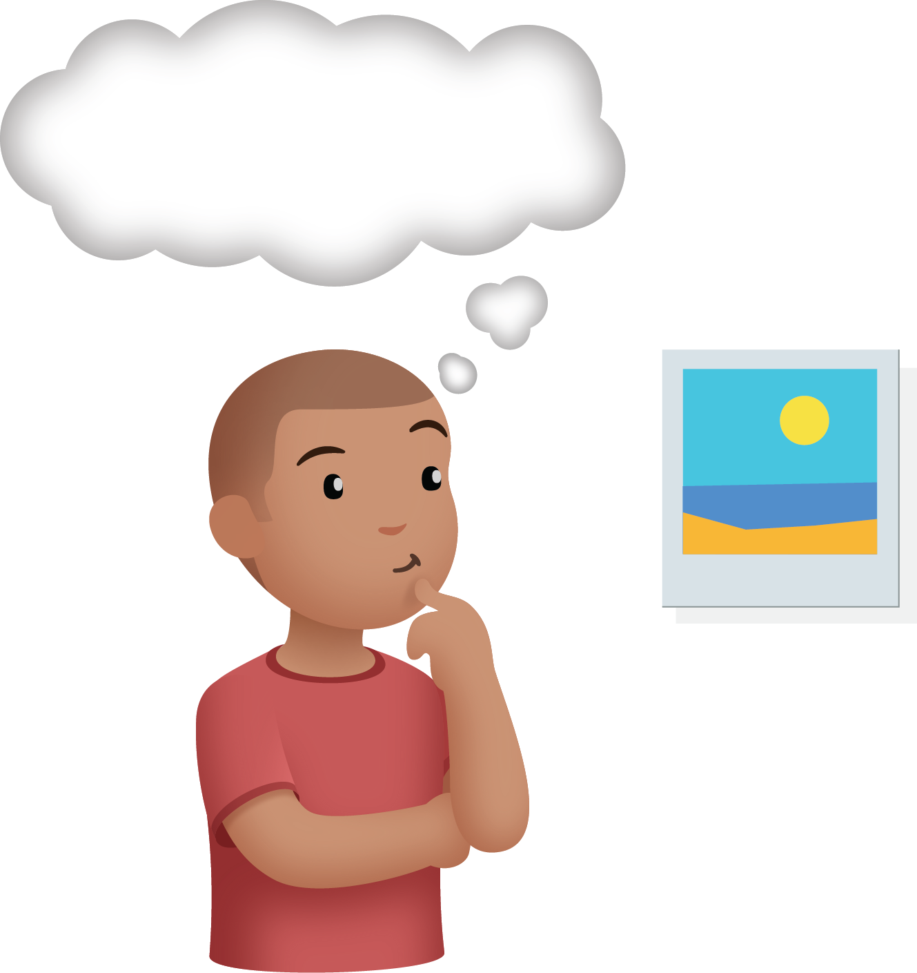
Math Libs
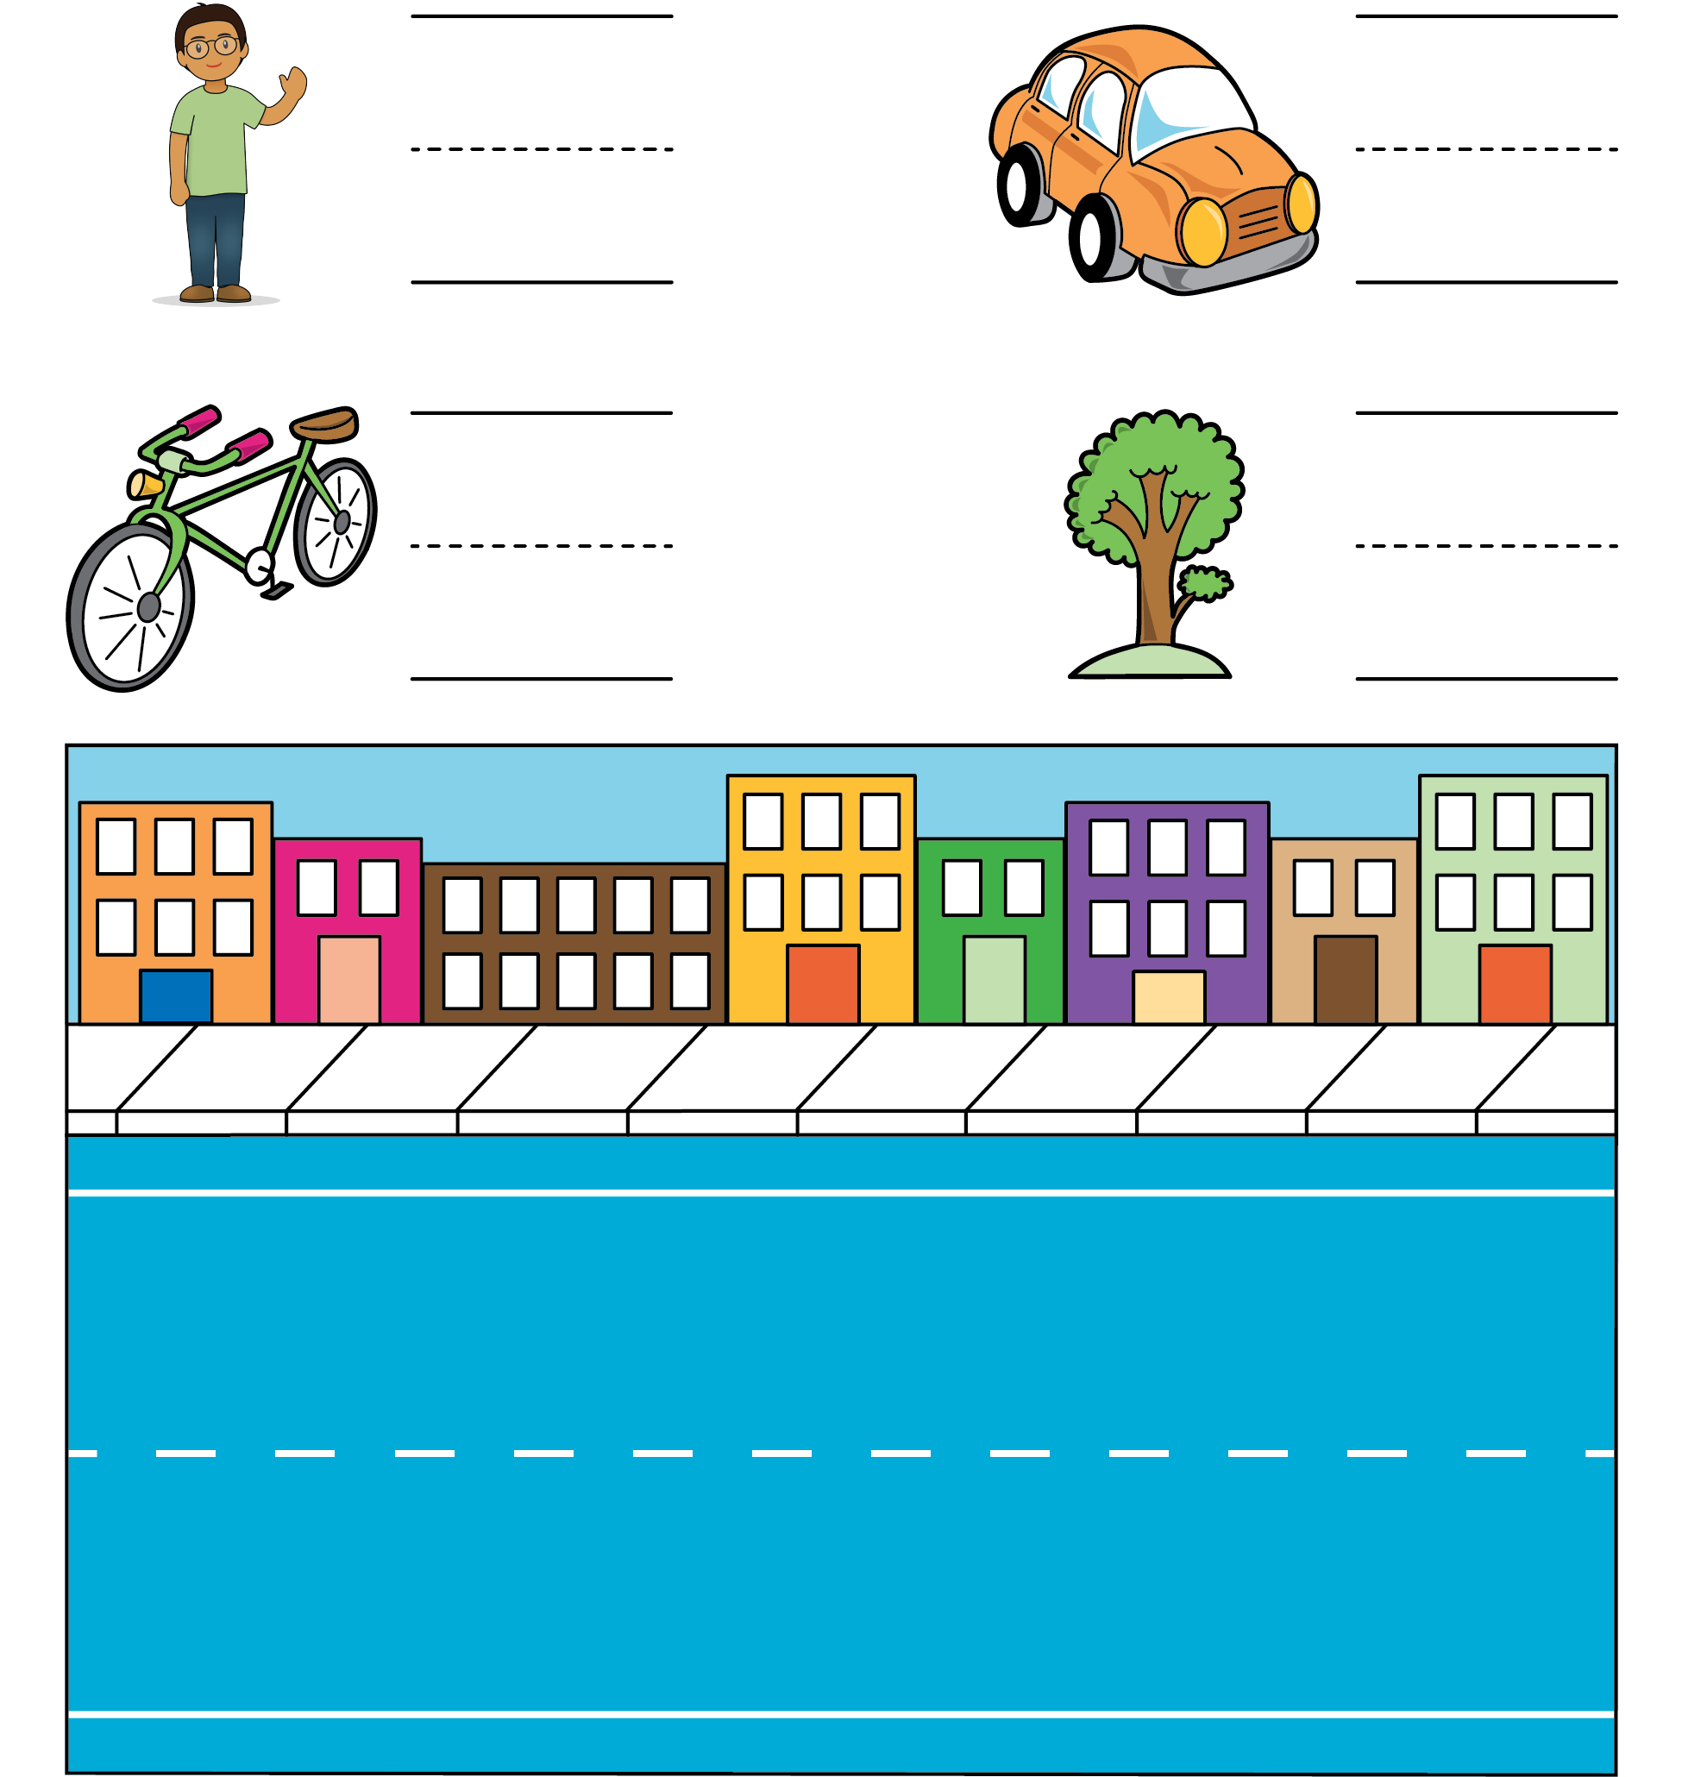
Number Race
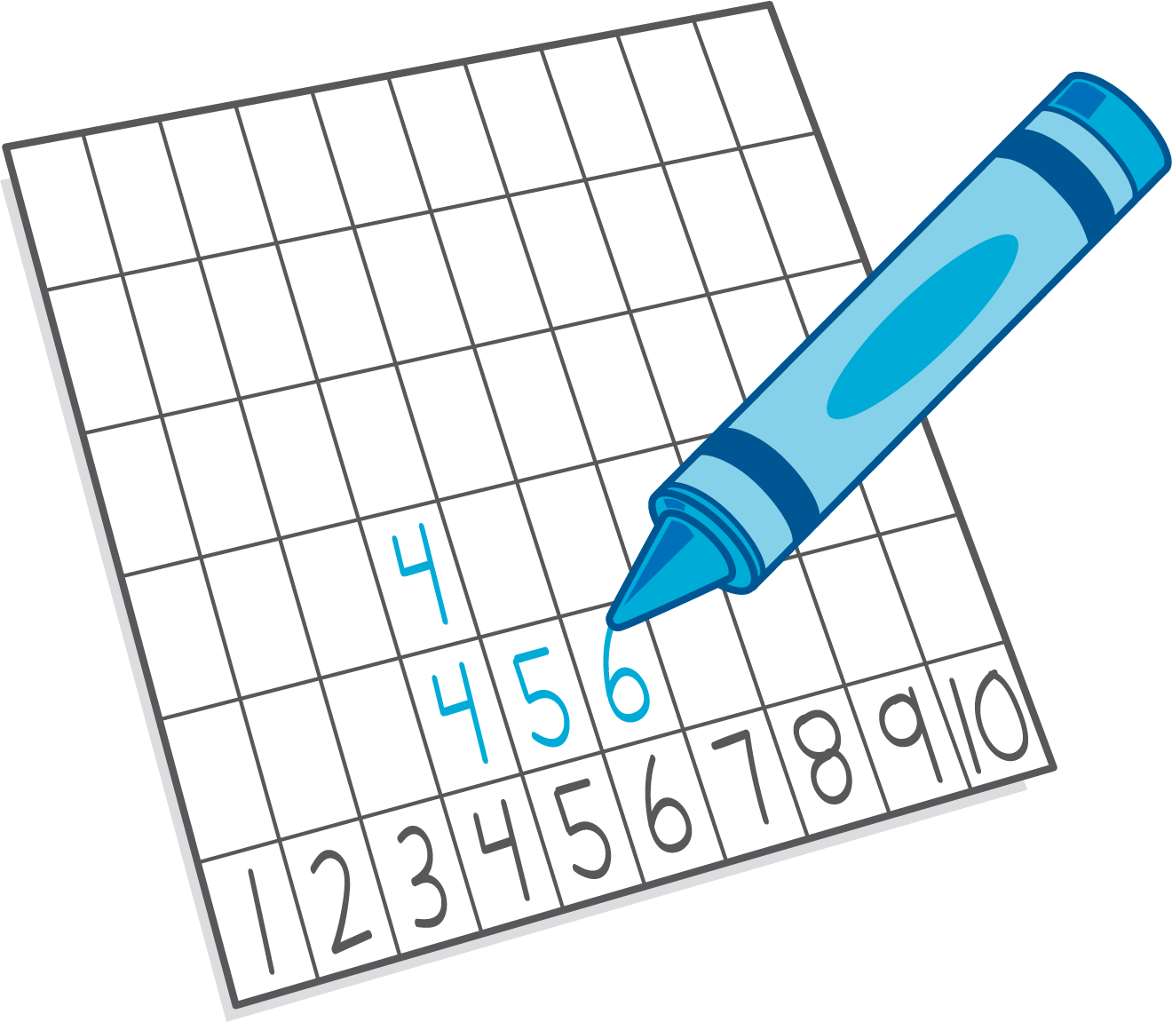
© CC BY 2021 Illustrative Mathematics®

