Unit 6 Lesson 12: Count Images (Part 2)

WU Which One Doesn’t Belong: Tons of Tens (Warm up)

Student Task Statement
Which one doesn’t belong?
A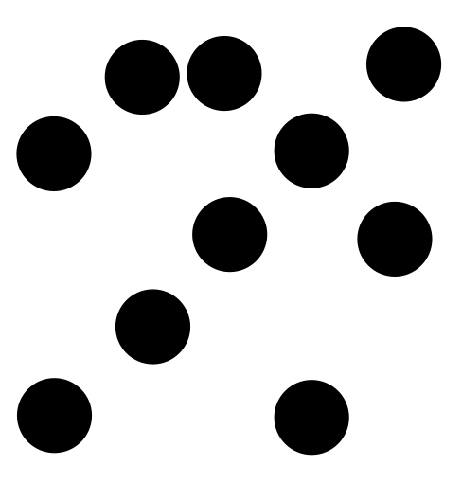
B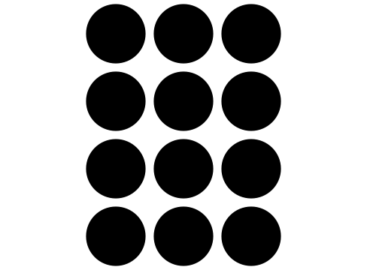
C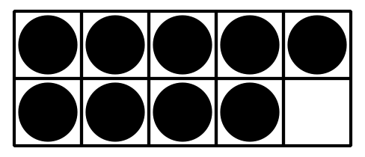
D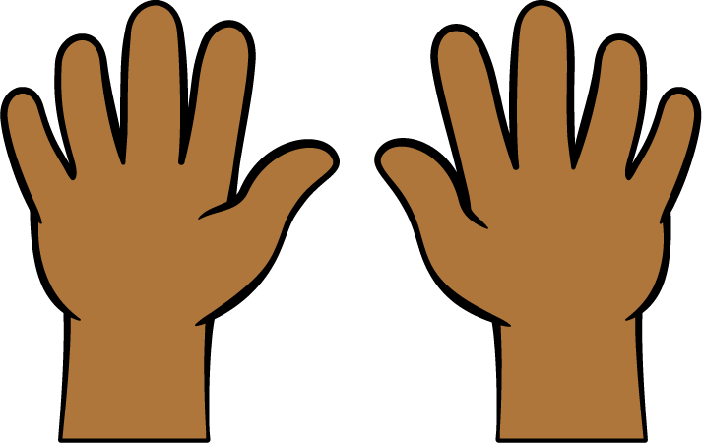

1 Count Images in Organized Arrangements (Optional)

Student Task Statement

- There are _______________ rectangles.

- 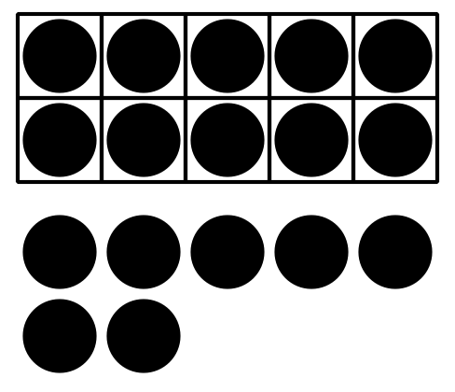
- There are _______________ dots.

- 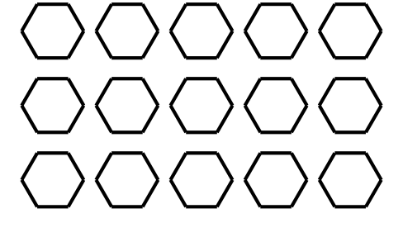
- There are _______________ hexagons.

- 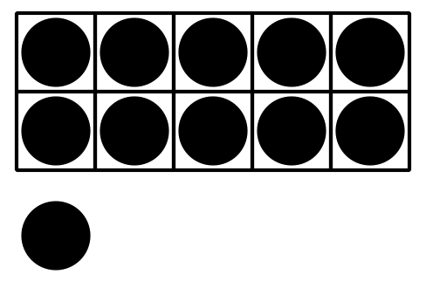
- There are _______________ dots.

- 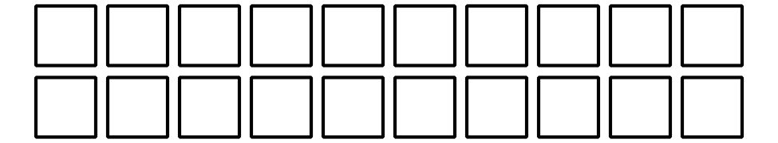
- There are _______________ squares.

- 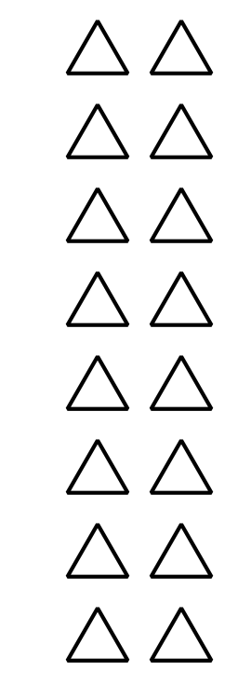
- There are _______________ triangles.

2 Count in Circles

Student Task Statement

- 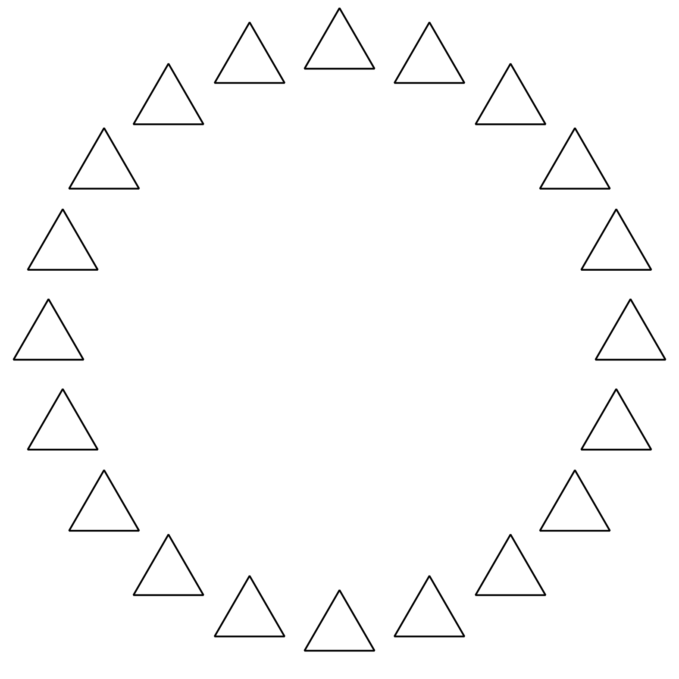
- There are _______________ triangles.

- 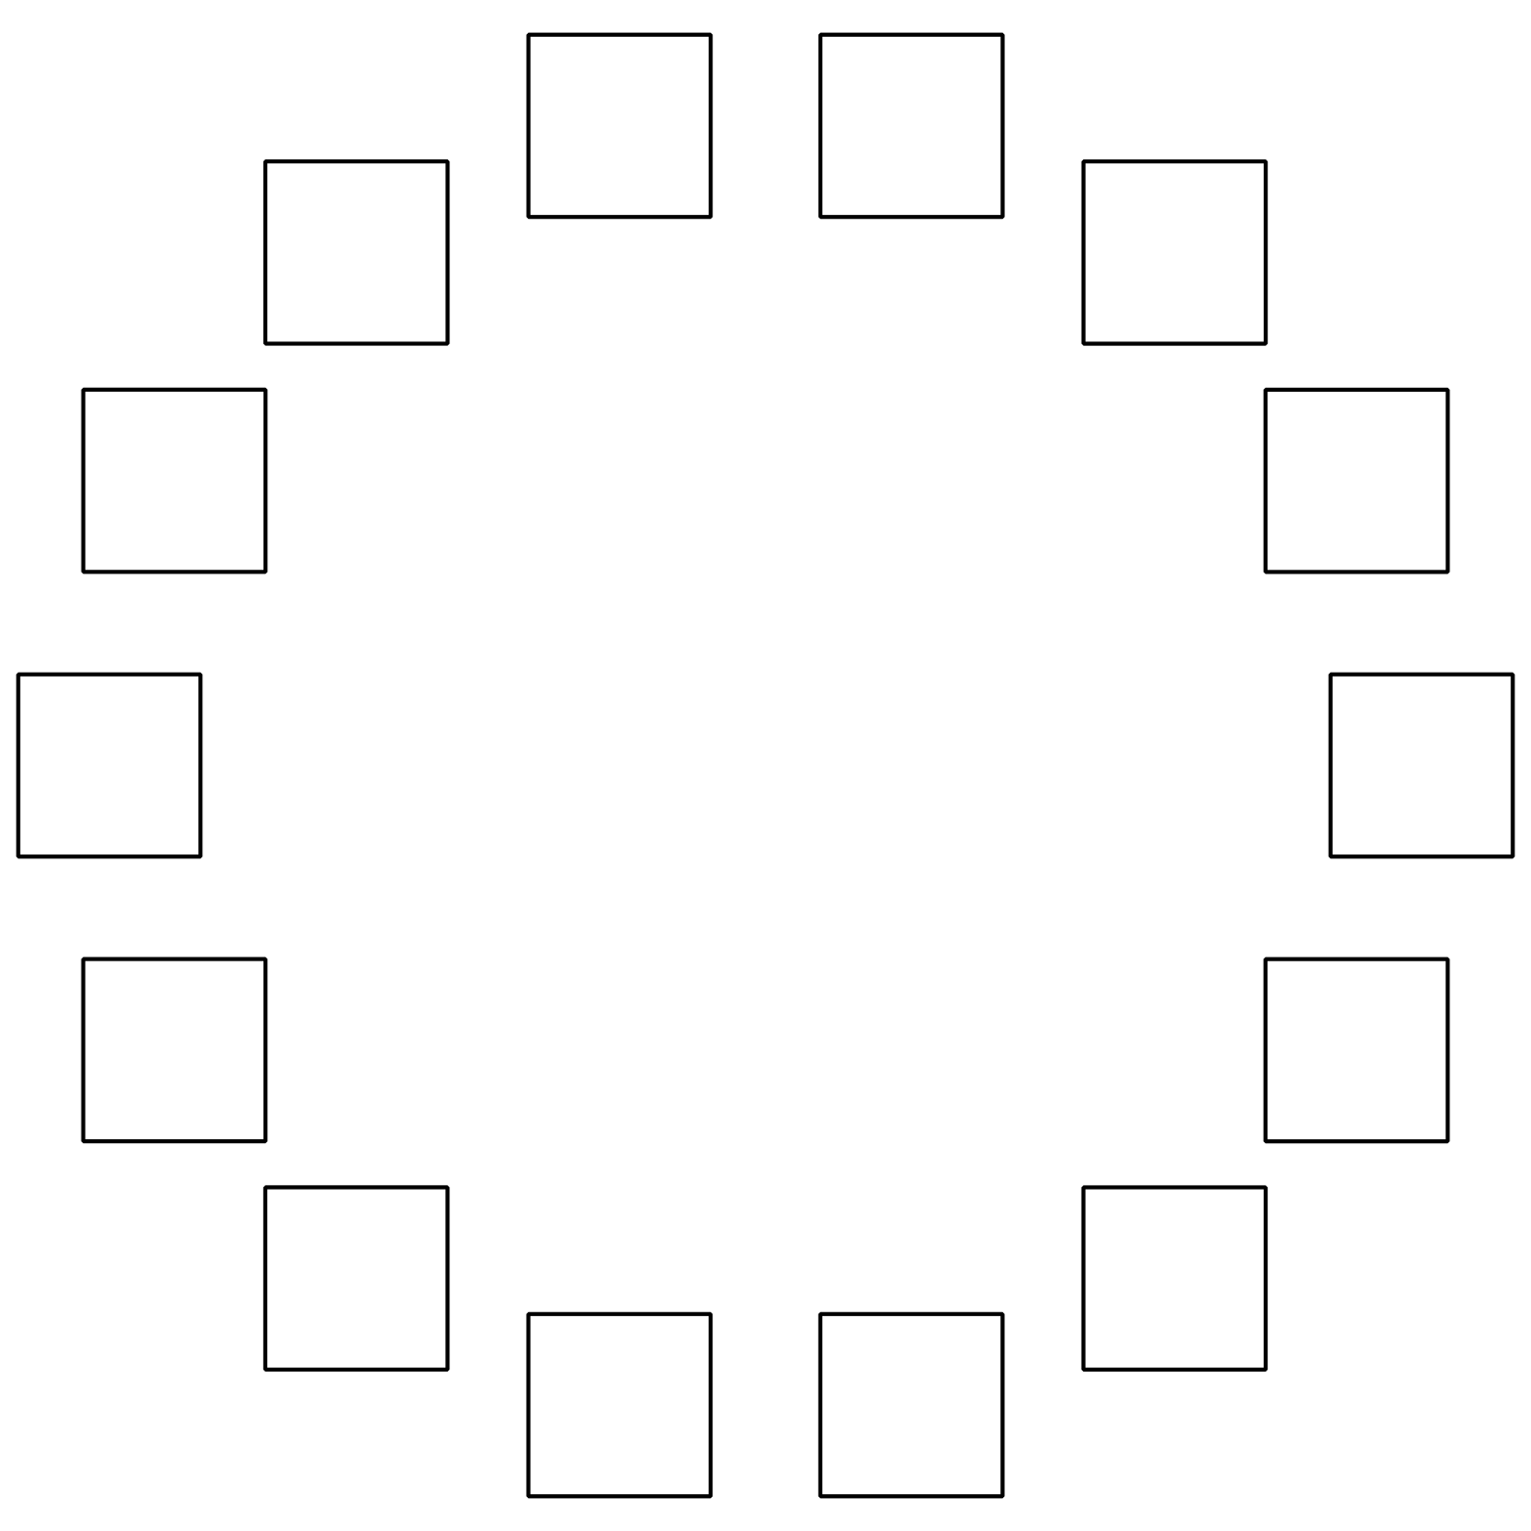
- There are _______________ squares.

- 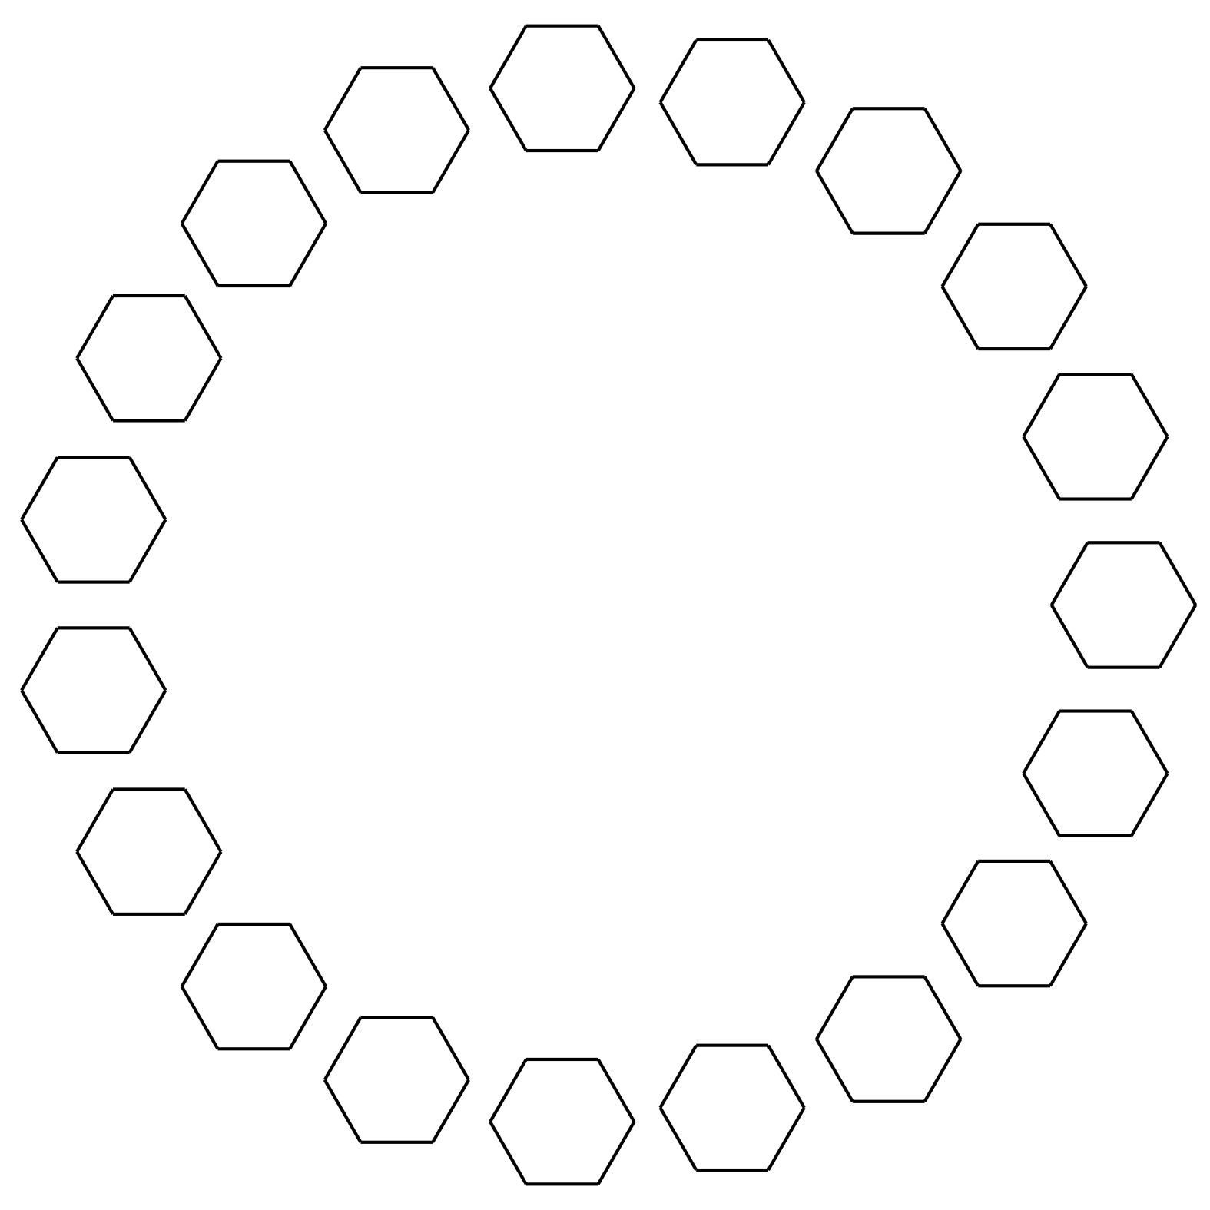
- There are _______________ hexagons.

- 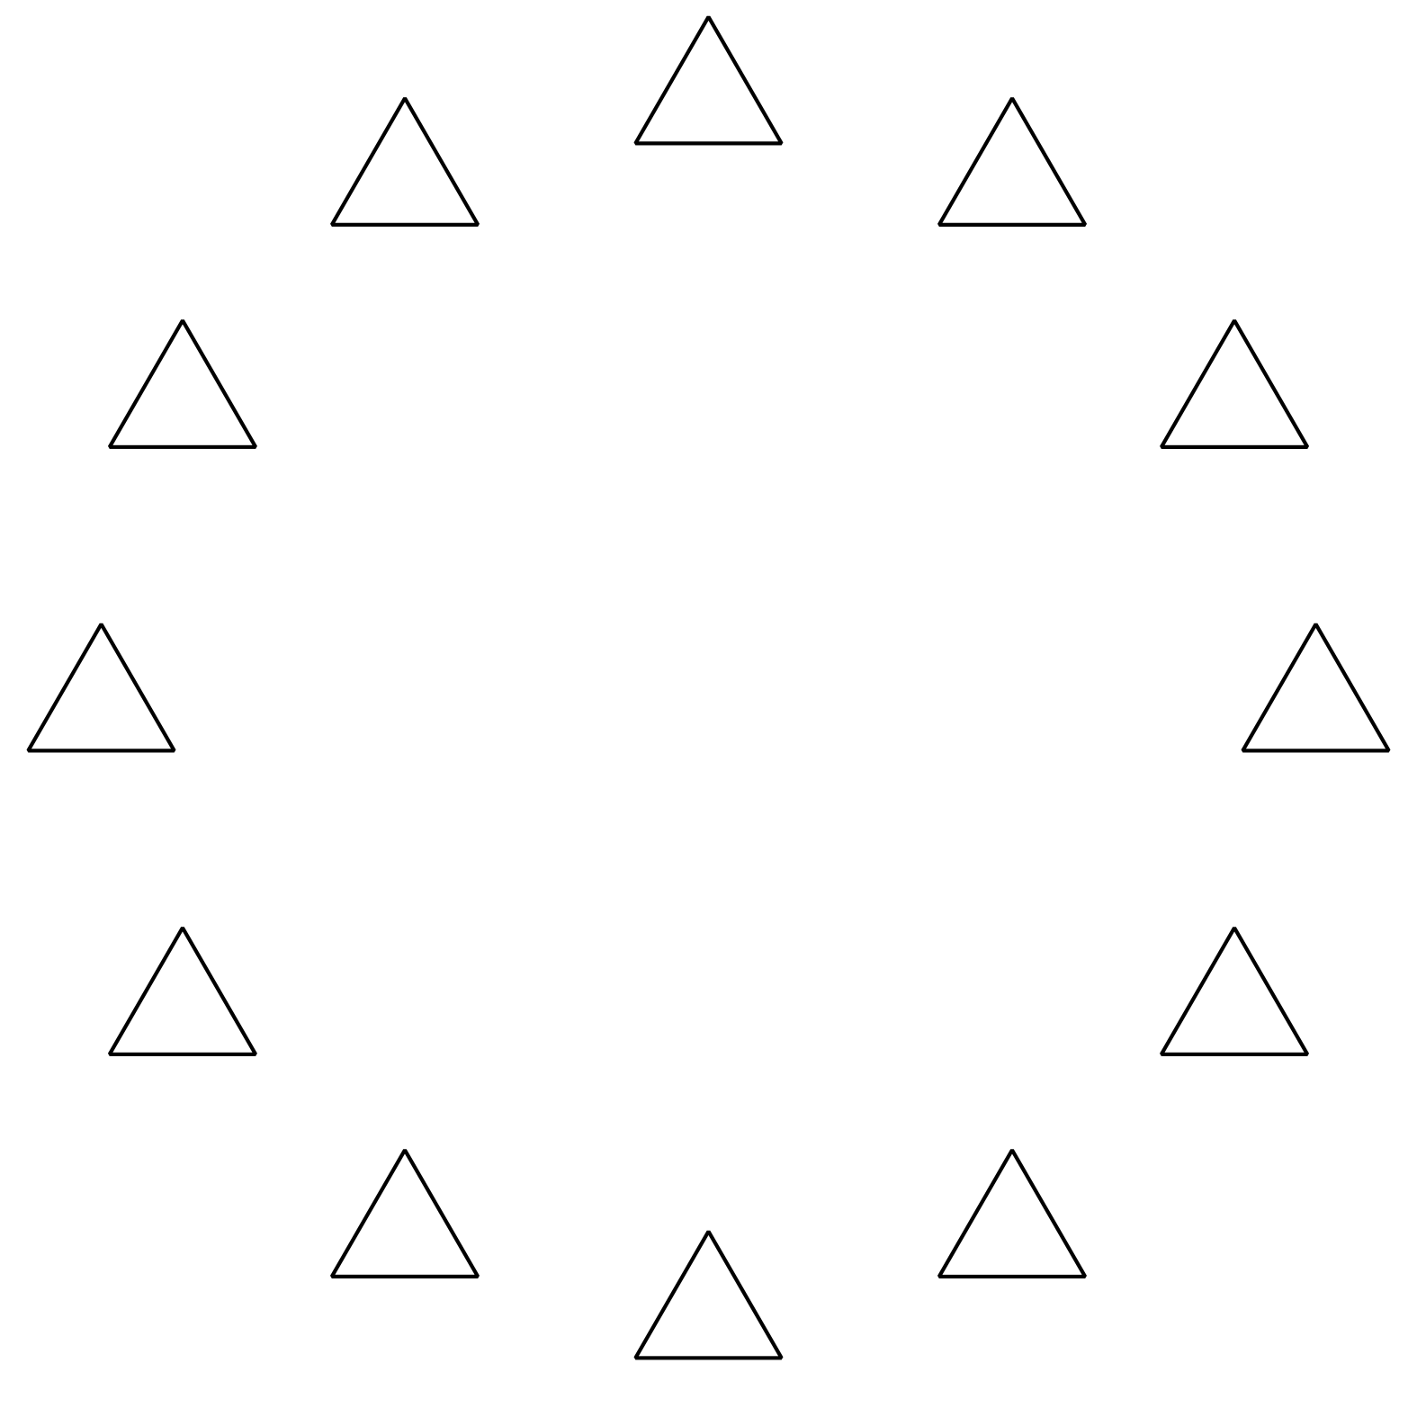
- There are _______________ triangles.

- 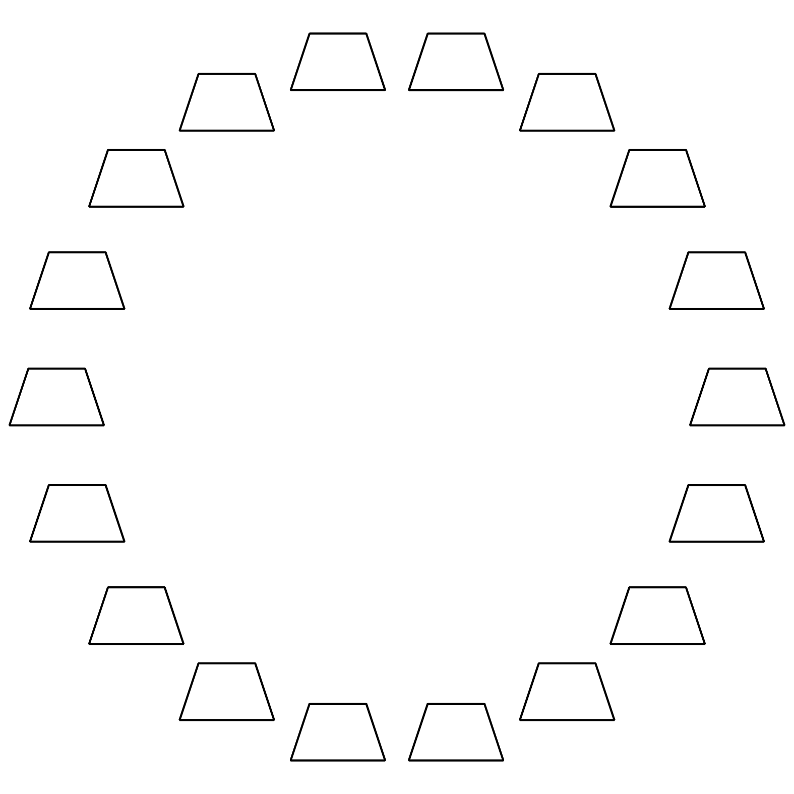
- There are _______________ trapezoids.

- 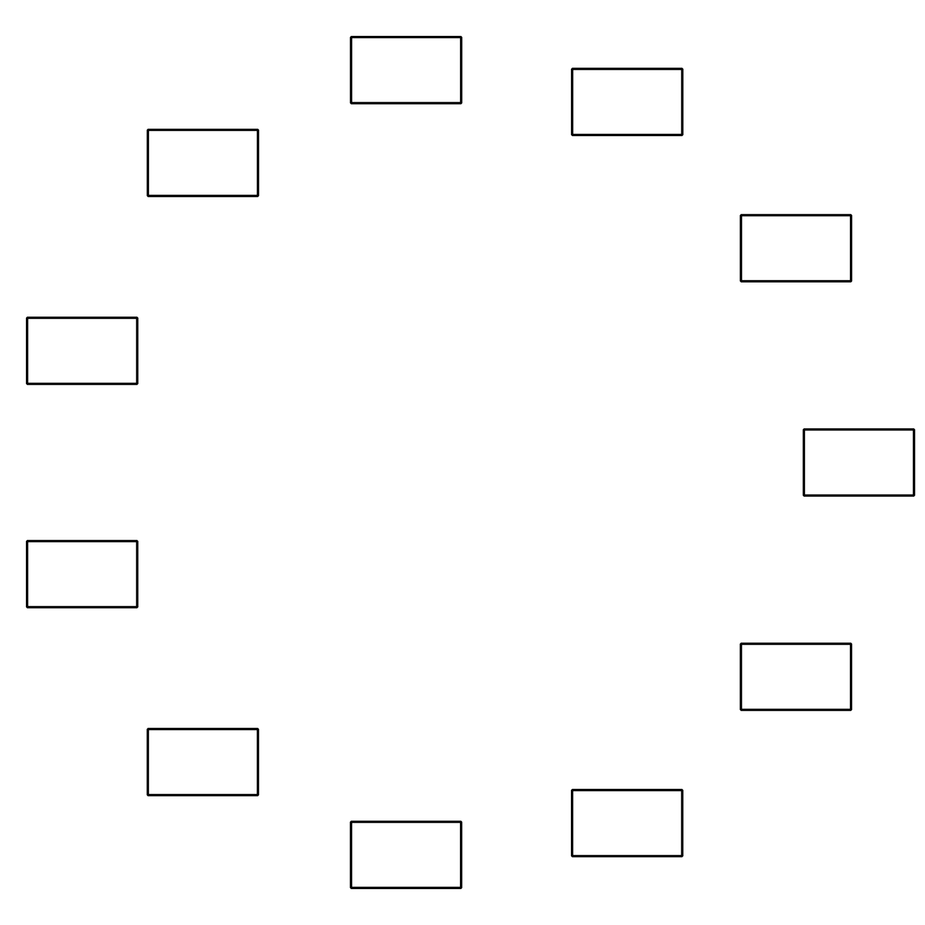
- There are _______________ rectangles.

3 Introduce Find the Pair, Make 10

Student Task Statement
Choose a center.
Find the Pair
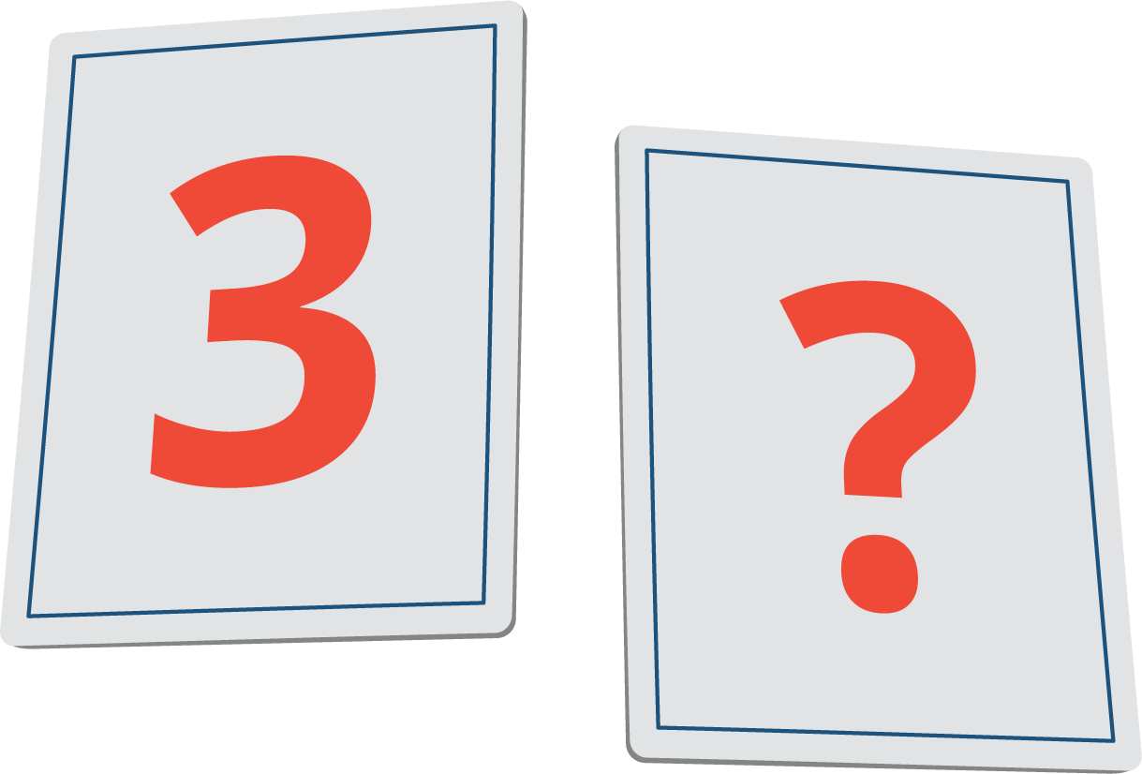
Find the Value of Expressions
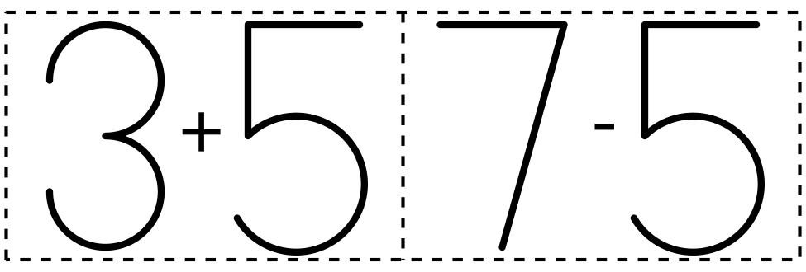
Make or Break Apart Numbers
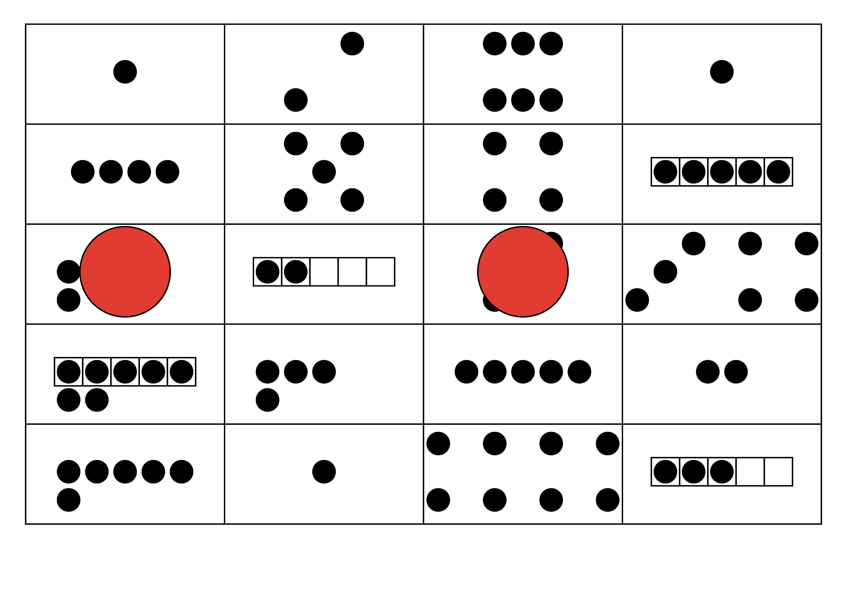
Bingo
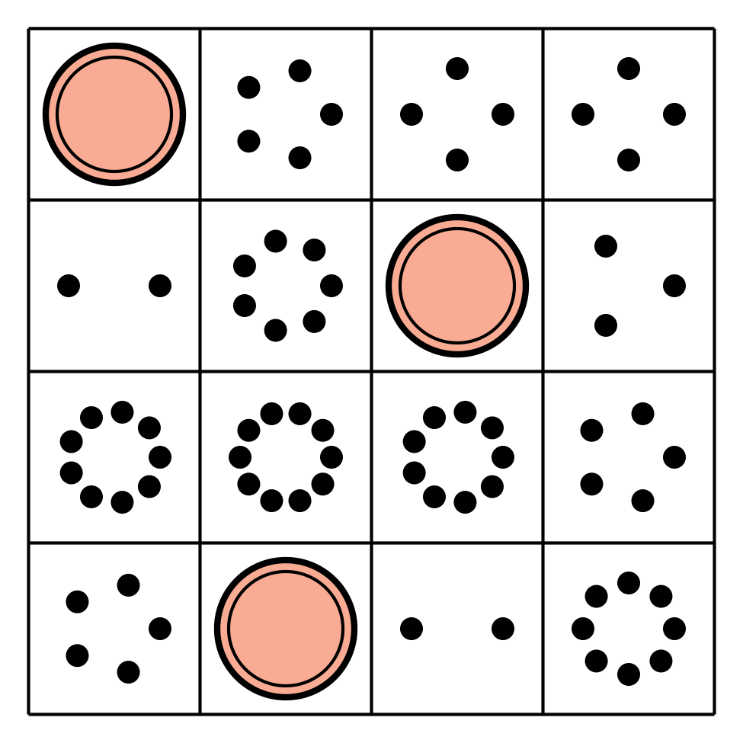

Images for Activity Synthesis
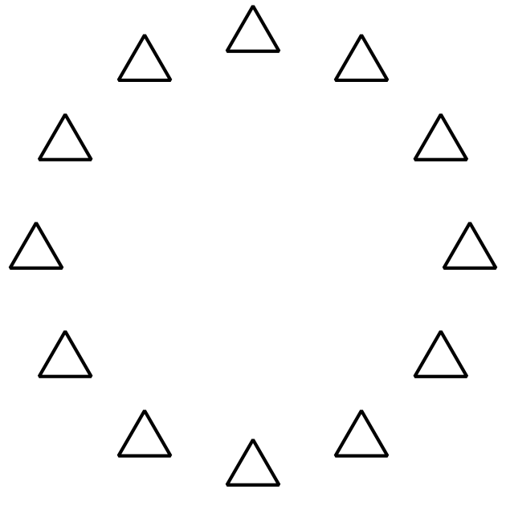
© CC BY 2021 Illustrative Mathematics®

