Lesson 11 Practice Problems
- Which point represents the complex number $\text{-}3+2i$?
- 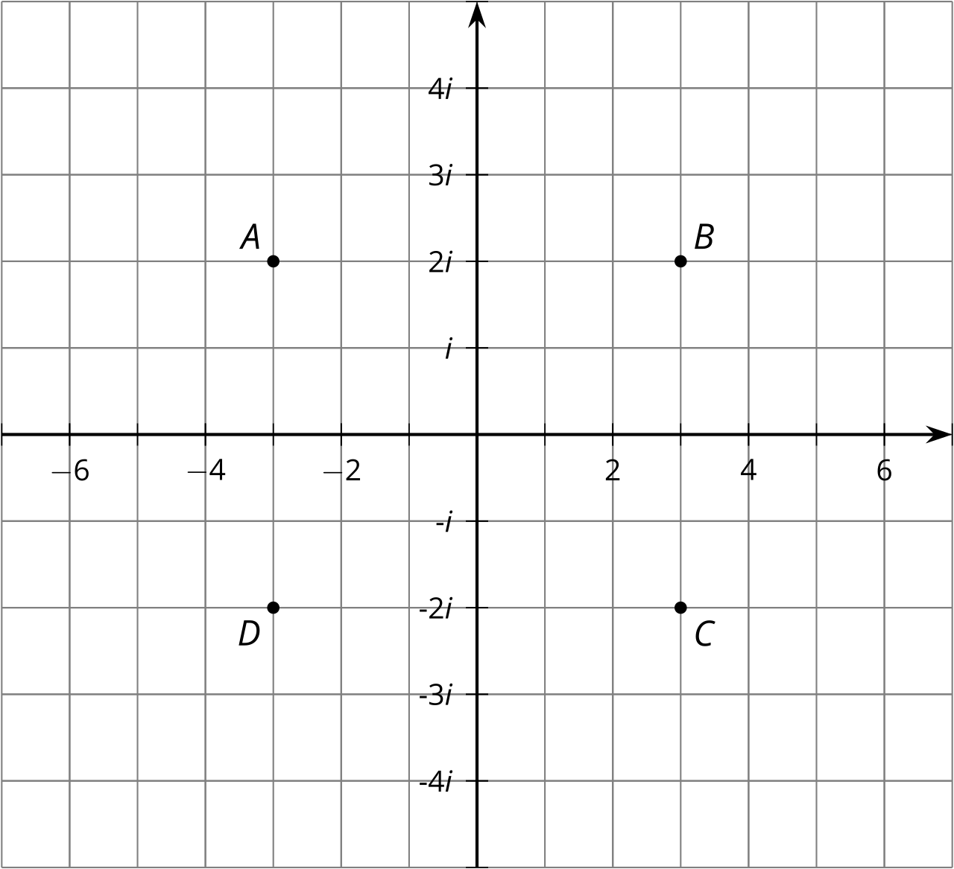
  - A
  - B
  - C
  - D
- Match each expression to an equivalent expression.
  - $2i⋅8$
  - $16i^{3}$
  - ${\left(2i\right)}^{4}$
  - $2i⋅8i$
  - -16
  - 16
  - $\text{-}16i$
  - $16i$

  - Diego squared a number and got 4. Andre squared a different number and got 4. What were the numbers that Diego and Andre squared?
  - Jada squared a number and got -4. Elena squared a different number and got -4. What were the numbers that Jada and Elena squared?
- Find all solutions to each equation.
  - $a^{2}=1$
  - $b^{2}=13$
  - $c^{2}=\text{-}9$
  - $d^{2}=\text{-}5$
- Find the exact solution(s) to each of these equations, or explain why there is no solution.
  - $\sqrt[3]{a+2}=4$
  - $\sqrt[3]{b}+5=4$
  - $\sqrt[3]{c−1}−14=\text{-}4$
- (From Unit 3, Lesson 8.)
- Explain how you know that $\sqrt{\text{-}1}$ is not a negative number.
- (From Unit 3, Lesson 10.)
© CC BY 2019 by Illustrative Mathematics®

