Lesson 7: No Bending or Stretching

7.1: Measuring Segments
For each question, the unit is represented by the large tick marks with whole numbers.
- Find the length of this segment to the nearest $\frac{1}{8}$ of a unit.
- 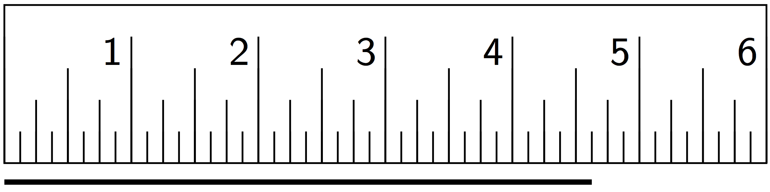
- Find the length of this segment to the nearest 0.1 of a unit.
- 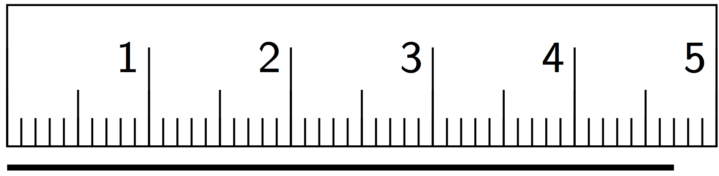
- Estimate the length of this segment to the nearest $\frac{1}{8}$ of a unit.
- 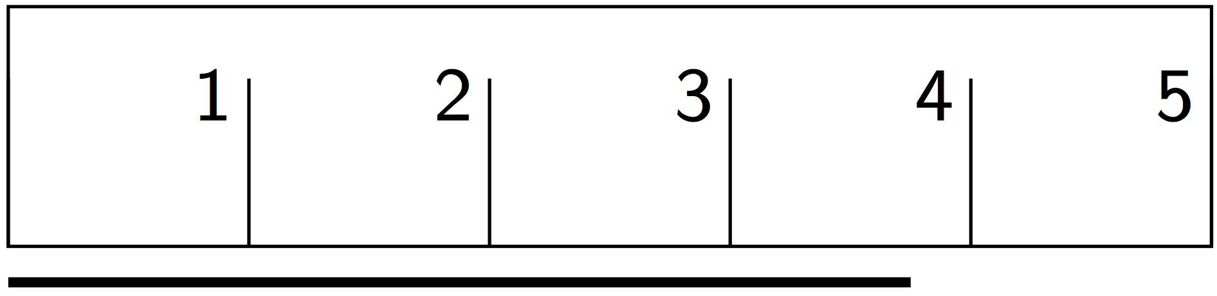
- Estimate the length of the segment in the prior question to the nearest 0.1 of a unit.

7.2: Sides and Angles
- Translate Polygon $A$ so point $P$ goes to point $Q$. In the image, write the length of each side, in grid units, next to the side.
- 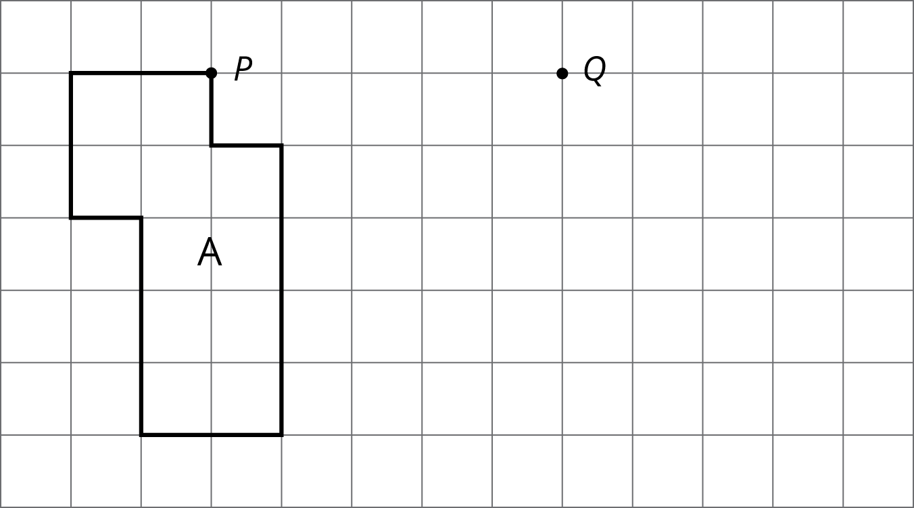
- Rotate Triangle $B$ 90 degrees clockwise using $R$ as the center of rotation. In the image, write the measure of each angle in its interior.
- 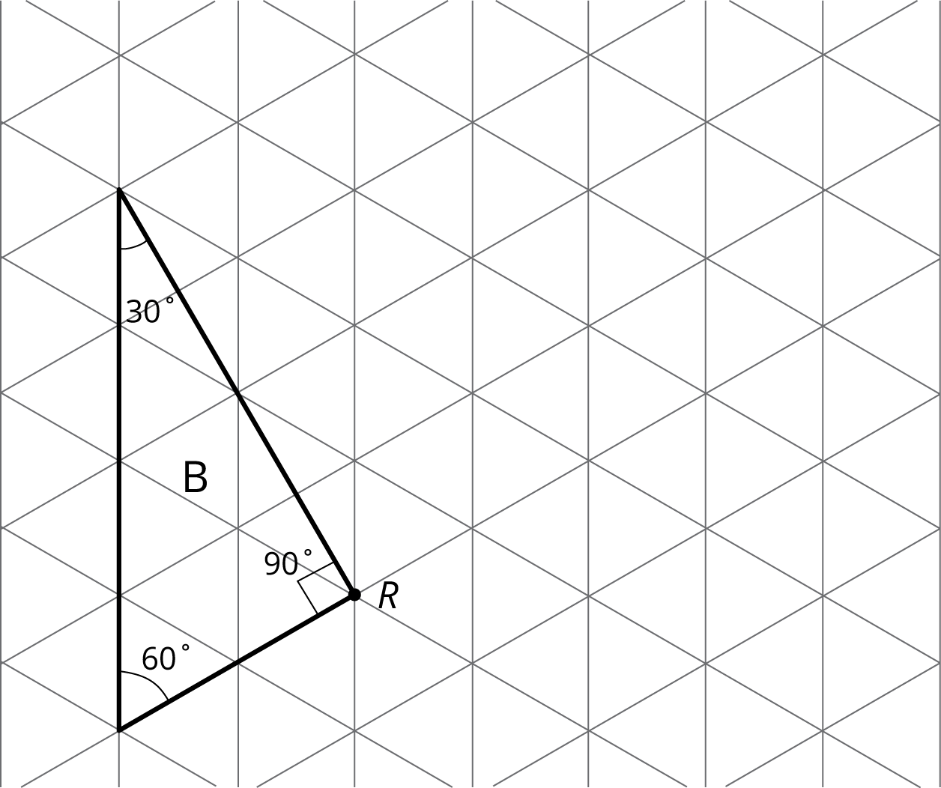

- Reflect Pentagon $C$ across line $ℓ$.
  - In the image, write the length of each side, in grid units, next to the side. You may need to make your own ruler with tracing paper or a blank index card.
  - In the image, write the measure of each angle in the interior.
- 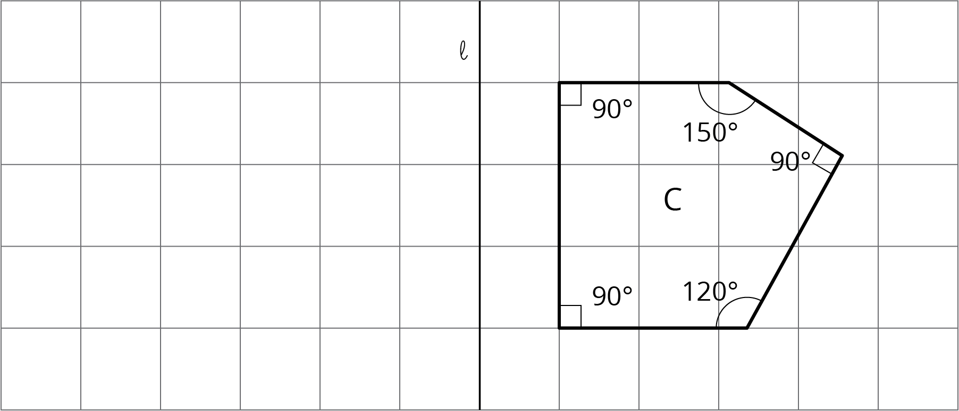

7.3: Which One?
Here is a grid showing triangle $ABC$ and two other triangles.
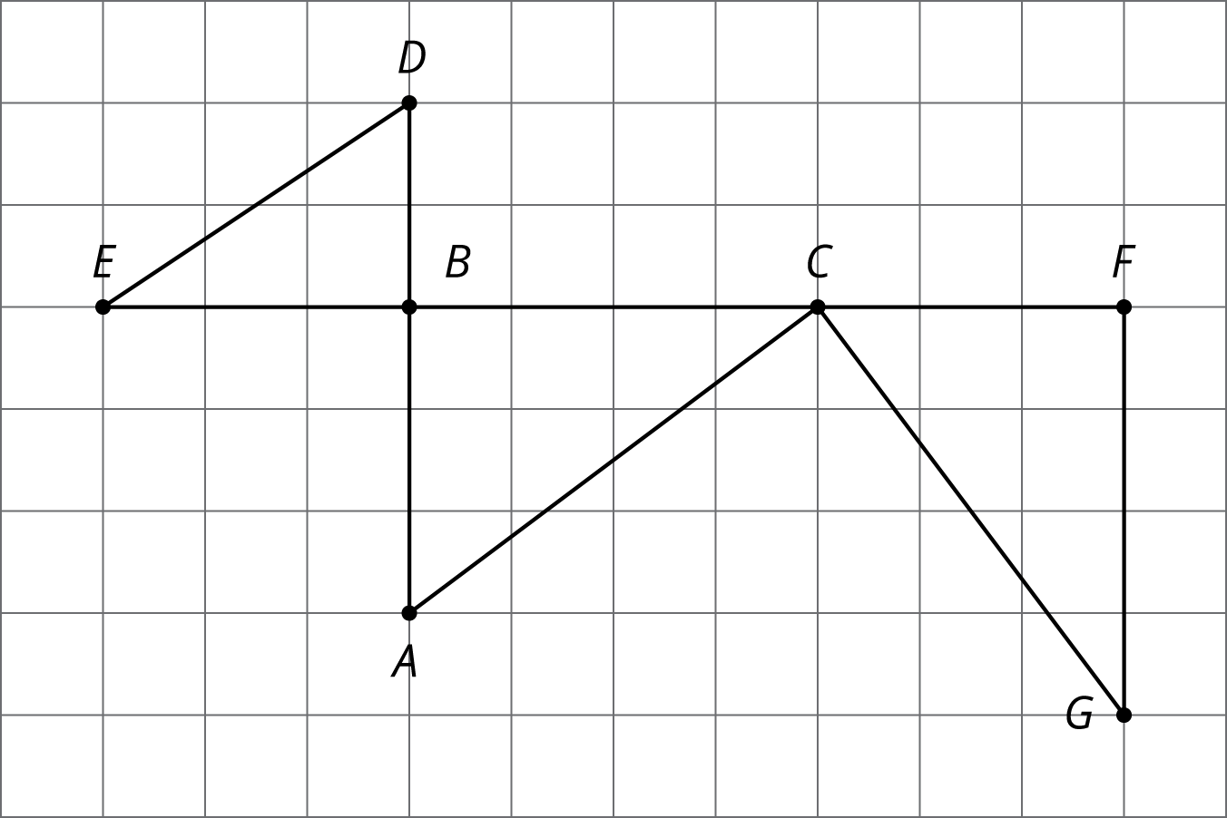
You can use a rigid transformation to take triangle $ABC$ to one of the other triangles.
- Which one? Explain how you know.
- Describe a rigid transformation that takes $ABC$ to the triangle you selected.

Are you ready for more?
A square is made up of an L-shaped region and three transformations of the region. If the perimeter of the square is 40 units, what is the perimeter of each L-shaped region?

Lesson 7 Summary
The transformations we’ve learned about so far, translations, rotations, reflections, and sequences of these motions, are all examples of rigid transformations. A rigid transformation is a move that doesn’t change measurements on any figure.
Earlier, we learned that a figure and its image have corresponding points. With a rigid transformation, figures like polygons also have corresponding sides and corresponding angles. These corresponding parts have the same measurements.
For example, triangle $EFD$ was made by reflecting triangle $ABC$ across a horizontal line, then translating. Corresponding sides have the same lengths, and corresponding angles have the same measures.
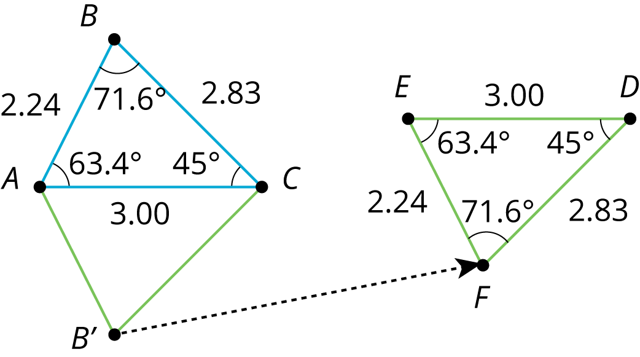
measurements in triangle $ABC$ | corresponding measurements in image $EFD$
$AB=2.24$ | $EF=2.24$
$BC=2.83$ | $FD=2.83$
$CA=3.00$ | $DE=3.00$
$m∠ABC={71.6}^{∘}$ | $m∠EFD={71.6}^{∘}$
$m∠BCA={45.0}^{∘}$ | $m∠FDE={45.0}^{∘}$
$m∠CAB={63.4}^{∘}$ | $m∠DEF={63.4}^{∘}$
© CC BY Open Up Resources. Adaptations CC BY IM.

