Lesson 1: Accessing Areas and Pondering Perimeters

1.1: Which One Doesn’t Belong: Quadrilaterals
Which one doesn’t belong?

A
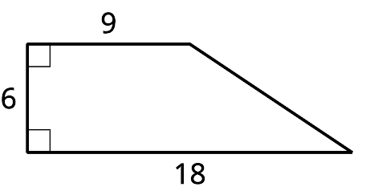

B
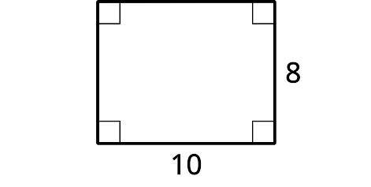

C
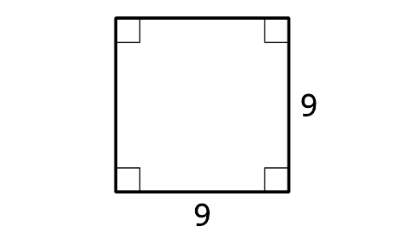

D
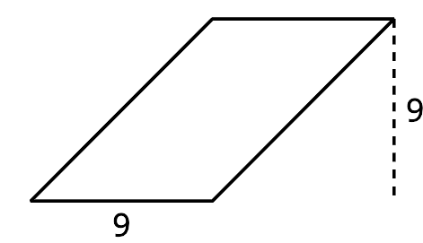

1.2: Inspect Some Rectangles
Here are some rectangles.
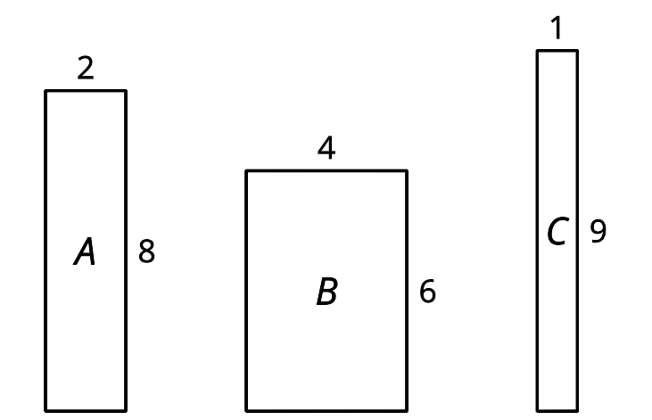
- Which rectangle has the greatest perimeter?
- Which rectangle has the greatest area?
- Find a rectangle with the same perimeter, but an even greater area than the previous answer.
- For the remaining questions, tables are provided to organize your work. Rectangle D has a perimeter of 32 units.
  - Find the side lengths of three different possible rectangles that have this perimeter.
  - Find a pair of side lengths for rectangle D that give the greatest area in square units.
  - Find a pair of side lengths for rectangle D that give the smallest area in square units.
- length (units) | - width (units) | - perimeter (units) | - area (square units)
- Rectangle E has an area of 36 square units.
  - Find 3 pairs of side lengths that give this area.
  - Find a pair of side lengths for rectangle E that give the greatest perimeter in whole-number units.
  - Find a pair of side lengths for rectangle E that give the smallest perimeter in whole-number units.
- length (units) | - width (units) | - perimeter (units) | - area (square units)

1.3: Inspect Some Tables
Here are two tables. The first shows some measurements for Rectangle A, with a side length of 5 cm. The second shows some measurements of Rectangle B, which is a square.
- Complete the table for Rectangle A and be prepared to explain your reasoning.
- length (cm) | - width (cm) | - perimeter (cm) | - area (sq cm)
- 5 | - 1
- 5 | - 2
- 5 | - 4
- 5 |  | - 20
- 5 |  |  | - 40
- 5 |  | - 28
- 5 |  |  | - 50
- 5 | - $x$
- Complete the table for Rectangle B and be prepared to explain your reasoning.
- length (cm) | - width (cm) | - perimeter (cm) | - area (sq cm)
- 1 | - 1
- 2 | - 2
- 3 | - 3
- 4 |  | - 16
 | - 8
 |  |  | - 100
 | - $x$
- Sketch the graph of each pair of quantities, where the width is plotted along the $x$-axis.
  - $x$ and the perimeter of Rectangle A
  - $x$ and the area of Rectangle A
  - $x$ and the perimeter of Rectangle B
  - $x$ and the area of Rectangle B
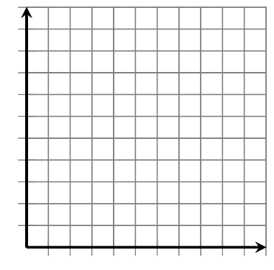
© CC BY 2019 by Illustrative Mathematics

