Lesson 5: Side Lengths of Rectangular Prisms

Standards Alignments
Addressing | 5.MD.C.5.b
Building Towards | 5.MD.C.5.b

Teacher-facing Learning Goals
- Describe rectangular prisms in terms of their side lengths.
- Find the volume of a right rectangular prism by multiplying the side lengths and connect that to finding volume by multiplying the area of the base by the height.

Student-facing Learning Goals
- Let’s describe the side lengths of a prism and find the volume.

Lesson Purpose
The purpose of this lesson is for students to formalize the language they use to describe the side lengths of a rectangular prism.
In previous lessons, students used the structure of a rectangular prism, namely layers, to find its volume. In this lesson, students describe the number of layers and the number of cubes in each layer in terms of the length, width, and height of the prism (MP6). Students choose a base for the prism and recognize that the number of cubes in each layer is the product of the length and width of the chosen base. They also recognize that the height that corresponds with the chosen base represents the number of layers in the prism. They connect this relationship to the product of the length, width, and height of a prism. With this understanding of how to find the volume of a rectangular prism, students do not always need to see the individual cubes that make up the prism. The poster from a previous lesson that displays language students used while building and describing prisms will be revised in this lesson synthesis to include the terms length, width, height, and area of a base.
Math Community
Tell students that, at the end of the lesson, they will be asked to identify specific examples of norms they experienced as they did math.

Access for:

Students with Disabilities
- Engagement (Activity 1)

English Learners
- MLR2 (Activity 2)

Instructional Routines
Notice and Wonder (Warm-up)

Materials to Gather
- Connecting cubes: Activity 1, Activity 2

Lesson Timeline
Warm-up | 10 min
Activity 1 | 10 min
Activity 2 | 15 min
Activity 3 | 10 min
Lesson Synthesis | 10 min
Cool-down | 5 min

Teacher Reflection Question
As students worked in their small groups today, whose ideas were heard, valued, and accepted? How can you adjust the group structure tomorrow to ensure each student’s ideas are a part of the collective learning?

Cool-down
(to be completed at the end of the lesson) 5min
Determine the Volume

Standards Alignments
Addressing | 5.MD.C.5.b

Student-facing Task Statement
Here is a base of a rectangular prism.
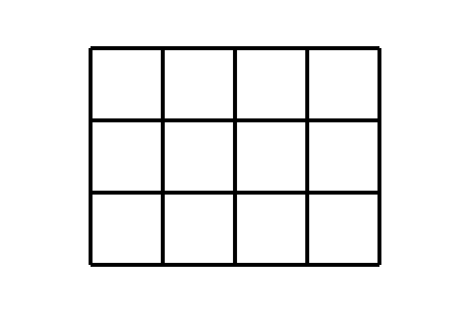
What is the volume of the prism if it has a height of 3?

Student Responses
- 36 cubes

