Unit 6 Lesson 8: Equivalent Quadratic Expressions

1 Diagrams of Products (Warm up)

Student Task Statement
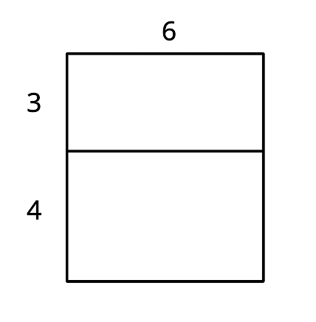
- Explain why the diagram shows that $6(3+4)=6⋅3+6⋅4$.
- Draw a diagram to show that $5(x+2)=5x+10$.

2 Drawing Diagrams to Represent More Products

Student Task Statement
Applying the distributive property to multiply out the factors of, or expand, $4(x+2)$ gives us $4x+8$, so we know the two expressions are equivalent. We can use a rectangle with side lengths $(x+2)$ and 4 to illustrate the multiplication.
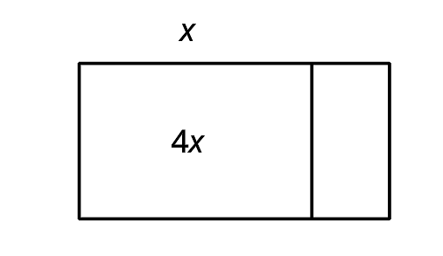
- Draw a diagram to show that $n(2n+5)$ and $2n^{2}+5n$ are equivalent expressions.
- For each expression, use the distributive property to write an equivalent expression. If you get stuck, consider drawing a diagram.
- a. $6\left(\frac{1}{3}n+2\right)$
- b. $p(4p+9)$
- c. $5r\left(r+\frac{3}{5}\right)$
- d. $(0.5w+7)w$

3 Using Diagrams to Find Equivalent Quadratic Expressions

Student Task Statement
- Here is a diagram of a rectangle with side lengths $x+1$ and $x+3$. Use this diagram to show that $(x+1)(x+3)$ and $x^{2}+4x+3$ are equivalent expressions.
- 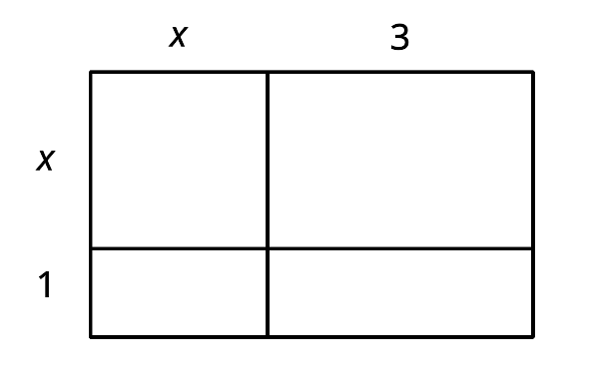
- Draw diagrams to help you write an equivalent expression for each of the following:
  - $(x+5)^{2}$
  - $2x(x+4)$
  - $(2x+1)(x+3)$
  - $(x+m)(x+n)$
- Write an equivalent expression for each expression without drawing a diagram:
  - $(x+2)(x+6)$
  - $(x+5)(2x+10)$

Activity Synthesis
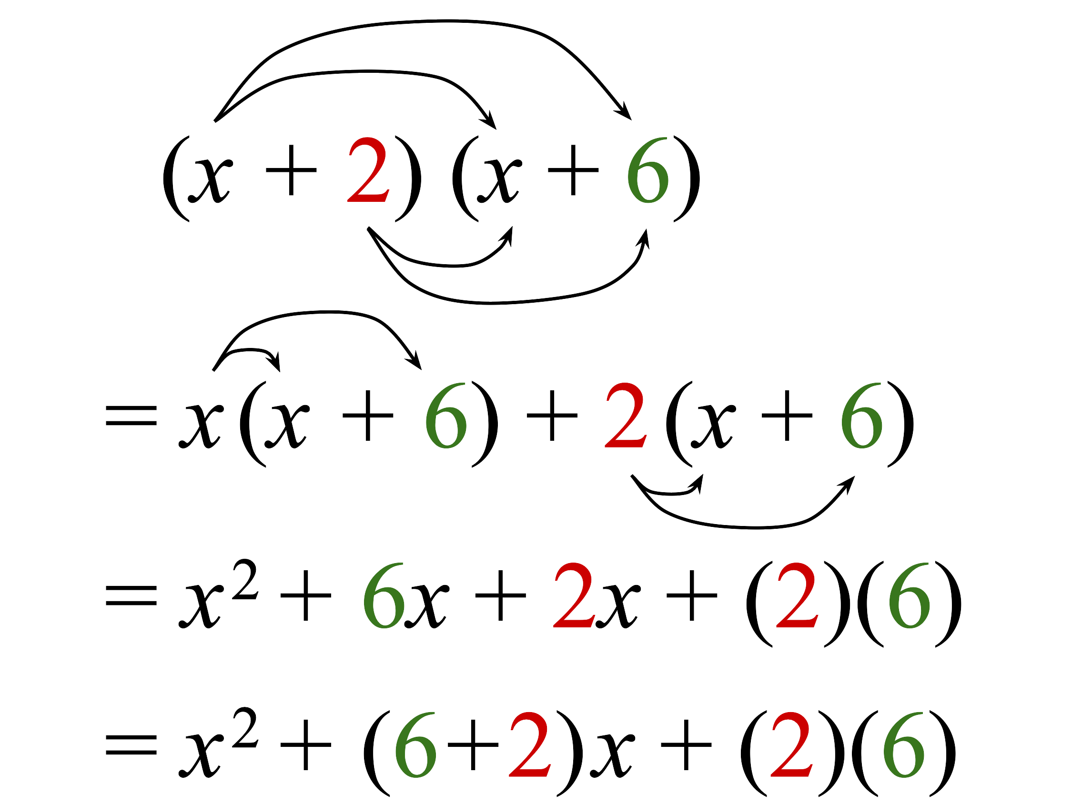
© CC BY 2019 by Illustrative Mathematics

