Unit 7 Lesson 2: Attributes of Triangles and Quadrilaterals

WU True or False: Multiples of Ten (Warm up)

Student Task Statement
Decide if each statement is true or false. Be prepared to explain your reasoning.
- $3×60=9×10$
- $180=3×60$
- $6×40=24×10$
- $24×10=240$

1 Card Sort: Triangles

Student Task Statement
Sort the triangles into categories. Record your categories and be prepared to explain how you sorted the shapes.
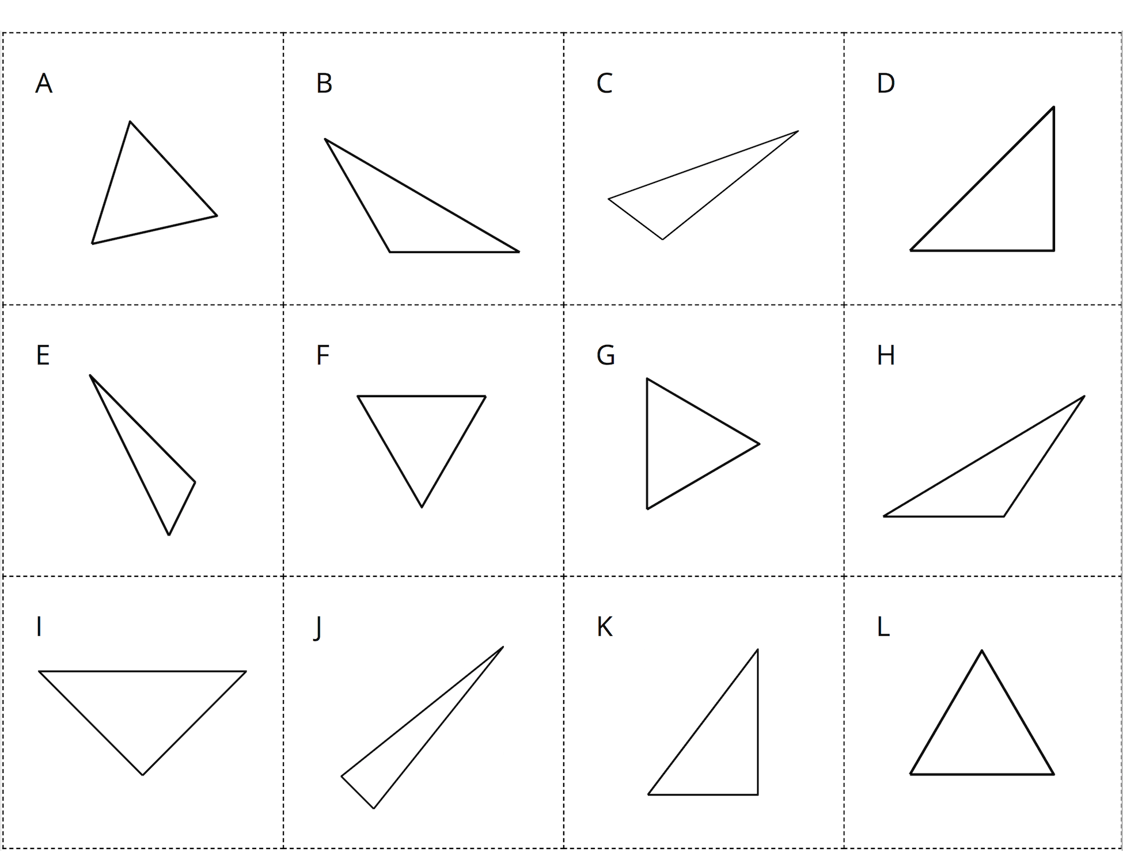

2 Card Sort: Quadrilaterals

Student Task Statement
Sort the quadrilaterals into categories. Record your categories and be prepared to explain how you sorted the shapes.
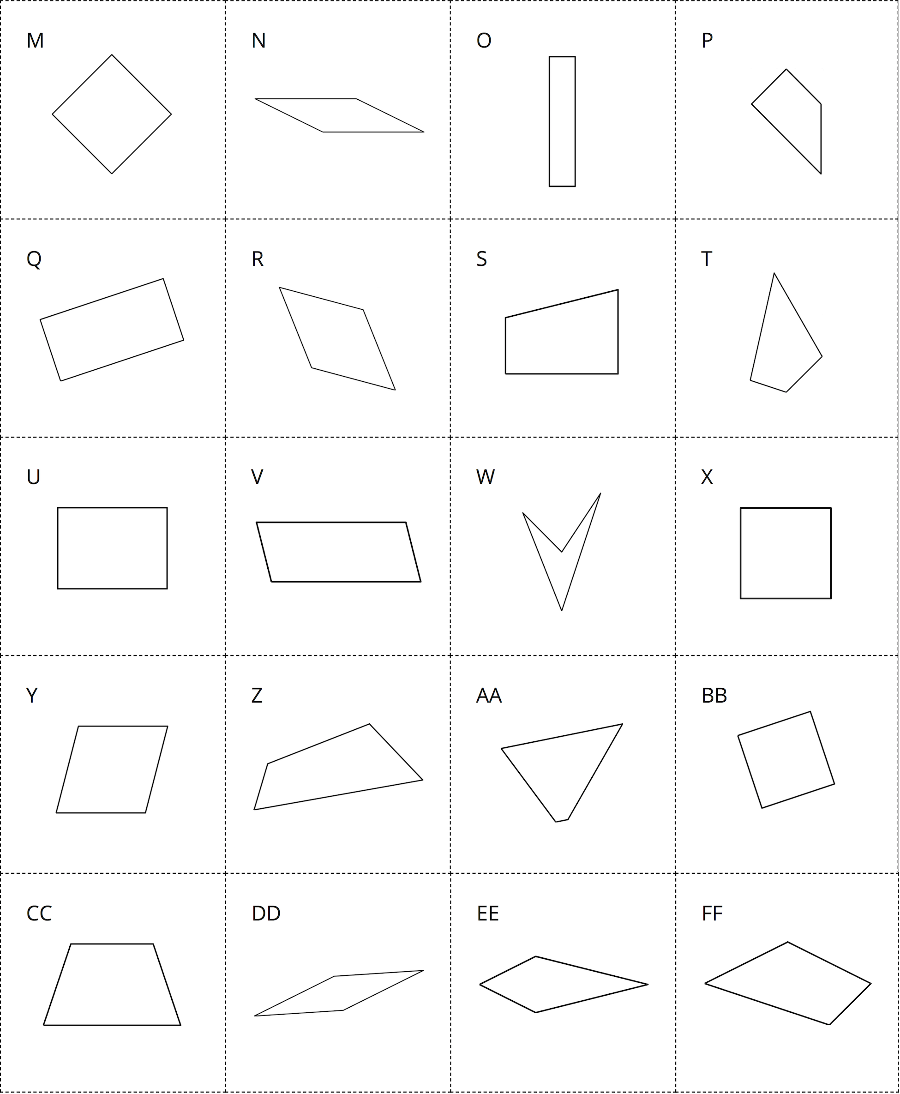
© CC BY 2021 Illustrative Mathematics®

