Lesson 21: From One- to Two-Variable Inequalities
- Let’s look at inequalities in two dimensions.

21.1: Describing Regions of the Plane
For each graph, what do all the ordered pairs in the shaded region have in common?

A

B

C

D

21.2: More or Less
- Write at least 3 values for $x$ that make the inequality true.
  - $x<\text{-}2$
  - $x+2>4$
  - $2x−1≤7$
- Graph the solution to each inequality on a number line.
- Using the inequality $x<\text{-}2$, write 3 coordinate pairs for which the $x$-coordinate makes the inequality true. Use the coordinate plane to plot your 3 points.
- 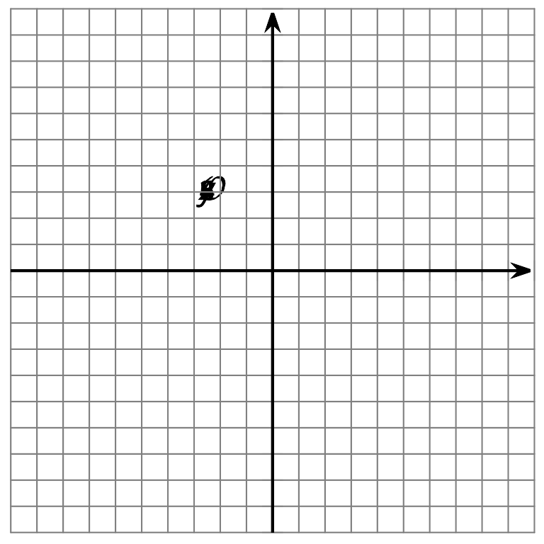

21.3: Above or Below the Line
- Graph the line that represents the equation $y=3x−4$
- 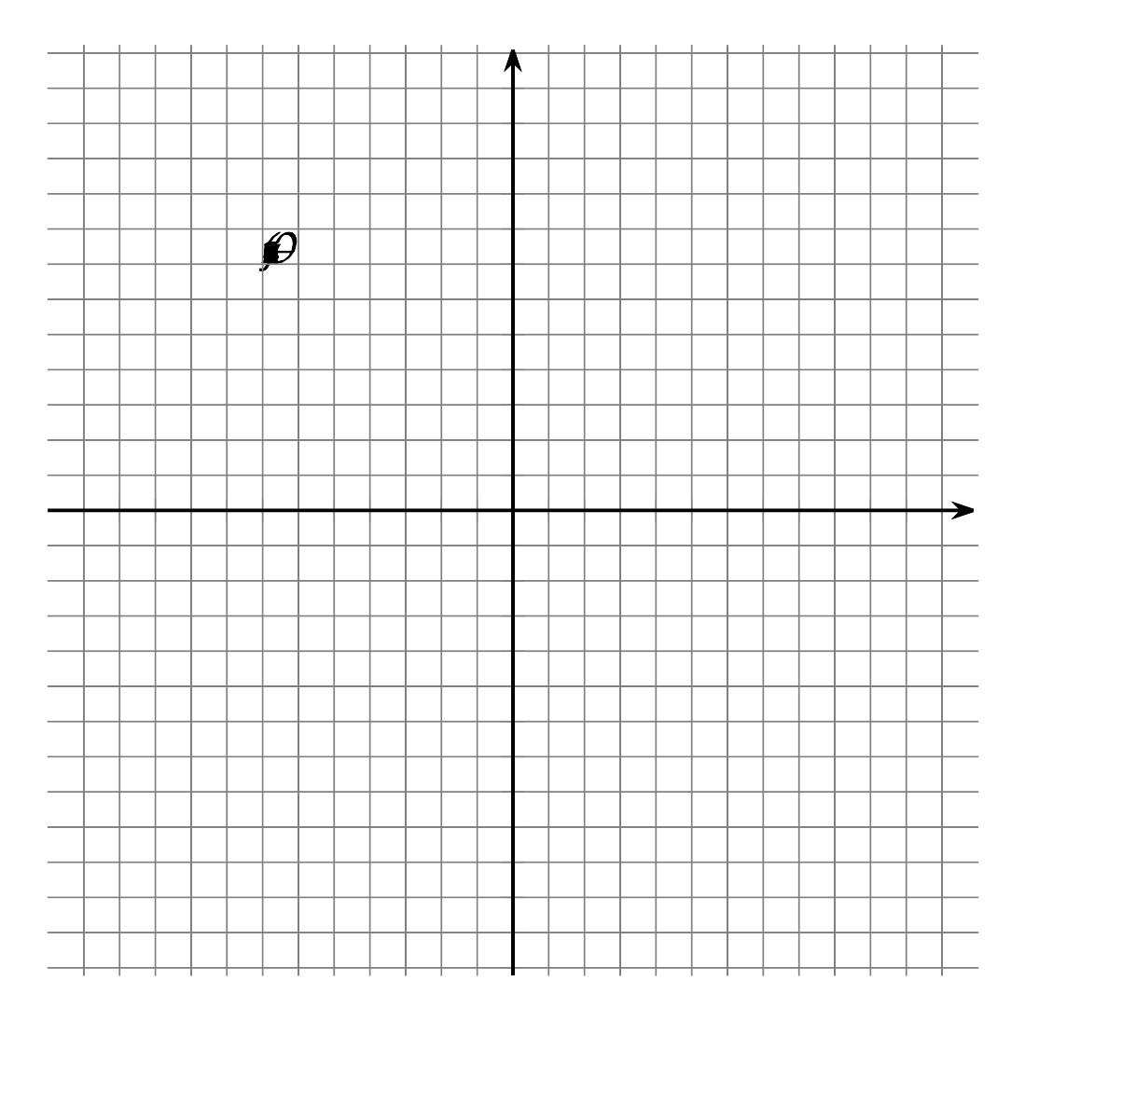
- Is the point $(4,8)$ on the line?
  - Explain how you know using the graph.
  - Explain how you know using the equation.
- Use the 3 points $(5,a),(\text{-}7,b)$ and $(c,20)$
  - Write values for $a,b,$ and $c$ so that the points are on the line.
  - Write values for $a,b,$ and $c$ so that the points are above the line.
  - Write values for $a,b,$ and $c$ so that the points are below the line.
© CC BY 2019 by Illustrative Mathematics®

