Unit 7 Lesson 2: Multiplying Powers of Ten

1 100, 1, or $\frac{1}{100}$? (Warm up)

Student Task Statement
Clare said she sees 100.
Tyler says he sees 1.
Mai says she sees $\frac{1}{100}$.
Who do you agree with?

2 Picture a Power of 10

Student Task Statement
In the diagram, the medium rectangle is made up of 10 small squares. The large square is made up of 10 medium rectangles.
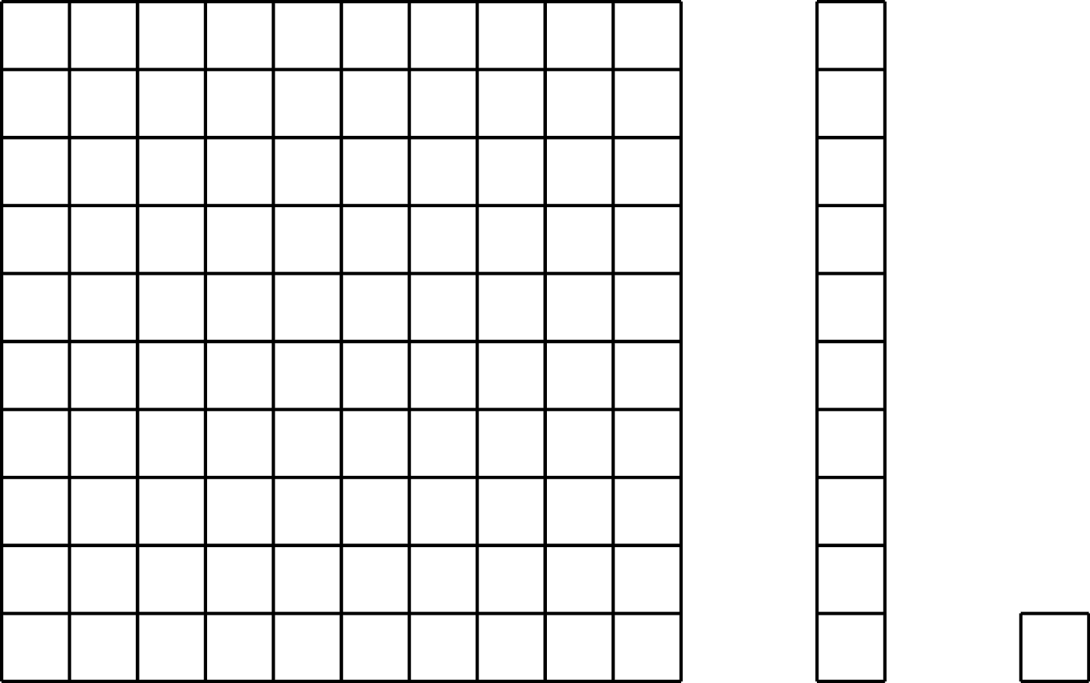
- How could you represent the large square as a power of 10?
- If each small square represents ${10}^{2}$, then what does the medium rectangle represent? The large square?
- If the medium rectangle represents ${10}^{5}$, then what does the large square represent? The small square?
- If the large square represents ${10}^{100}$, then what does the medium rectangle represent? The small square?

3 Multiplying Powers of Ten

Student Task Statement
  - Complete the table to explore patterns in the exponents when multiplying powers of 10. You may skip a single box in the table, but if you do, be prepared to explain why you skipped it.
- expression | - expanded | - single power of 10
- ${10}^{2}⋅{10}^{3}$ | - $(10⋅10)(10⋅10⋅10)$ | - ${10}^{5}$
  - ${10}^{4}⋅{10}^{3}$
  - ${10}^{4}⋅{10}^{4}$
 | - $(10⋅10⋅10)(10⋅10⋅10⋅10⋅10)$
  - ${10}^{18}⋅{10}^{23}$
  - If you chose to skip one entry in the table, which entry did you skip? Why?
  - Use the patterns you found in the table to rewrite ${10}^{n}⋅{10}^{m}$ as an equivalent expression with a single exponent, like 103.
  - Use your rule to write ${10}^{4}⋅{10}^{0}$ with a single exponent. What does this tell you about the value of ${10}^{0}$?
- The state of Georgia has roughly ${10}^{7}$ human residents. Each human has roughly ${10}^{13}$ bacteria cells in his or her digestive tract. How many bacteria cells are there in the digestive tracts of all the humans in Georgia?

Activity Synthesis
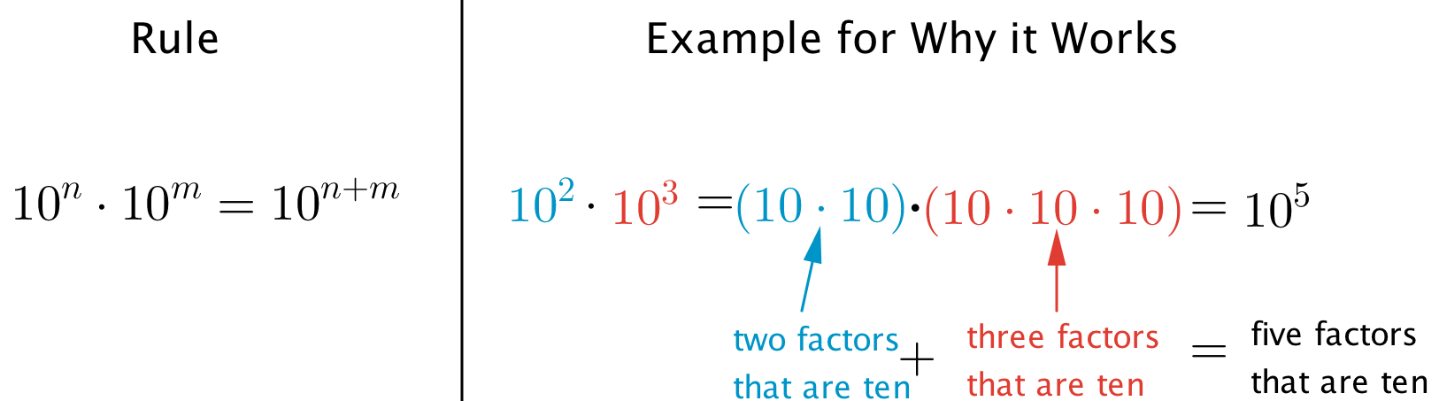
© CC BY Open Up Resources. Adaptations CC BY IM.

